Navigation: ctcLink site for mobile devices > Dashboard > Class Information > Class Search
- Choose how to access the class schedule:
  - Select ‘Classes’ on the Bellevue College website
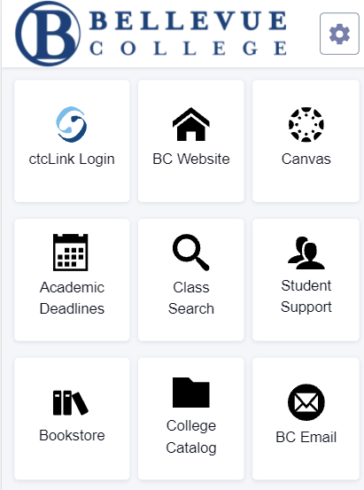
  - Select the ‘Class Search’ tile on the Bellevue College ctcLink mobile site (wa080.ctclink.us).
  - Enter https://www.bellevuecollege.edu/classes/ in your preferred browser.

NOTE:
You must be logged in to enroll in a class and add a class to your Shopping Cart or Planner. If you have applied or are a current student, please log in to your account before searching if you want to search and enroll at the same time.

- Use the options and filters to narrow your search. You must select a Term and a Subject Field. Both are required fields. You can click More Filters to expand the list of search criteria.

NOTE:
Ensure you have the Term and Subject Fields selected. Both are required fields.

- Select desired Subject from the dropdown list. The Subject dropdown list shows ALL classes for subjects that have CCN (BIOL&, ENGL&, CHEM&) and non-CCN courses (BIOL, ENGL, CHEM).

NOTE:
CCN and regular (non-CCN) courses are listed separately. Be sure to look in BOTH subject lists (example, CHEM - Chemistry and CHEM& - Chemistry (CCN)) or use Subject Begins with to see ALL the Chemistry classes offered that quarter. What are CCN courses? Common course numbered (CCN) courses allow for easier transfer between colleges and are noted by an “&” after the department name.

- Search by Subject, Class Number, Instruction Mode, Course Attribute, Location, and other filters.
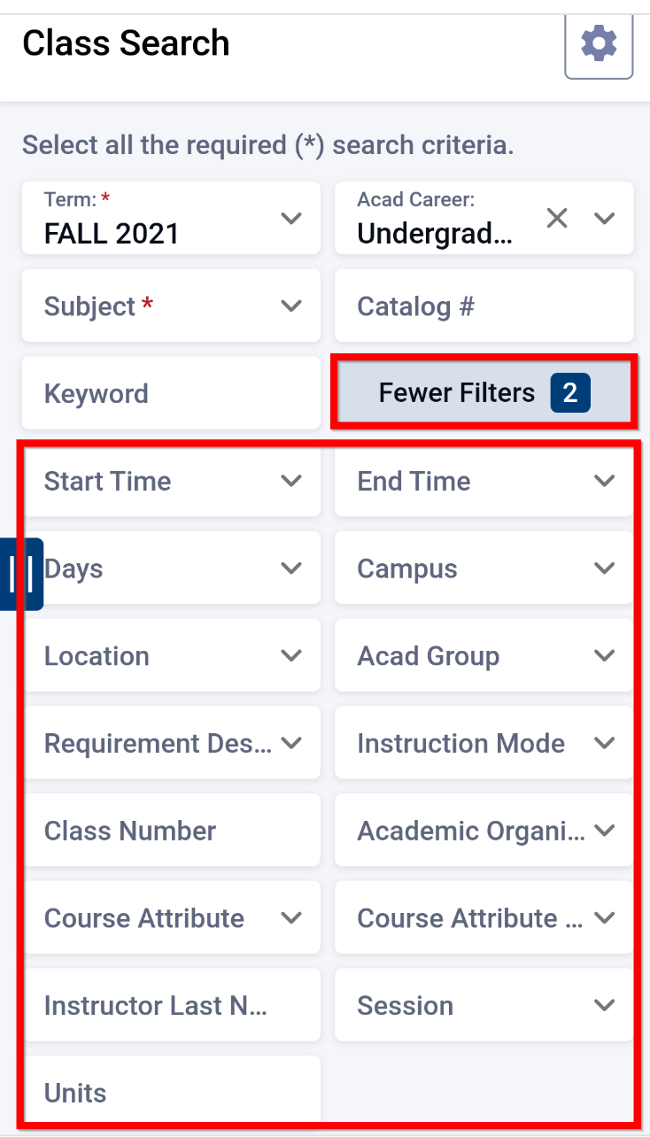

NOTE:
The Fewer Filters button allows you to unclutter the screen by removing filters from view. It also shows a count of how many filters are currently applied.

- To choose Course Attributes as a filter:
  - Choose your college from the Course Attribute dropdown menu.
  - Select a Course Attribute Value to narrow to specific types of courses such as “Natural Sciences w/ Lab” or “Performance Course”.

- To filter for Continuing Education classes or Undergraduate classes, select that type of course using the Acad Career filter.

- Once your filters are set, click Search.

NOTE:
If you only want to see open classes, check the Show Open Classes Only box. Don’t check this box if you may want to add yourself to the Waitlist of a full class.

- Review the course/class options. Pay attention to the Section name: LEC = Lecture and LAB = Laboratory/Studio. Click View on the class section to see more information about it, including special registration instructions, class notes, and textbook information. Review the Status of each Section. The first number is the number of spots still available, and the second number is the total number of spots for the class or waitlist.

NOTE:
To check the availability of a class, look at Status. The first number is the number of spots still available, and the second number is the total number of spots for the class or waitlist.
.

