Drop/Withdraw from a Course (Mobile-Friendly)

Purpose:
These instructions provide a quick guide for students to withdraw from classes using a mobile device.

Audience:
Students at Bellevue College

Navigation: ctcLink site for mobile devices > Dashboard > Enrollment

- Select the ctcLink Login tile on the Bellevue College mobile site.

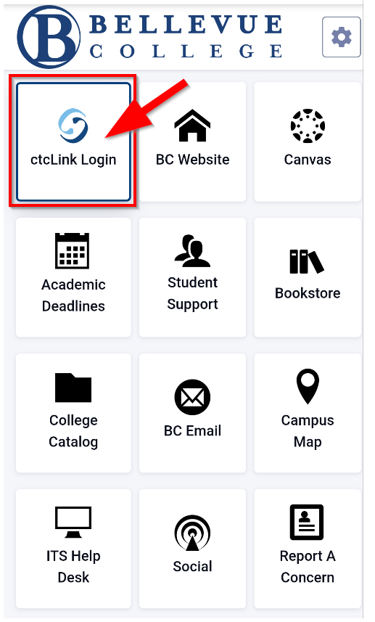
- Enter your ctcLink ID and select Next. Then enter your Password and select Verify. If this is your first time signing in, click Activate your Account and follow the steps to activate your account before logging in. For additional instructions on activating your account, follow the account activation guide.

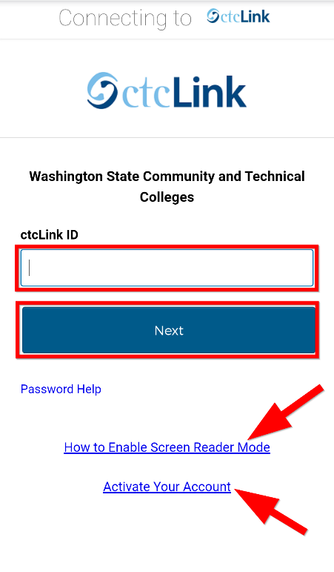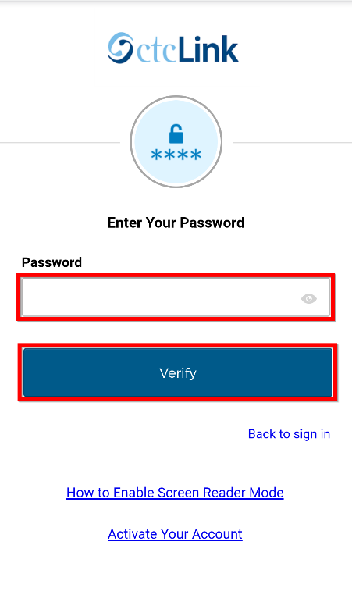

Note:
If you have forgotten your password, select Password Help.
If you will be using a screen reader, select the How to Enable Screen Reader Mode link.
If this is your first time logging in, be sure to Activate Your Account.

- Click the “hamburger” menu icon on the left to expand the menu options. You can expand the menu at any time using the menu icon.

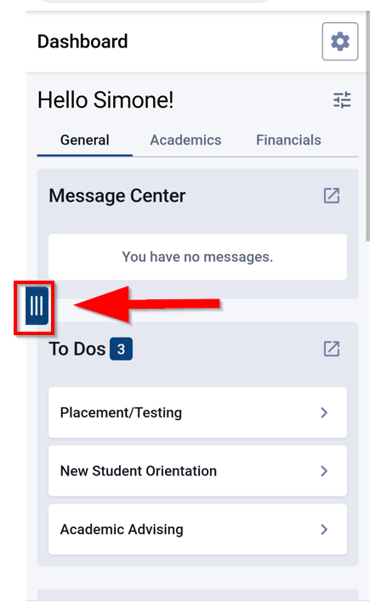

- From the expanded menu, select the Enrollment dropdown menu and then select Drop Classes.

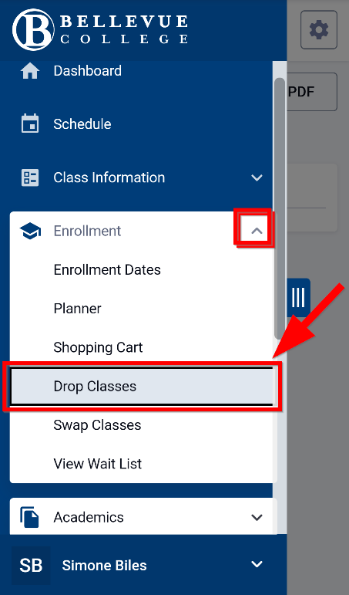

Note:
Dropping/withdrawing from a class:
- May impact your Financial Aid or student account balance
- Does not guarantee a 100% refund (pay attention to key refund dates each quarter)
- Could impact your college transcript

Talk to a Financial Aid Specialist or an Academic Advisor to learn how dropping/withdrawing a class will impact your funding and/or academic plans.

- Click to add a checkmark in the checkbox next to the class you want to drop. Then select the Drop button at the top right of the screen.

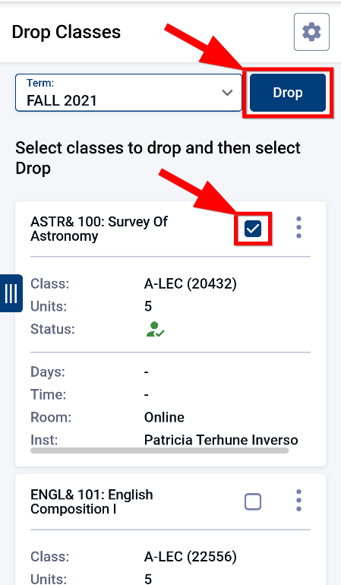

- Click the Drop button to confirm you want to drop/withdraw from the class. Click Cancel to go back.

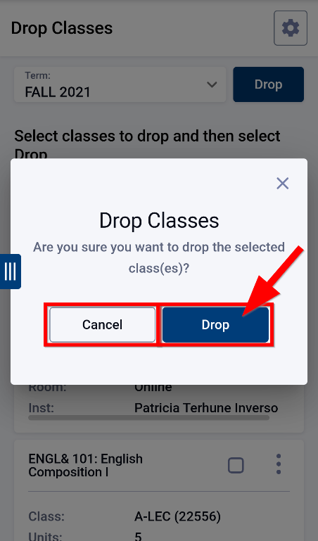

- You have successfully dropped/withdrawn from the class. Select OK to return to your schedule.

Document Owner: Steve Downing

