Enroll in a Class (Mobile-Friendly)

Purpose:
These instructions provide a quick guide for students to enroll in classes on their mobile device.

Audience:
Students at Bellevue College

Navigation: ctcLink site for mobile devices > Dashboard > Class Search

- Select the ctcLink Login tile on the Bellevue College mobile site.
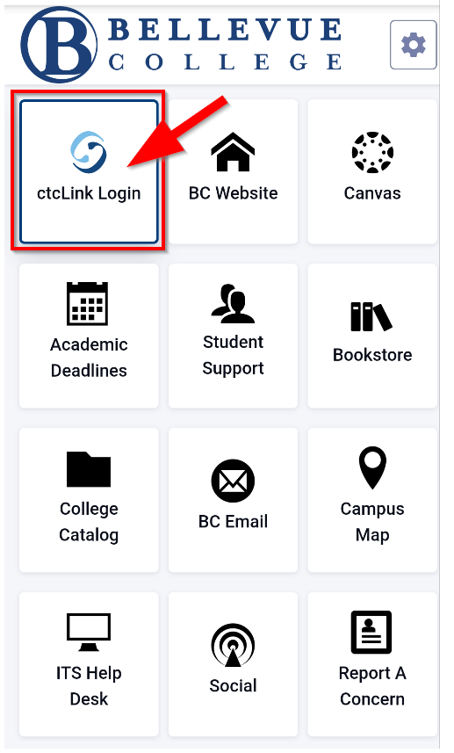
- Enter your ctcLink ID and select Next. Then enter your Password and select Verify. If this is your first time signing in, click Activate your Account and follow the steps to activate your account before logging in. For additional instructions on activating your account, follow the account activation guide.
Note:
If you have forgotten your password, select Password Help.
If you will be using a screen reader, select the How to Enable Screen Reader Mode link.
If this is your first time logging in, be sure to Activate Your Account.
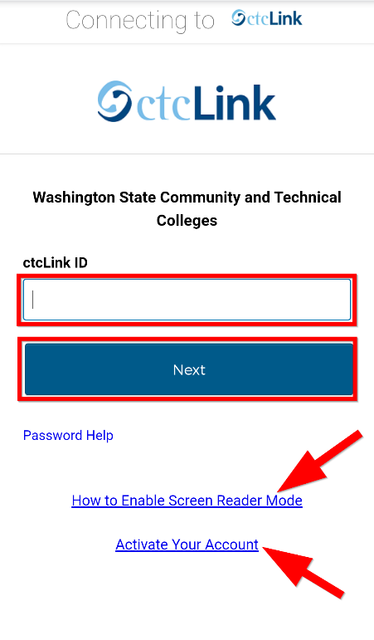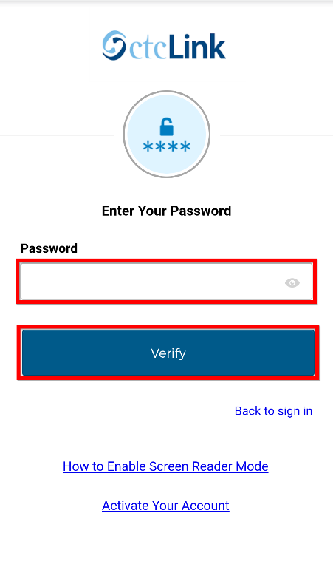

- Click the “hamburger” menu icon on the left to expand the menu options. You can expand the menu at any time using the menu icon on the left.

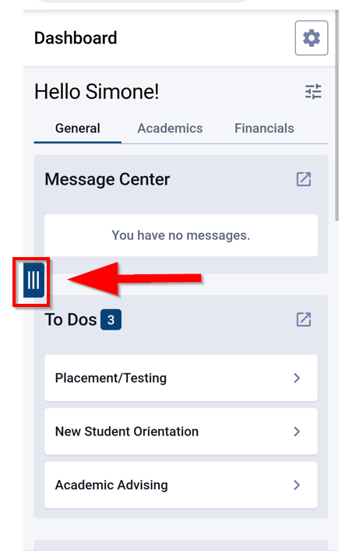

- Click the dropdown arrow next to Class Information and select Class Search to search for a class by Subject, Keyword, Instructor Last Name, Time, Days, Instruction Mode, and many other criteria.
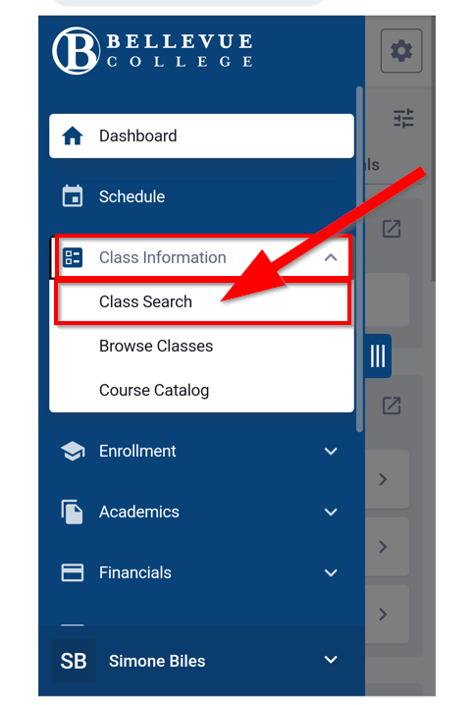

Note:
You can use Browse Classes to see all classes by Term and Subject.

- On the Class Search page, ensure you have the term and subject fields selected. Both are required fields. Use any of the other fields and additional filters to narrow your search. Then click Search.

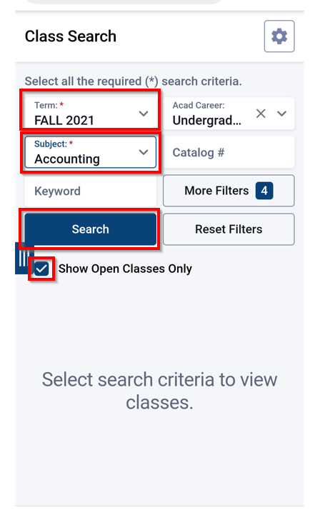

Note:
Check the Show Open Classes Only box to see only Open Classes. Do not check this box if you want to add yourself to the Waitlist of a full class.

- Review the course/class results. Pay attention to the Section name: LEC = Lecture and LAB = Laboratory/Studio. Click on View next to the class section to view more information about it, including special registration instructions, class notes, and textbook information.

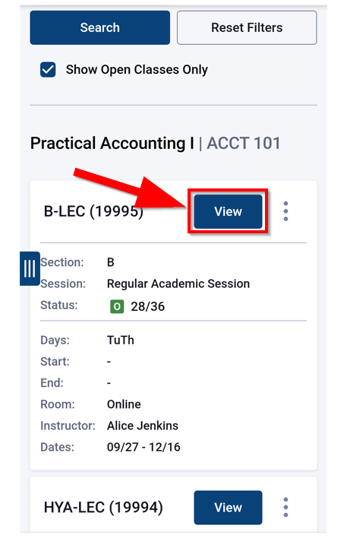

- You can enroll or take other actions from the expanded view by selecting the “Additional Options” menu which is accessed by clicking on the three vertical dots next to the Add to Cart button. Or you can select Add to Cart to enroll in the class later.

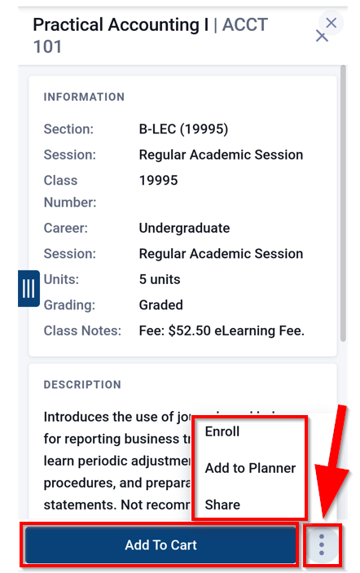

- Alternatively, you can enroll in classes and take other actions directly from the search results list by using the “Additional Options” menu which is accessed by clicking on the three vertical dots next to the View button.

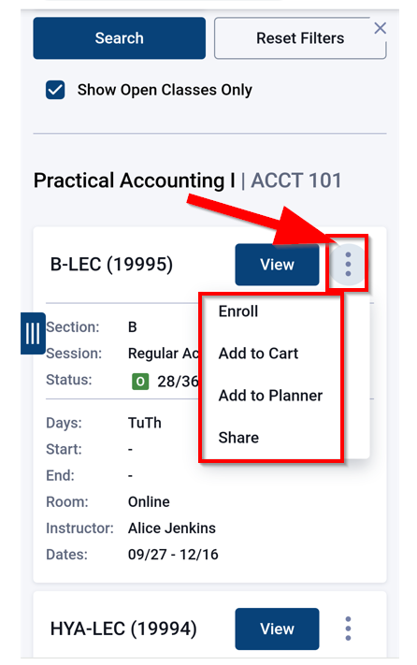

- To enroll now, click the Enroll button. To enroll later, click Add To Cart. You can also add the class to your Planner or share it.

Note:
If you choose Add to Cart, you will need to enroll for your classes through Enrollment > Shopping Cart once you have finished adding classes to your cart and you are ready to continue. The remaining instructions assume you have selected Enroll.
- You may be prompted to choose a Lab/Studio section. Select the “radio button” next to your preferred Lab/Studio section and click Continue. If there is only one option, you will select the “radio button” for the appropriate lab. If NOT prompted to choose a Lab/Studio section, go to the next step.

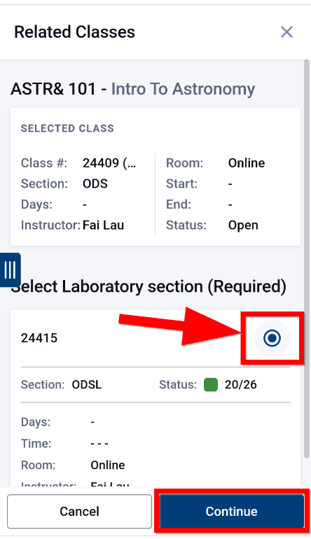

- Enter a Permission Number if required. Choose whether or not you are interested in being added to the Waitlist if the class is full. If you want to be added to the Waitlist, select the checkbox indicating you want to be added to the “Wait list if the class is full.” Then click Save.

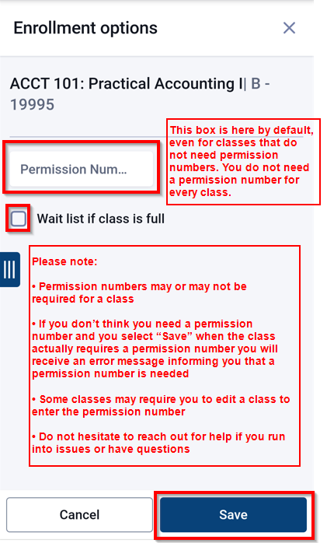

Note:
The Permission number box is included on the screen by default. This does not mean your class necessarily requires a permission number.

- Review the Enrollment Results to confirm you have been added to the class. A green box = Success! A red box = Error. If you have a green box, make note of the message below the results to ensure the class has been added to your schedule, then click OK to exit. The class has now been added to your schedule. If you have a red box, review the reason for the error and resolve as needed.

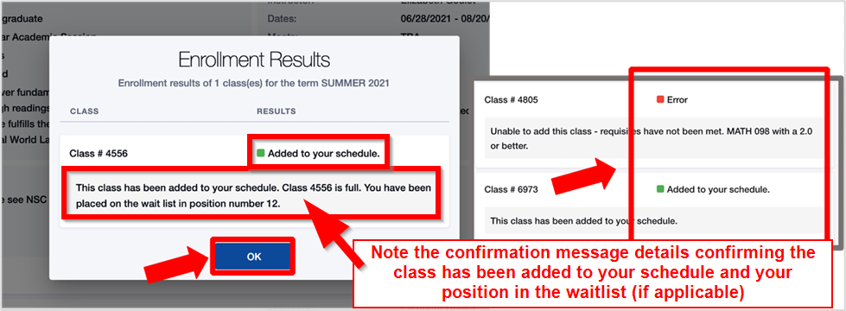

Note:
You will see additional notes below the red or green indicator box indicating if the class has been added to your schedule, your position number in the waitlist (if applicable), or if there is an error that needs to be resolved. The error message will provide additional information for follow-up.

