Find Your Enrollment Date (Mobile-Friendly)

Purpose:
These instructions provide a quick guide for students to find their enrollment date using a mobile device.

Audience:
Students at Bellevue College

Navigation: ctcLink site for mobile devices > Dashboard > Enrollment

- Select the ctcLink Login tile on the Bellevue College mobile site.

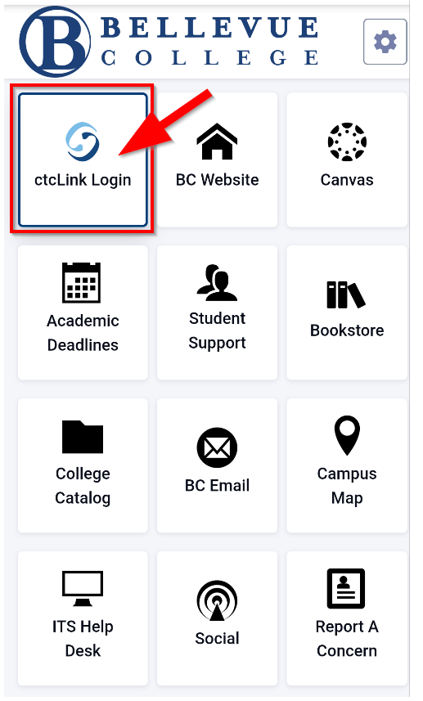
- Enter your ctcLink ID and select Next. Then enter your Password and select Verify. If this is your first time signing in, click Activate your Account and follow the steps to activate your account before logging in. For additional instructions on activating your account, follow the Account Activation guide.

Note:
If you have forgotten your password, select Password Help.
If you will be using a screen reader, select the How to Enable Screen Reader Mode link.
If this is your first time logging in, be sure to use the Account Activation Guide.
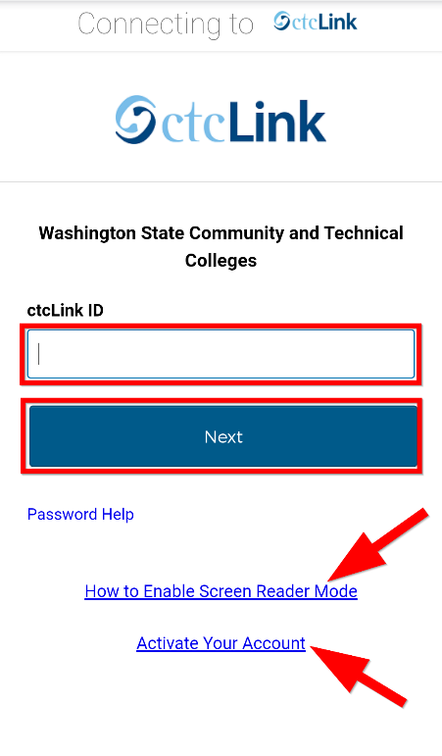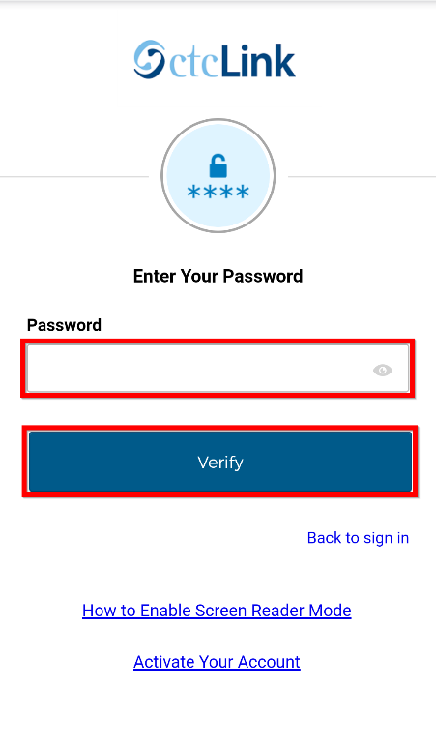

- Select the “hamburger” menu icon on the left to expand the menu options. You can expand the menu at any time using the hamburger menu icon.

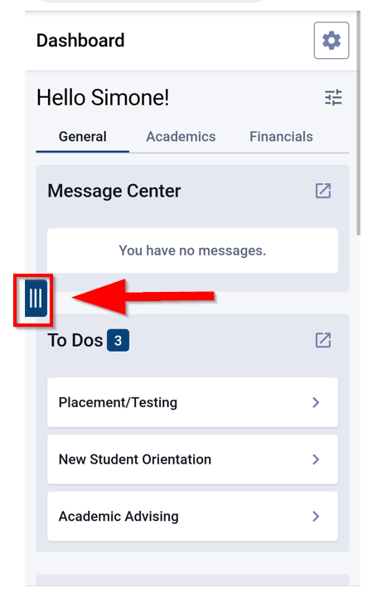

- Click the dropdown arrow next to Enrollment and select Enrollment Dates to view your enrollment dates.

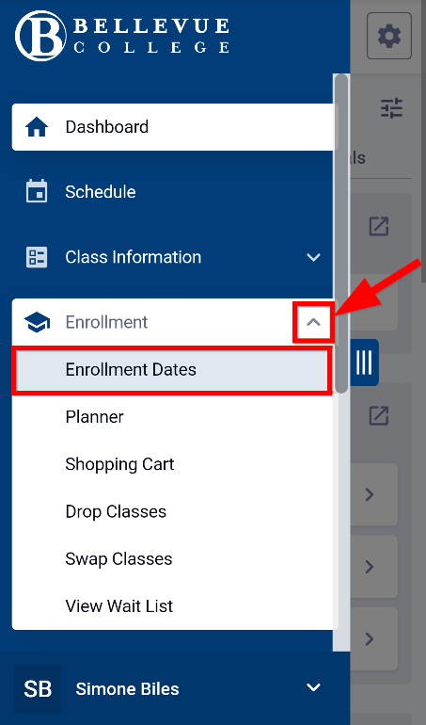

- If you do not have an Enrollment Appointment at the top of your screen, select View Details to view the enrollment dates for the appropriate term.

Note:
If you are a continuing student, you will have a box with your Enrollment Appointment at the top of the screen. See left screenshot below.
If you are a new student, you will select View Details for the appropriate term to find your Enrollment Dates. See right screenshot below.

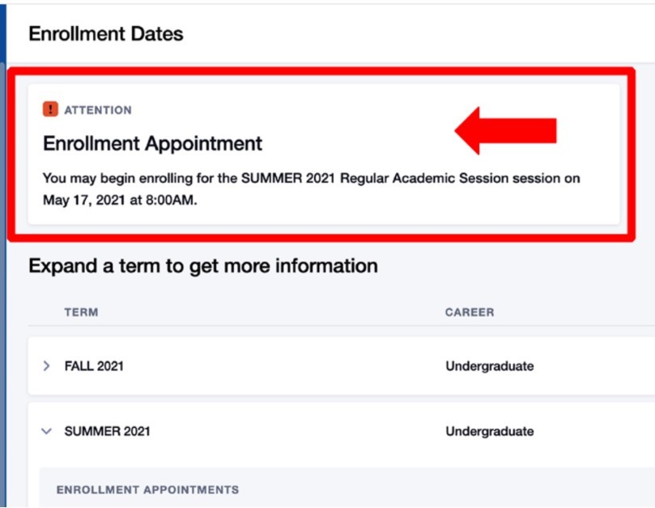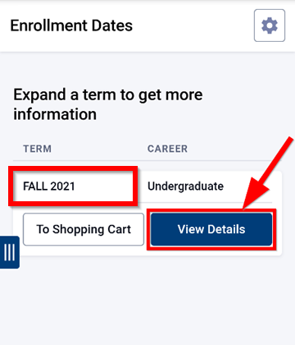

- View the Enrollment Dates for the selected term. Different session types may have different enrollment dates, so be sure to check the session type when noting the dates for enrollment. On this screen you can also view the max number of units for your enrollment for the term.
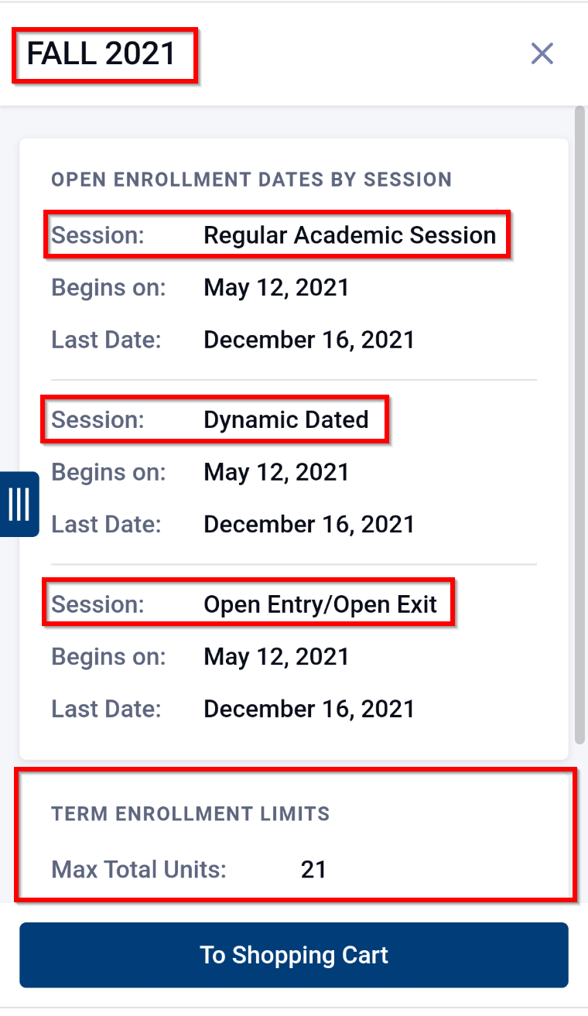

Document Owner: Steve Downing

