# Purpose:

Use this document as a reference for activating new accounts in ctcLink. During this process you will get your ctcLink ID number.

# Audience:

All ctcLink Users

# Navigation: ctcLink Gateway > Activate Your Account

**Tips before beginning**:

* Make sure to safely store the password you create and write down the ctcLink ID number once your account is activated.
* Disable pop-up blockers in your browser.
* Contact the BC IT Help Desk if you have problems with sign-in credentials, usernames, passwords or student ID numbers.

1. First, go to ctcLink at [gateway.ctclink.us](https://ptprd.ctclink.us/psp/ptprd/?cmd=login)

**Note**:   
Save this link in your browser to access ctcLink in the future.

1. Click **Activate your Account.**

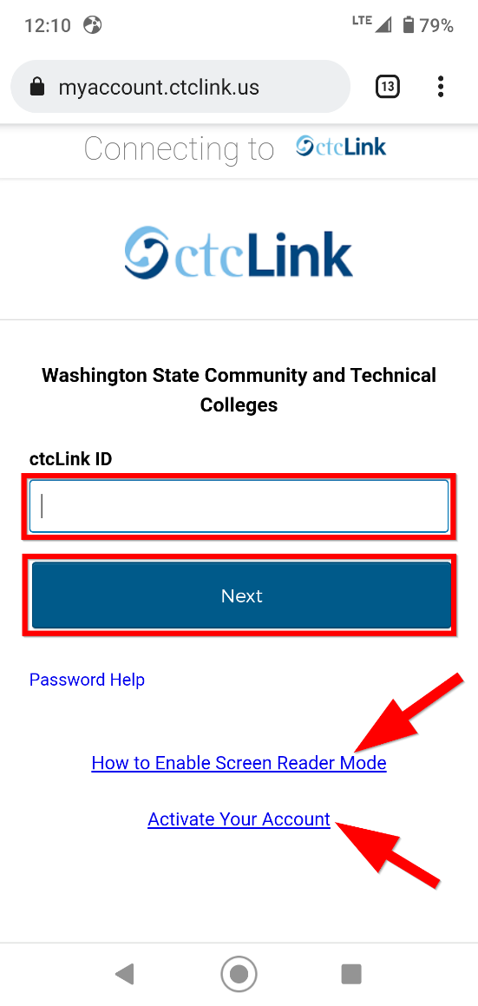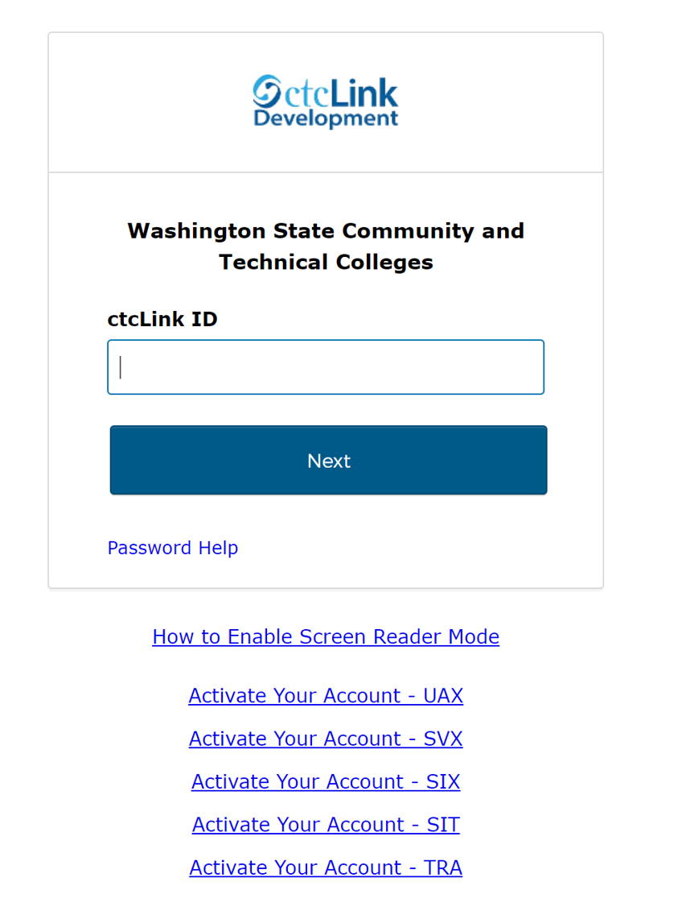

1. On the Account Activation page, enter your **full legal First Name** and **Last Name**. Make sure you have entered your name correctly. **Don’t worry, it’s safe. The college already knows this information. They are just verifying that it is really you.**

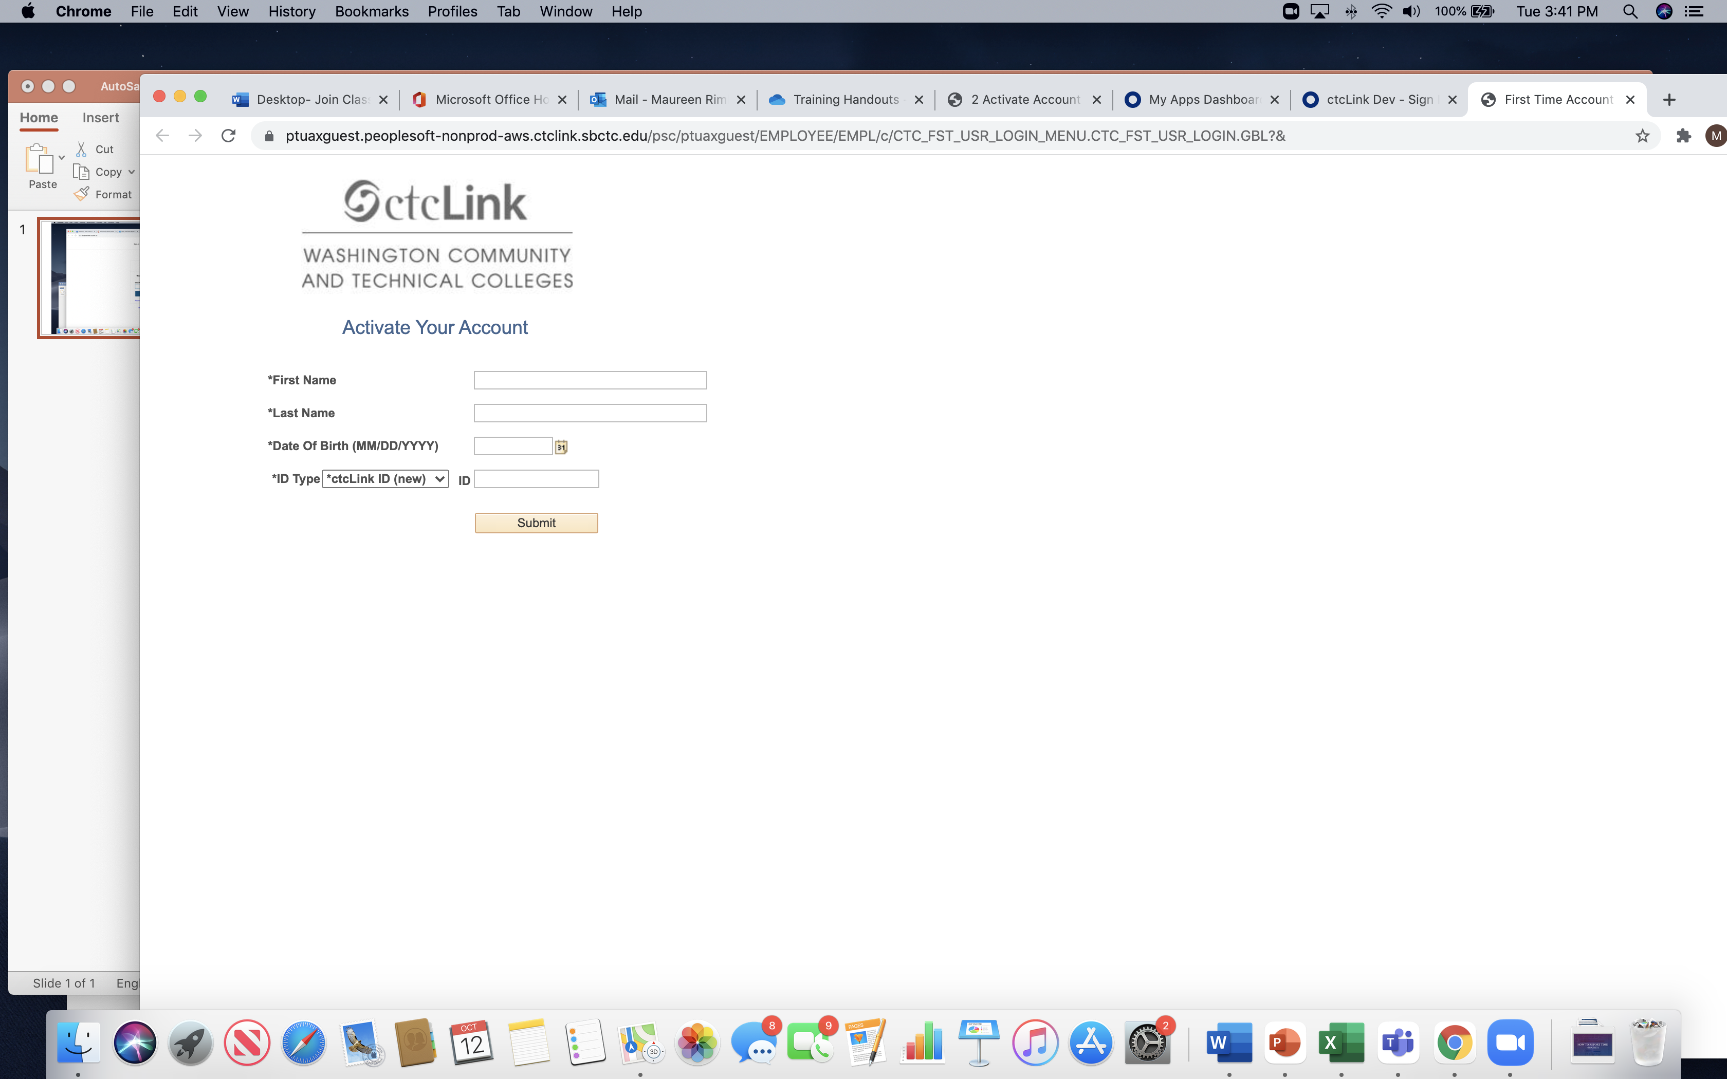

**Note**:   
If your legal name is a single name — such as Pran, Madonna or Nani — you must enter a hyphen [-] in the First Name field and enter your single name in the Last Name field.

1. Enter your **Date of Birth (MM/DD/YYYY)** or use the calendar icon.



1. Select **ID Type** to **“SID (old)”** for existing and returning students and employees or **ctcLink ID (New)** for new students and employees.

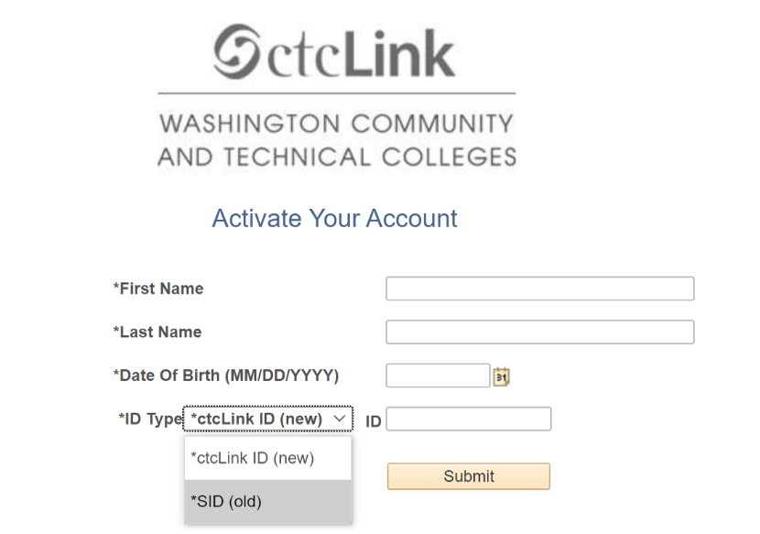

**Note**:   
Your SID is a 9-digit number. Employees use it to access Instructor Briefcase and the Time & Leave Reporting [TLR] system, and students use for it for web registration.

1. Enter your **old (current) Employee Number (SID)** or **ctcLink ID (new)** and hit **Submit.**

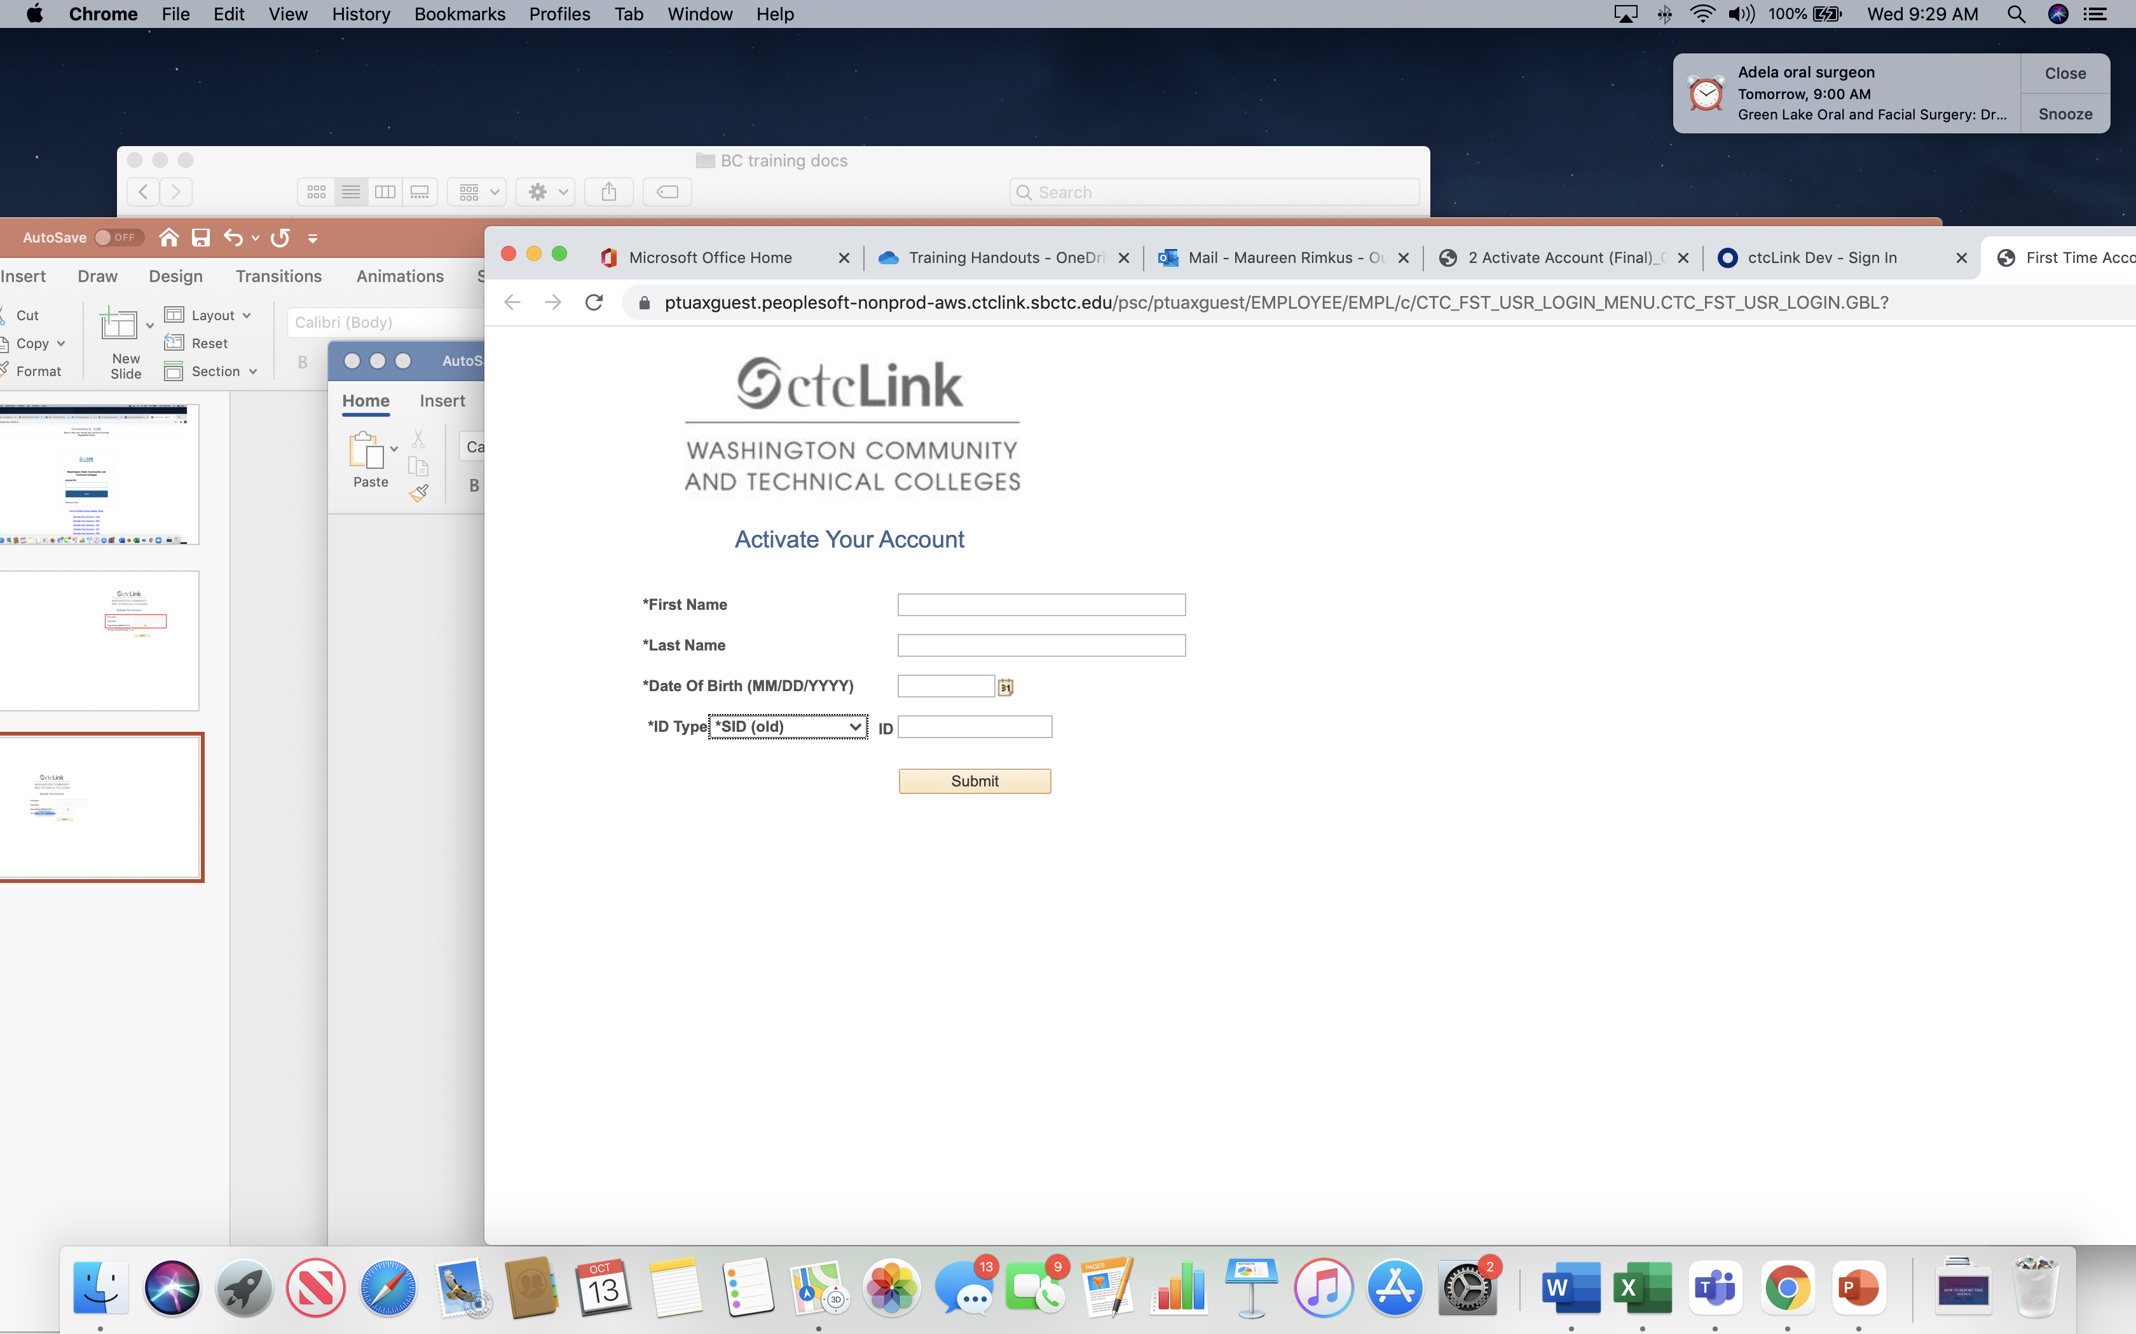

1. Enter a Phone Number for Account Recovery.

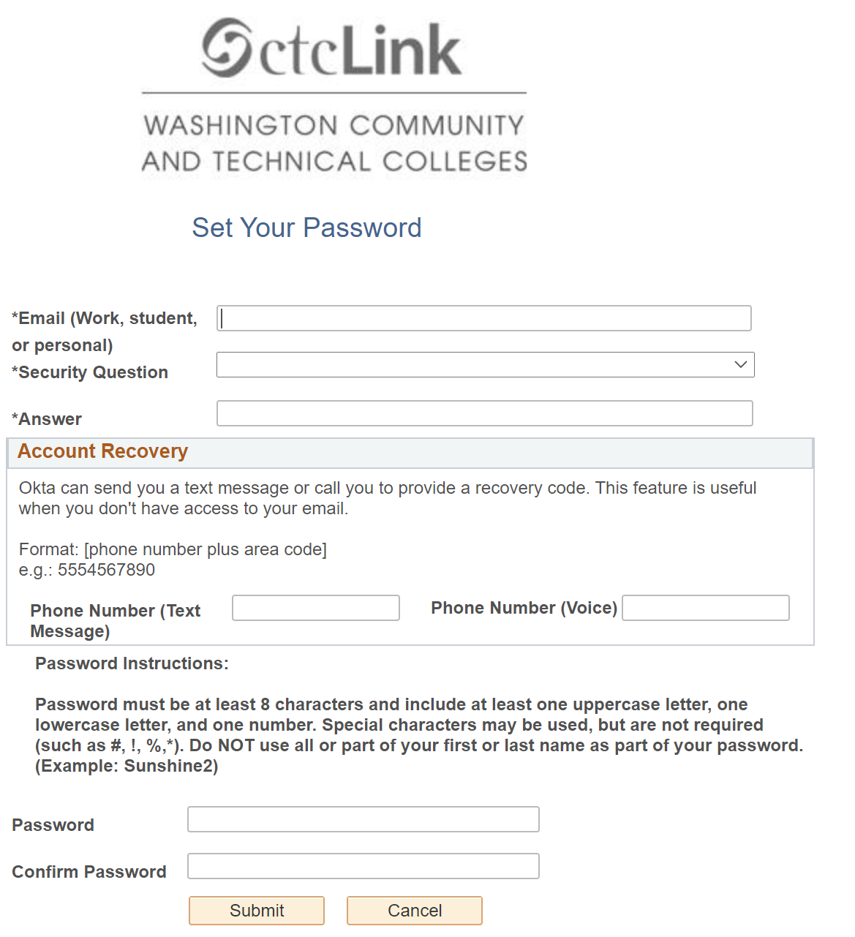

1. Enter email address. Select security question and provide the answer.



**Note**:   
Choose a question and supply an appropriate answer that you will remember.

1. Enter your new desired password in the **Password** and **Confirm Password** fields. **Be sure to write down your password**.



**Note**:   
Passwords must be at least eight characters and include at least one uppercase letter, one lowercase letter and one number. Do not use all or part of your first name or last name as a part of your password.

1. If you are satisfied with all the data you have entered, click on **Submit**. Click **Cancel** to re-enter data.



1. View the message your specific new EMPLID.

**Be sure to write down your new ID and password and keep in a safe location.** Then click **OK.**

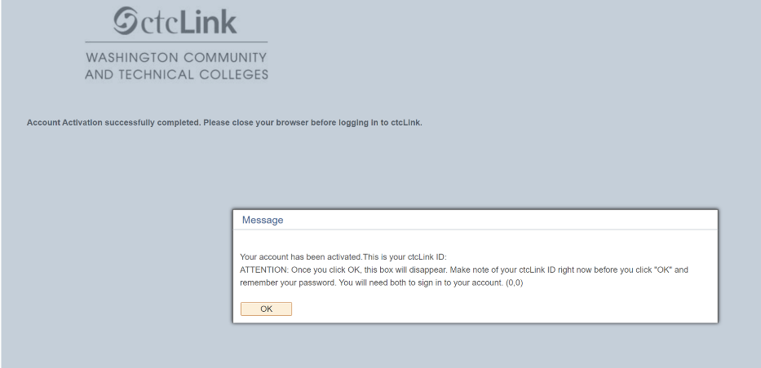

1. The Account Activation confirmation message will appear.

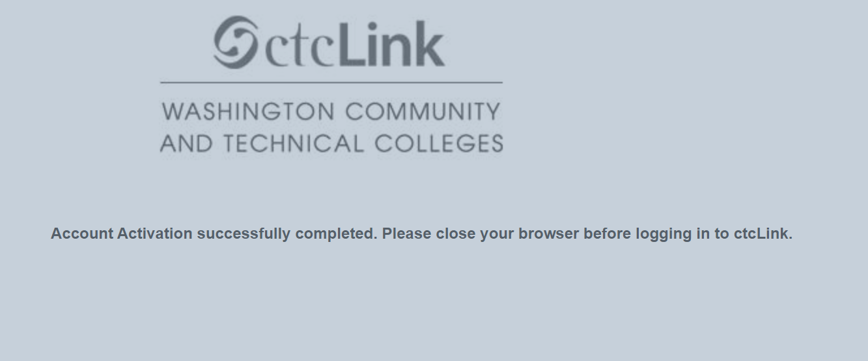

1. Your account is now activated! It will take you back to the login screen where you can now enter your new ctcLink ID and password. If you run into problems, try closing all browser windows completely (including all open tabs) for updates to take effect.

DOCUMENT OWNERS: [ctcLink@bellevuecollege.edu](mailto:ctcLink@bellevuecollege.edu)