View Your Class Schedule (Mobile-Friendly)

Purpose:
These instructions provide a quick guide for students to view their class schedule using a mobile device.

Audience:
Students at Bellevue College

Navigation: ctcLink site for mobile devices > Dashboard > Schedule

- Select the ctcLink Login tile on the Bellevue College mobile site.

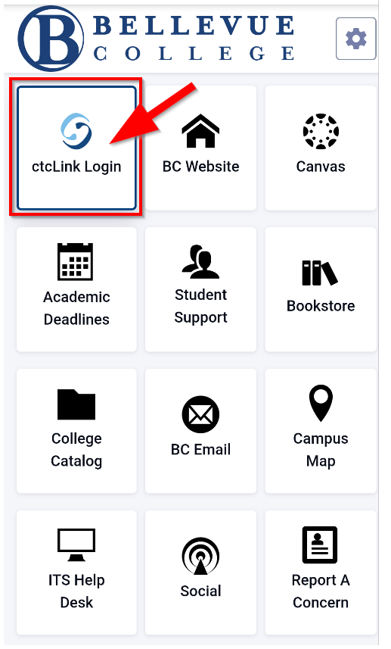
- Enter your ctcLink ID and select Next. Then enter your Password and select Verify. If this is your first time signing in, click Activate your Account and follow the steps to activate your account before logging in. For additional instructions on activating your account, follow the Account Activation guide.

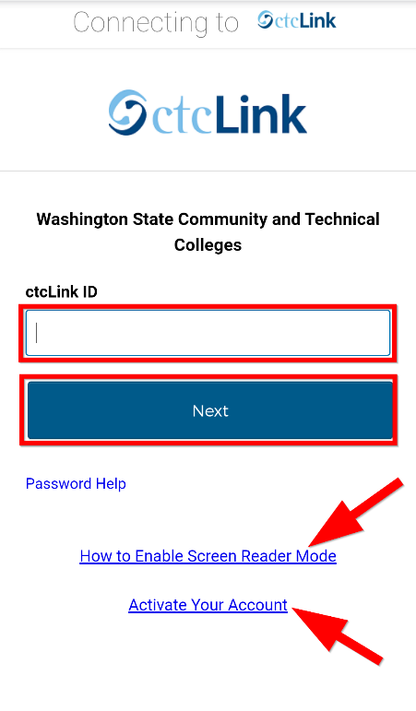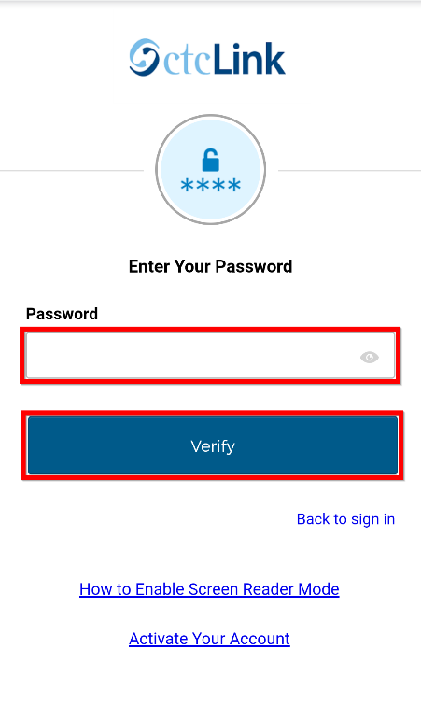

Note:
If you have forgotten your password, select Password Help.
If you will be using a screen reader, select the How to Enable Screen Reader Mode link.
If this is your first time logging in, be sure to Activate Your Account.

- Select the “hamburger” menu icon on the left to expand the menu options. You can expand the menu at any time using the menu icon.

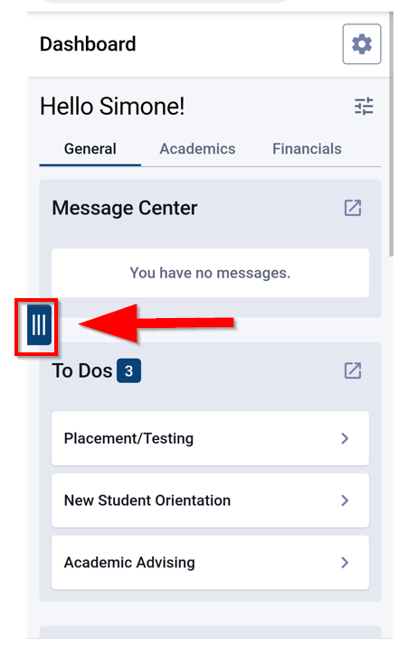

- Click Schedule to view your class schedule in list or calendar view.

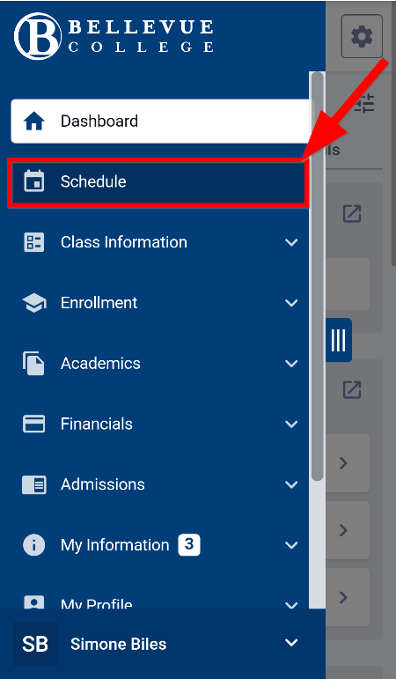

- To view a list of your classes in list view, select the list icon. To view your classes in calendar view, select the calendar icon.

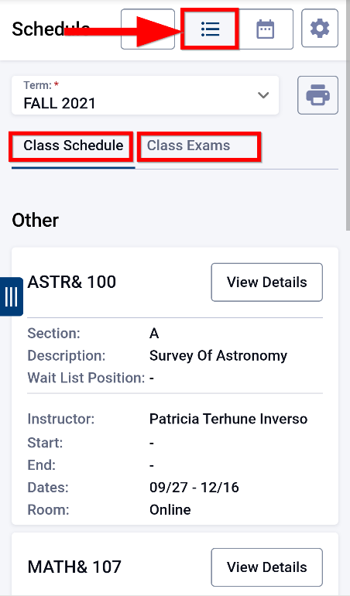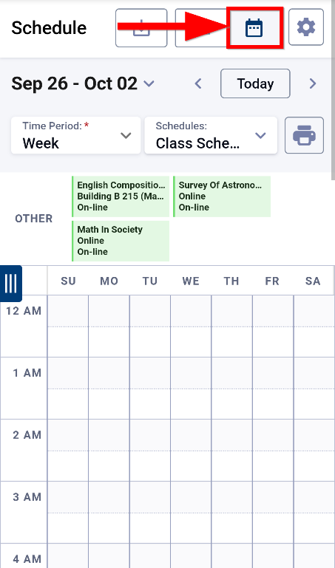

Notes:
In list view, you can toggle between Class Schedule and Class Exams by selecting the appropriate tab.
In calendar view, your online classes will appear at the top of the calendar in the OTHER row.

- In calendar view, you can select a different day, week, or month by clicking on the date range at the top left of the screen. A calendar will pop up that allows you to select a different date or date range. Use the right and left arrows to view other months. Alternatively, you can select the right or left arrow next to the Today button.

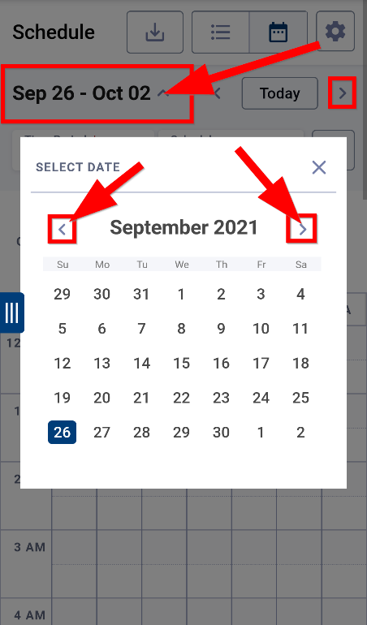

- You can also choose different views based on what works best for you. You can select between day, week, or month view by selecting the Time Period dropdown.

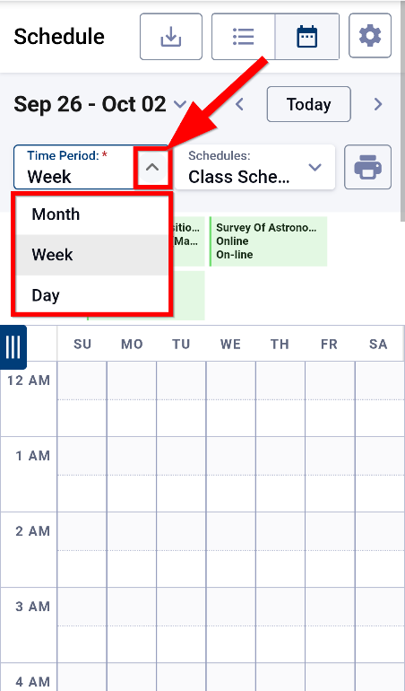

- You can also choose whether to view Class Schedule, Class Exams, and/or Wait List Classes by checking or unchecking the boxes under the Schedules dropdown.

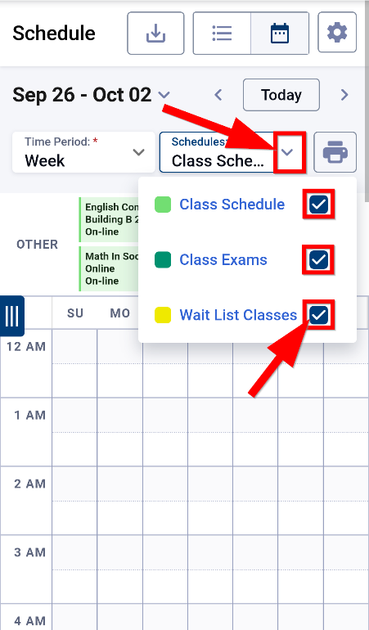

- To download your schedule, select the download icon from the list or calendar view. To print your schedule, select the print icon from the list or calendar view.

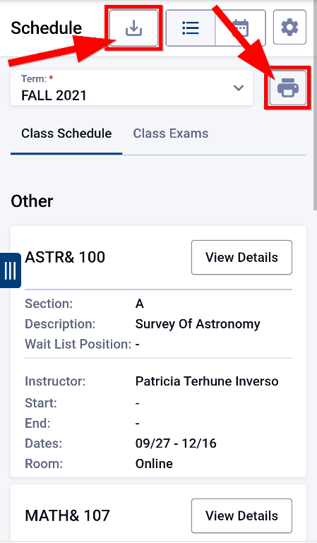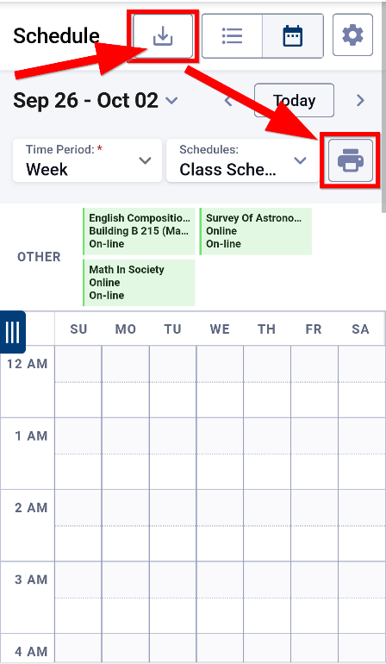

Document Owner: Steve Downing.

