Purpose:
This topic will give you a basic understanding of how to view and update your personal details. At the end of this document, you will be able to view your personal details in the profile tile and update your preferred name.

Audience:
Students

Navigation: ctcLink Gateway > Student Self Service (Homepage) > Profile (Tile)

- First, sign in to ctcLink with your ctcLink ID and Password. Enter your ctcLink ID and select Next. Then enter your Password and select Verify.
Note:
If this is your first time signing in, click Activate your Account and follow the steps to activate your account.
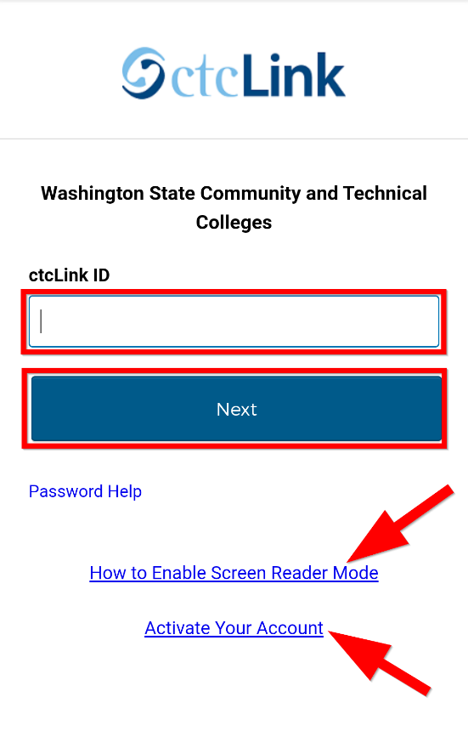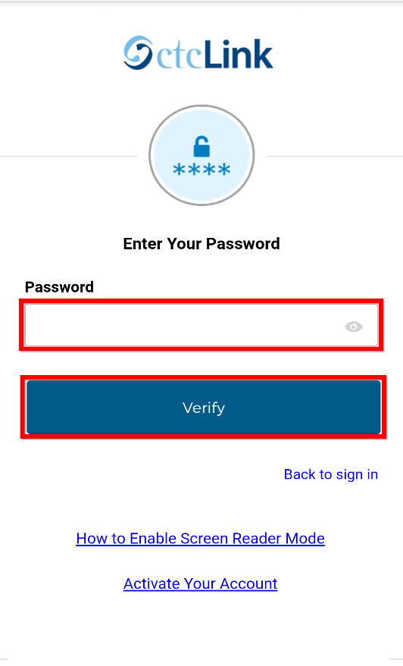
Note:
If you have forgotten your password, select Password Help.
If you will be using a screen reader, select the How to Enable Screen Reader Mode link.

- Once signed in to ctcLink, select Student Homepage.

- Select Profile from the Student Home Page.

- Personal Details page displays. You can review your personal details such as, name, date of birth and social security number.

- Select Primary Name to view the legal name that is on file. You can only view the primary name to verify, you cannot update this online.

Note:
If this information is incorrect, you will need to visit your institution in person and provide documentation as proof of your legal name.
.

- If you have another name that you prefer to go by versus your legal name, select Plus [+] to add a preferred name. This will allow for the services within Bellevue College to see that you go by another name other than your legal name. As an example, if your name is William but you go by Billy, staff within Bellevue College will be able to address you as Billy.

- The Add Name page will display. Choose from the drop down the type of "Preferred".

- Enter your preferred name and select Save.

- The personal details page is now updated with a second line for the preferred name you entered.

- Add additional Optional Biographic Details by clicking the Biographic tab.

- To view values for Gender Identity or Sexual Orientation select the arrow next to each.

- Make your selection from the drop-down list and click Save.

- Your personal details have now been updated.

SMEs Involved: Steve Downing

