View/Update Biographic Information
Learn how to view and/or update your biographic information

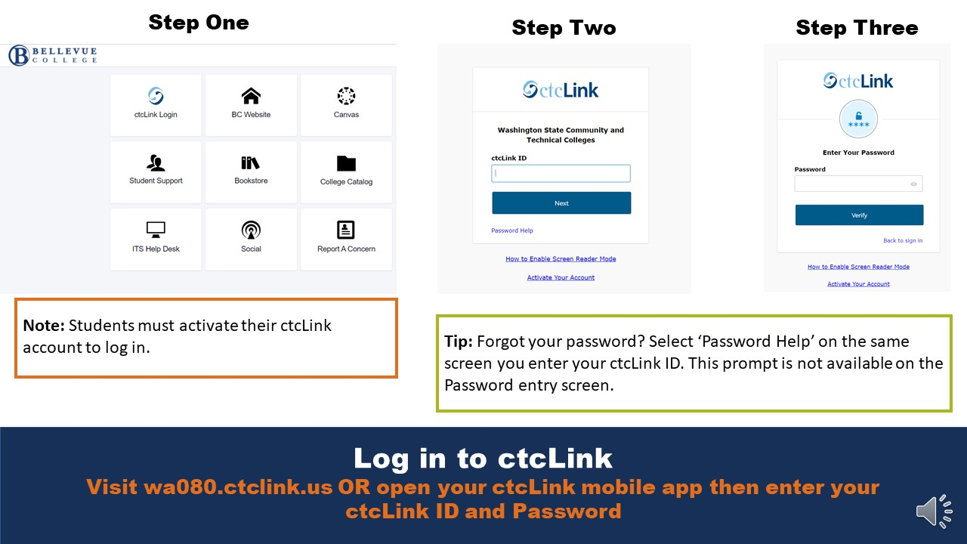
Log in to ctcLink
Visit wa080.ctclink.us OR open your ctcLink mobile app then enter your ctcLink ID and Password

Select ‘Biographical Information’
Expand ‘My Profile’ dropdown then select ‘Biographical Information’.

Review Biographic Information
Some fields may not contain information or be editable

Note: You can edit/add the following information in ctcLink:
- Preferred Name
- Degree Name
- Gender Identity
- Ethnicity

Note: Students who identify as ‘White’ do not have that ethnicity display.

Tip: Use the tabs at the top to navigate between additional personal information you can update.

Update Biographic Information: Names
Select ‘Add Name’ and choose to add a ‘Preferred’ or ‘Degree’ name

Note: Your ‘Preferred’ name is the name you want the college, its faculty, and staff to refer to you by. Your ‘Degree’ name is the name you want listed on any degree and/or certificate you receive.
Add Your Preferred or Degree Name Information
‘First Name’ and ‘Last Name’ are required fields. Click Save.

Update Biographic Information: Gender Identity
Click ‘Edit’ (pencil) icon. Expand selection options. Select preferred Gender Identity. Click Save.

Update Biographic Information: Ethnicity
Click ‘Edit’. Update IPEDS Ethnicity information.

Note: If you select ‘American Indian or Alaska Native’, ‘Asian’, ‘Black or African American’, or ‘Native Hawaiian or Pacific Islander’ you can click ‘Background’ to select more specific ethnic background options.

Update Biographic Information: Ethnicity
When finished, click save. Review changes.

