Find Your Enrollment Date
Learn when you can register for classes

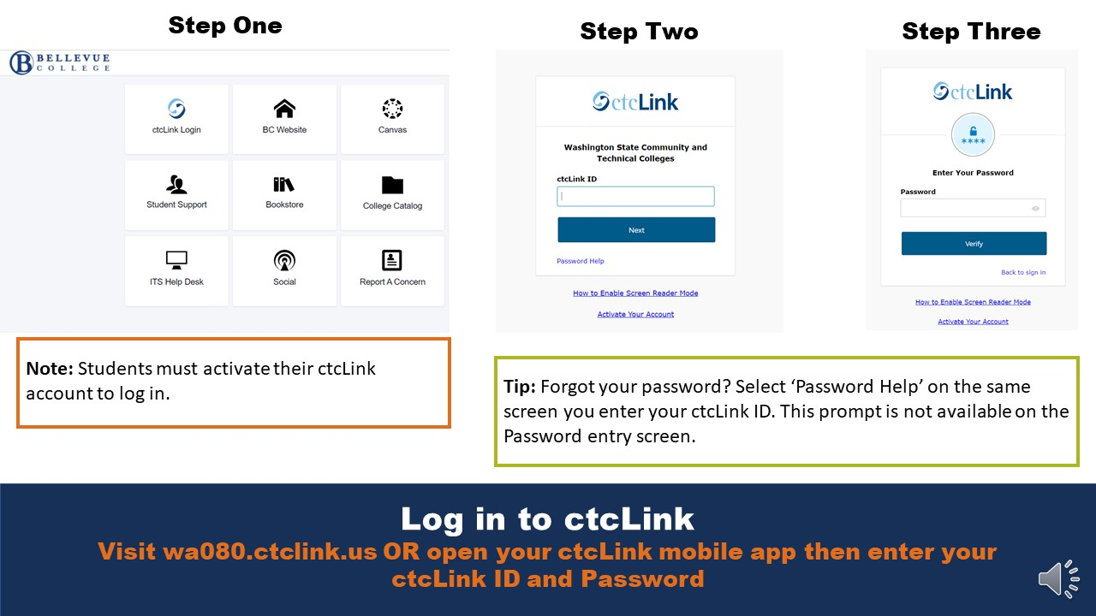
Log in to ctcLink
Visit wa080.ctclink.us OR open your ctcLink mobile app then enter your ctcLink ID and Password

Note: Students must activate their ctcLink account to log in.

Tip: Forgot your password? Select ‘Password Help’ on the same screen you enter your ctcLink ID. This prompt is not available on the Password entry screen.

Expand the Enrollment dropdown
Select ‘Enrollment Dates’

View Enrollment Appointment
View Your Enrollment Appointment in the announcement (continuing students) OR Expand a term to view registration dates and times.

Note: Continuing students have an Enrollment Appointment message at the top. New applicants do not.

Note: Unless new students are in a specific program that has early registration, all new students start registration on the same date and at the same time.

