Enroll in a Class
How to Enroll in a class using class search

Log in to ctcLink
Visit wa080.ctclink.us OR open your ctcLink mobile app then enter your ctcLink ID and Password

Note: Students must activate their ctcLink account to log in.

Tip: Forgot your password? Select ‘Password Help’ on the same screen you enter your ctcLink ID. This prompt is not available on the Password entry screen.

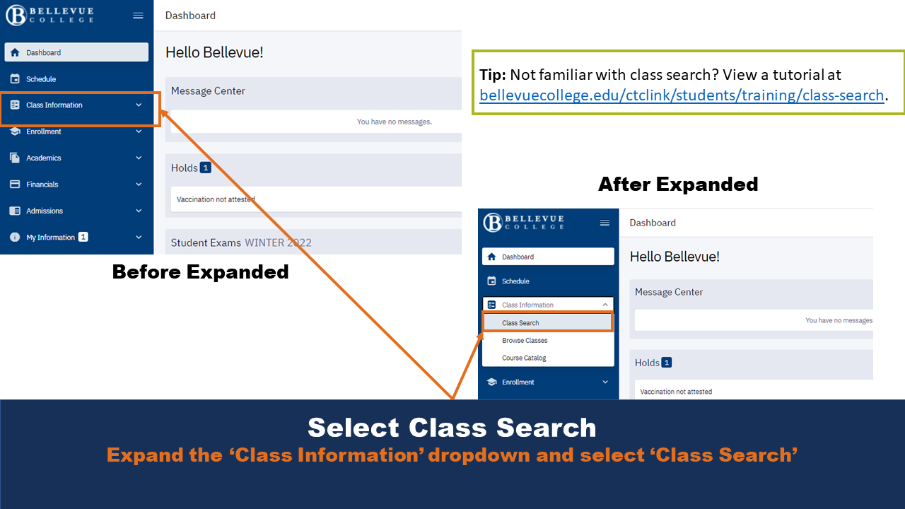
Select Class Search

Expand the ‘Class Information’ dropdown and select ‘Class Search’

Tip: Not familiar with class search? View a tutorial at bellevuecollege.edu/ctclink/students/training/class-search/

Search for Your Class
Search by Subject, Keyword, Instructor Last Name, Time, Days, Instruction Mode, and many other criteria.

Note: ‘Term’ and ‘Subject’ are required fields.

Tip: Want to find classes using additional criteria? Select ‘More Filters’.

Tip: Plan your classes before you want to Enroll. Check out a tutorial: https://www.bellevuecollege.edu/ctclink/students/training/plan-classes/

Select ‘Search’ When Ready
Check ‘Show Open Classes Only’ to show those courses with space available. Do not check this if you want to see courses with Waitlists.

Tip: Pay attention to the subjects that have—and do not have—(CCN). CCN stands for Common course numbered. These courses allow for easier transfer of credits between colleges in the Washington state community and technical college system.

CCN course names will display with an “&” after the department name. For example: a CCN English course name starts with ENGL&

Review Course Results
Expand course(s) you want to learn more about or Enroll in.

Summary fields include:
- Days: Indicate what days of the week the course takes place
- Start/End: Indicate start and stop times for classes
- Room: Where class is located on campus
- Instructor: Who teaches the course
- Status: How many spots are available

Tip: Pay attention to the Section name. This provides information on the course format.
- LEC: Lecture
- LAB: Laboratory/Studio

Select Course Enrollment Option
Available options include: ‘Add to Planner’, ‘Add to Cart’, or ‘Enroll’. Located in bottom-right in expanded view.

Enroll: Most direct method to Enroll in a course. Enroll in one course at a time.

Add to Cart: Adds the course to your ‘Shopping Cart’. This option allows you to revisit and view all courses at once before you Enroll. A great option if you want to see a “full quarter” view.

Add to Planner: Adds the course to a planner that contains other “saved” courses. Best used if Enrollment is not open or you want to make note of the course for future quarters.

Tip: You can enroll from the course summary information by clicking the three vertical dots (additional options).

Indicate Waitlist Preference. Click ‘Save’.
You do not need a permission number for every course. The box still displays even if a permission number is not required. It is an optional field.

Note: A pop up message displays if the class is successfully added to your cart.
Enter Permission Number (if required) and Indicate Waitlist Preference. Click ‘Save’.
Remember, most courses DO NOT require a permission number. This box will still display even if you don’t need one.

Note: Successful Enrollment displays ‘Added to your schedule.’ under ‘Results’. If you chose to be added to a wait list, additional information is included in the confirmation message, including your position on the wait list.

Note: Unsuccessful Enrollment displays an error under ‘Results’ and a message that indicates why you could not Enroll in the course.

Continue to Add Courses from the Class Schedule
Remember, there are several ways to complete enrollment: enroll using the direct method, enroll from your shopping cart, or enroll from the planner.

How to Enroll From Your Shopping Cart
Step One: Expand ‘Enrollment’ Drop Down and select ‘Shopping Cart’

How to Enroll From Your Shopping Cart
Step Two: Select (check) the courses you want to Enroll in and click ‘Enroll’

Tip: Before you click ‘Enroll’, click ‘Validate’ to make sure you can Enroll in the selected course(s). An error message will display for the course(s) you cannot Enroll in.

Tip: Make sure you select the appropriate Enrollment term.

View Your Enrollment Results
If you enrolled for more than one course in your shopping cart, they will all display. If Enrollment is not successful, a detailed error message will display.

