Uploading questions in Canvas using Respondus and Microsoft Word.
You will need to download Respondus before starting the process.

Open Microsoft Word:
- Open Word and paste all the questions from the original source. Remove all formatting using the Styles Group and using the Clear Formatting button.
- Apply manual formatting as shown below. Do not use the “auto numbering feature”
- Save your Word document and name your file with a meaningful name.

How to format your Microsoft Word document?

These directions are for multiple choice and true/false type questions
Open Word, Type your questions and Save you document as a .txt file for the Respondus 4.0 upload.
Example 1:
1) Who determined the exact speed of light?
a. Albert Einstein
*b. Albert Michelson
c. Thomas Edison
d. Guglielmo Marconi

2. Relation between mass & energy determined by?
*a) Albert Einstein
b) Albert Michelson
c) Thomas Edison
d) Guglielmo Marconi

3) Edison sent the first wireless message overseas.
a. T
*b. F

4. A binocular is used to view distance objects.
*a) True
b) False

These directions are for essay type questions.
Open Word, Type your questions and Save your document as a .docx file, for the Respondus 4.0 upload.
Example 2:
Type listed should be E, add the points for each question and question numbering. End with a) for an text box to be created in Canvas
Type: E
Title: Q1
1. The scientific study of plant life is known as what?
a)

Type: E
Title: Q2
2. The movement of pollen from the anthers to the stigma of a flower is known as what?
a)

Type: E
Title: Q3
3. How do plants contribute to the ecosystem services upon which humanity depends?
a)

Open Respondus:

- Open Respondus and select Current Personality as “IMS QTI 1.1+”
- Use the Import Questions button.
- Select Type of File as DOCX, Browse and select the Word document where the questions have been created.
- Give the Quiz a Title, click the Preview button, the response should be “No Warnings”. This means your quiz has been converted. Click on the Finish button. You will receive a File Saved notification.

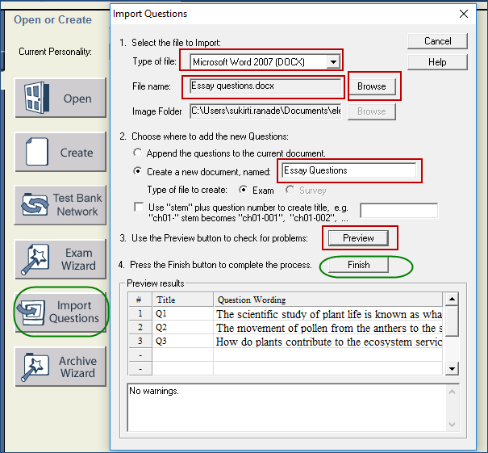

- On the Edit tab, select the length of the response, recheck the Point Value, use the edit button to edit each question.
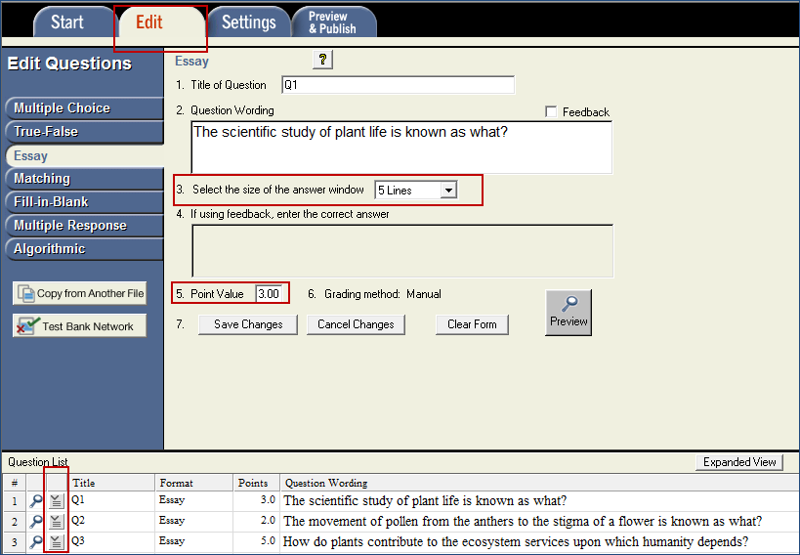
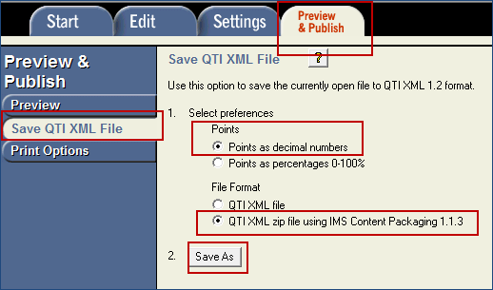
- On the Preview & Publish tab, select Points as decimal numbers and QTI XML zip file using IMS Content Packaging. Save the zipped folder on your computer.
- The zipped file can now be imported to Canvas.

