Create an Account on Talent Acquisition Management (TAM) and Apply!

Instructions
Below are the steps to follow in order to complete the Bellevue College online job application:
- Once you have all your documents in order, it takes between 10 to 30 minutes to complete the online application process.
- BC’s recruitment system works best with Chrome or Firefox browsers.
- There is an option to “Save as Draft” if you would like to take a break and continue the process at a later time.
- The “Previous” button lets you navigate to any of the previous pages you have filled out and you can edit information till you are satisfied with the application.
- The “Next” button will take you to the next page to be filled out. If there is an error in the page it will not allow you to move forward until the error is rectified or the required information is filled out.


How to Access the BC Careers Page
- To view and apply for Work-Study jobs at Bellevue College, visit Job Opportunities at Bellevue College .

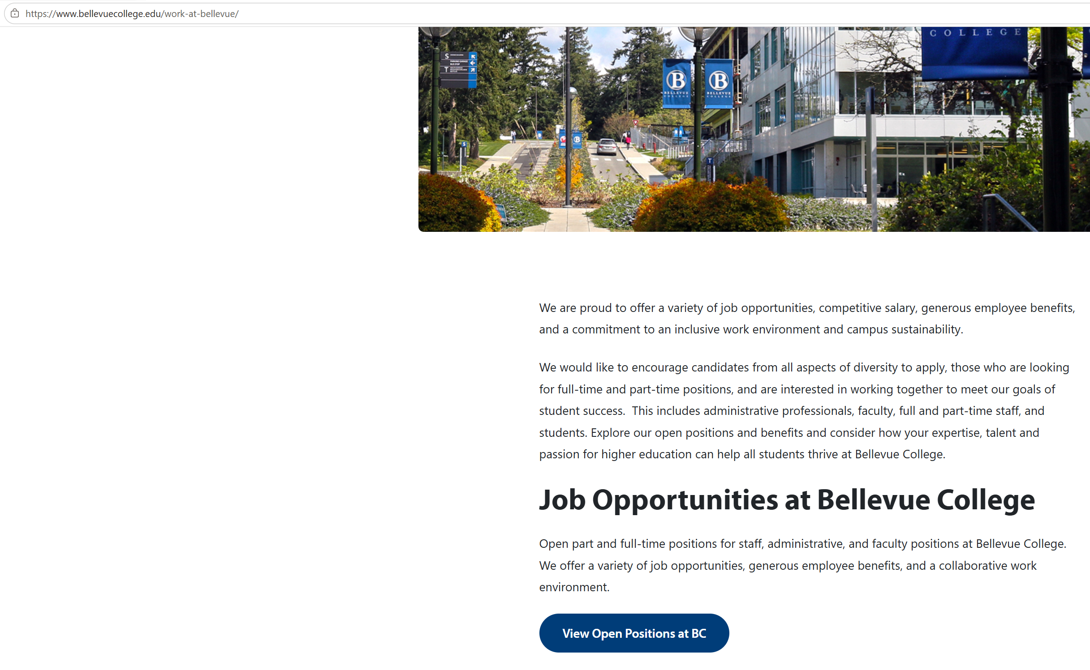

- On the Job Search Resources page, click on “View Open Positions at BC.” Then, click View All jobs
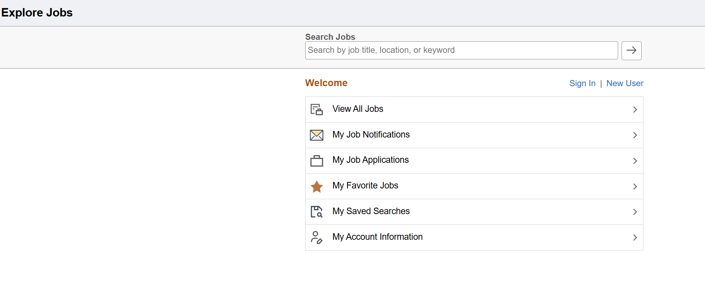

How to Create an Applicant Account
An account does not need to be created to browse through the job postings. However, to apply for a position, an applicant must first create an account or “Sign in” to a previously created account.
- If you are a returning applicant, which means you have an account with ctcLink Jobs at Bellevue College or any of the other Washington State community colleges, and have applied for a position before or applied for and saved an application as draft; click “Sign In” on the top right-hand corner. If you forgot the password or username, click Forgot Username link or Forgot Password link to retrieve the information.
- If you are a new user, i.e. you have not created an account with ctcLink Jobs, click “New User” on the top right-hand corner. Fill out all the details to create your account, then click “Register” on the top right-hand corner.
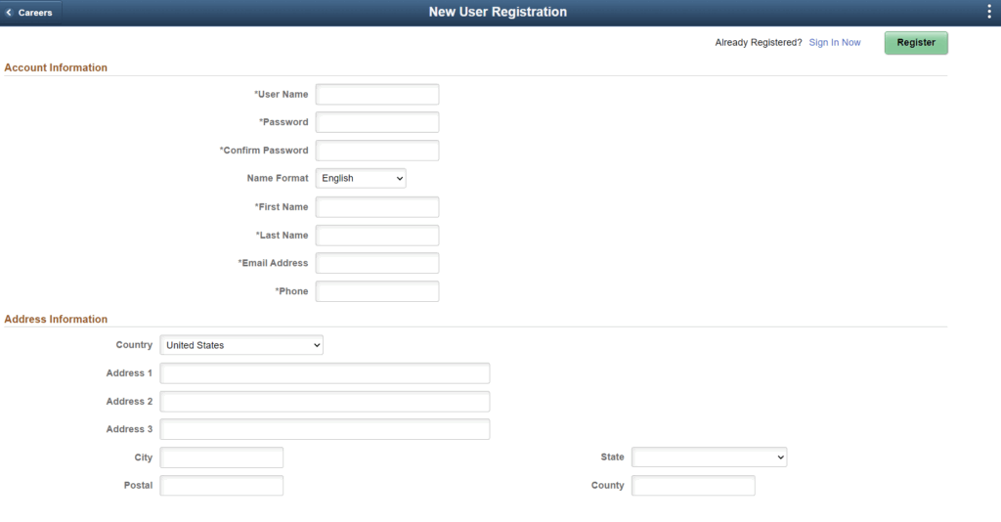
NOTE: While creating the password for your account, you may notice that when you hit the Tab key on your keyboard, the number of dots shown in the password field do not match the number of the alpha numeric password you just created. The system automatically prepopulates this field. This is okay! Please continue with the process.
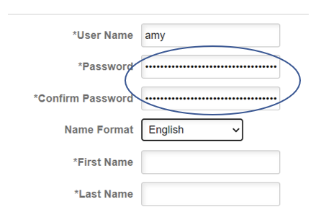

How to Apply for Work-Study Jobs
- To apply for any position, you must sign into your account first.
- In Search Jobs page, go to the Search Jobs field and type “work study.” The resulting search should show you all open work study positions posted:
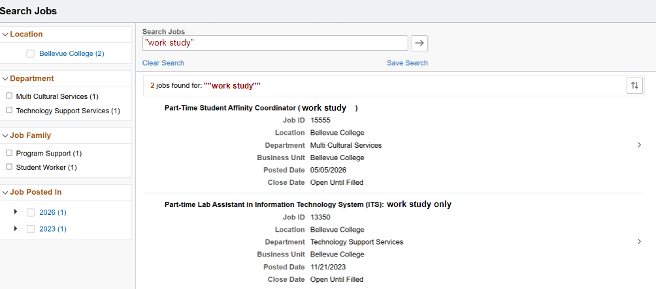
- If there is a Work Study position posted that you are interested in applying for, click on the title of the position to review details of position and qualifications. If you meet the minimum qualifications, click “Apply for Job” button at the top of the right corner of the page to start the application process.

Steps to Complete Your Application

Step 1
- Notice the numbered application steps shown on the left-hand side of the page. You need to complete the application page of each step in order to advance to the next steps.
- Please make sure to Save as Draft frequently, especially if you do not have stable internet connection in your dorm/place or if you plan to finish it later. You can find the Save as Draft button in the upper right corner of the page.
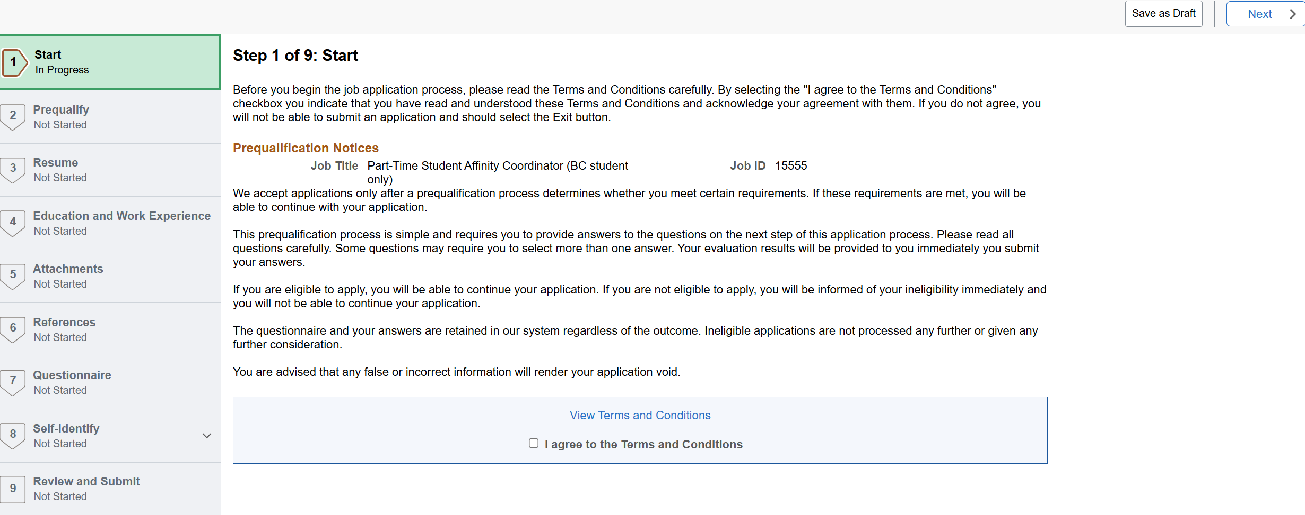

Step 2
Please review and answer all pre-qualifying questions carefully and accurately. Your responses are used to determine eligibility, and answers that do not meet the required criteria may lead to disqualification, then the application being rejected by the system.
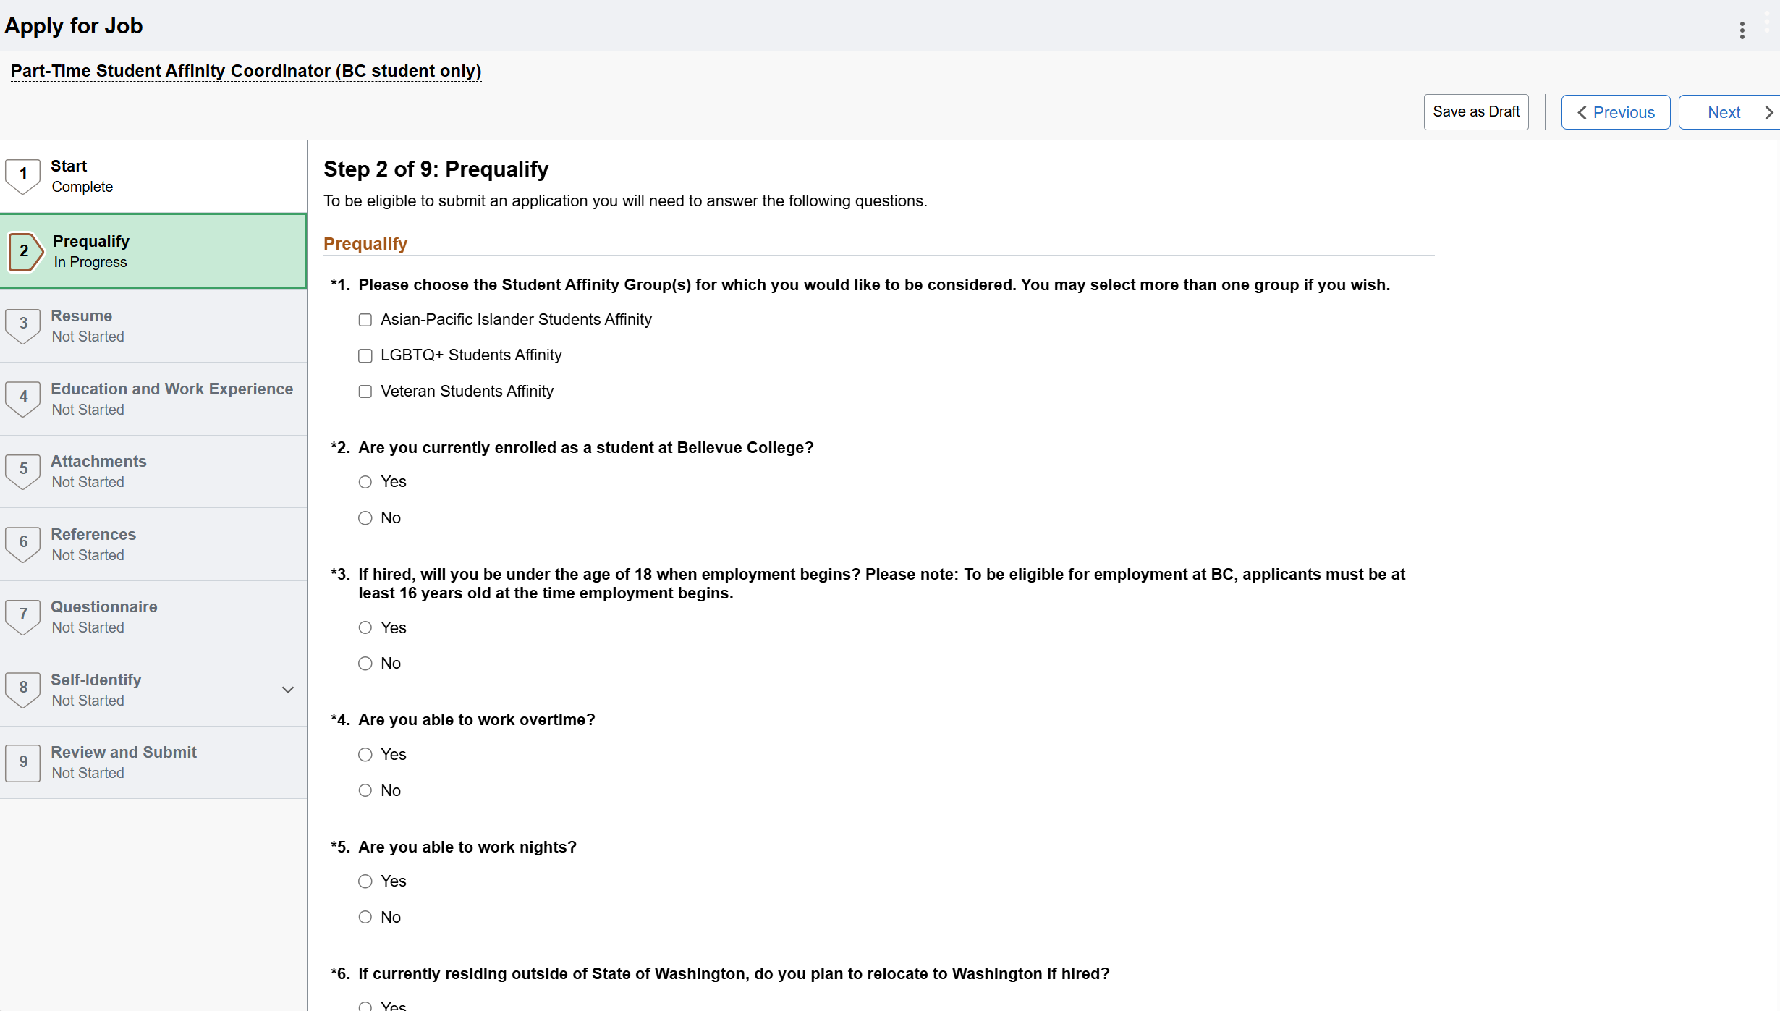

Step 3
It requests you to upload your resume and cover letter.
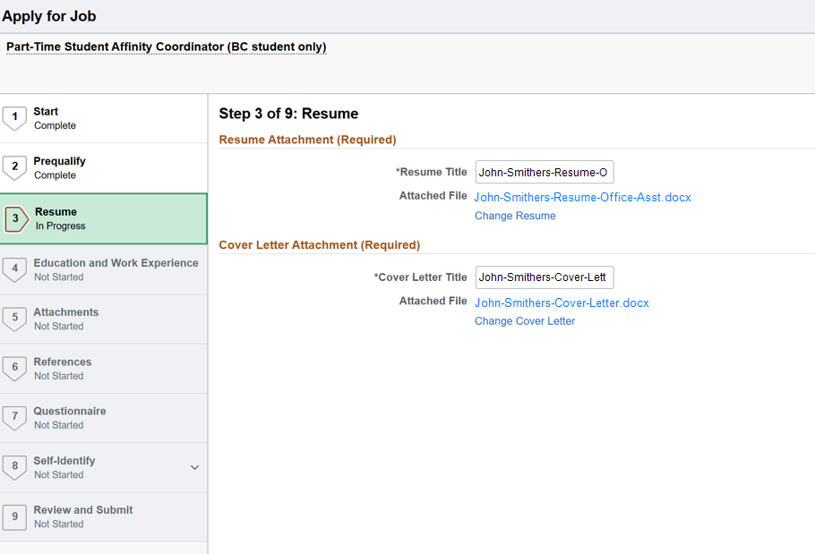

Step 4
- Provide brief information of your current and previous experience. You can include volunteer, research, and any relevant experience, including class/group projects, to demonstrate your experience and skills relevant to the position posted.
- If you have already provided full details of current and previous experience in your resume, then you may choose to complete only the * fields such as Start Date, Employer, and Ending Job Title.
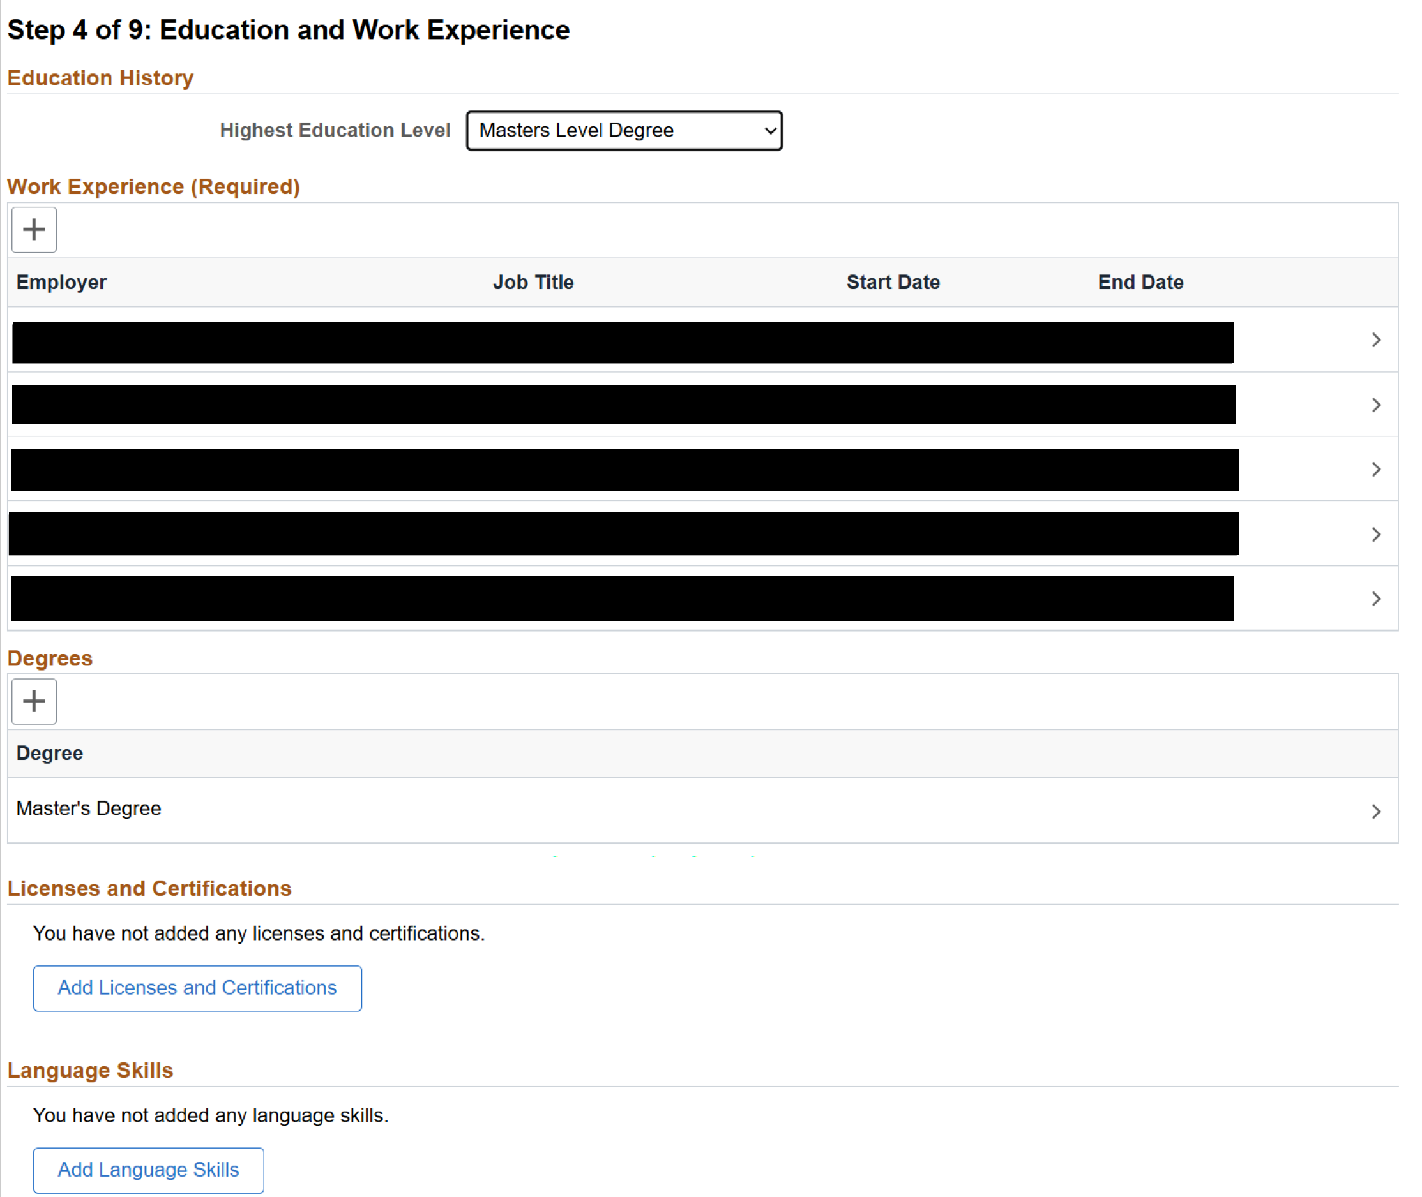

Step 5
- Make sure to include any other required attachments as outlined in the “How to Apply” section in the job posting.
- If you wish, you may also include items like an opinion piece that you wrote for a local newspaper, a blog on relevant issues, or unofficial transcripts. It is ok not to attach anything in step 5 if they are not required in the job posting.

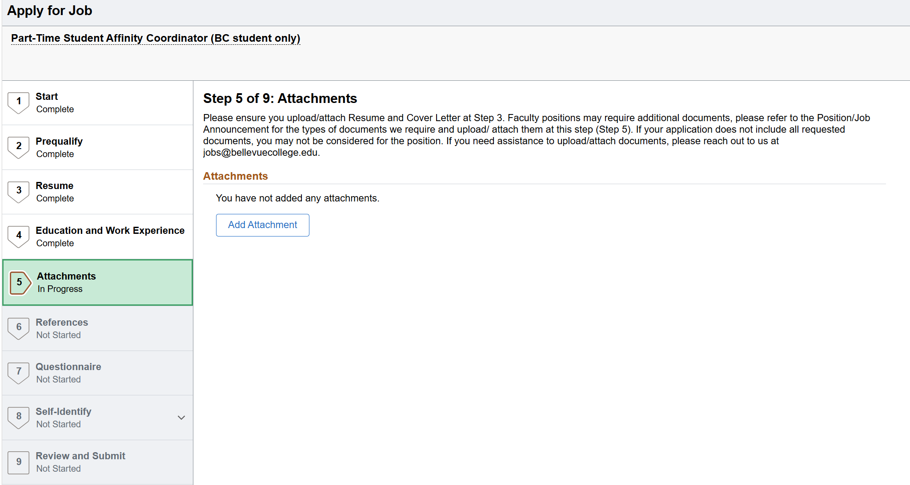

Step 6
You will be prompted to input reference information, which is required in order to move to the next steps. We understand that students might not have any professional experience. Therefore, you may choose to provide instructor who oversaw your class/group projects, research, or community leader with whom you have volunteered.
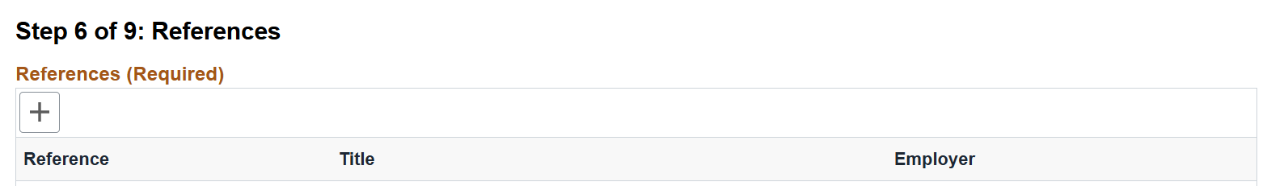

Step 7
You will be asked another series of questions.
- Questions under subsection Job Preferences are optional, you may skip them as you wish. However, here are some tips if you choose to answer questions inside this subsection.
- For preferred start date, please pick the date carefully so the hiring team knows if they need to adjust their timelines for onboarding. For example, if you have exams coming up and prefer to start after the exams, then choose applicable date. If you’d rather start as soon as possible and then take time off for a few hours on the day of the exam, it is also acceptable. Only you know what works best for your schedule and academic performance.
- You must be in good academic standing to keep the job. All student roles are part-time up to 19 hours per week, so you must pick “part-time” for the employment type question.
- Please read the position description carefully. Some positions may require working on specific days of the week. Therefore, mark the days that you are available on the days of the week question. Your hiring manager might select candidates based on matching availability. If the position is not listing any days, you can pick all days that you are available. Answer questions relating to your availability as honestly as you can. Compare your school schedule realistically with your desired work arrangements. If your school schedule changes later, you can update your immediate supervisor as changes take place.
- If the work-study job posting does not mention a specific day/night/compressed shifts, then you should answer question 7 by selecting “Not applicable”.
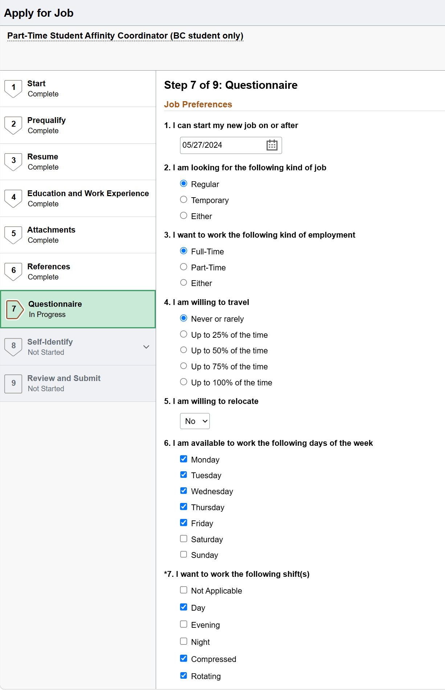
- To answer question 8, please assess how many hours realistically you can commit to this role, you can pick a number between 1 and 19 hours per week.
- Question 9 asks you about the minimum pay rate that you desire. You can choose to list the current WA state min wage or a different desired pay rate, along with selecting the “Frequency” as hourly. All student jobs are paid by the hours, and are not eligible for medical, dental, or retirement benefits.
- The next subsection in step 7 is Employment Questionnaire. Make sure to answer all questions inside this subsection.
- One of the required questions in this subsection is about disclosing any relatives or any significant others who currently work at Bellevue College. You must list their names and type of relationship, or list N/A if not applicable. It would be useful to learn this disclosure early so you can work with the hiring manager to minimize the conflicts as needed.
- The next subsection in step 7 is Referrals. You must answer all questions with *. We appreciate it when you also answer questions without *.
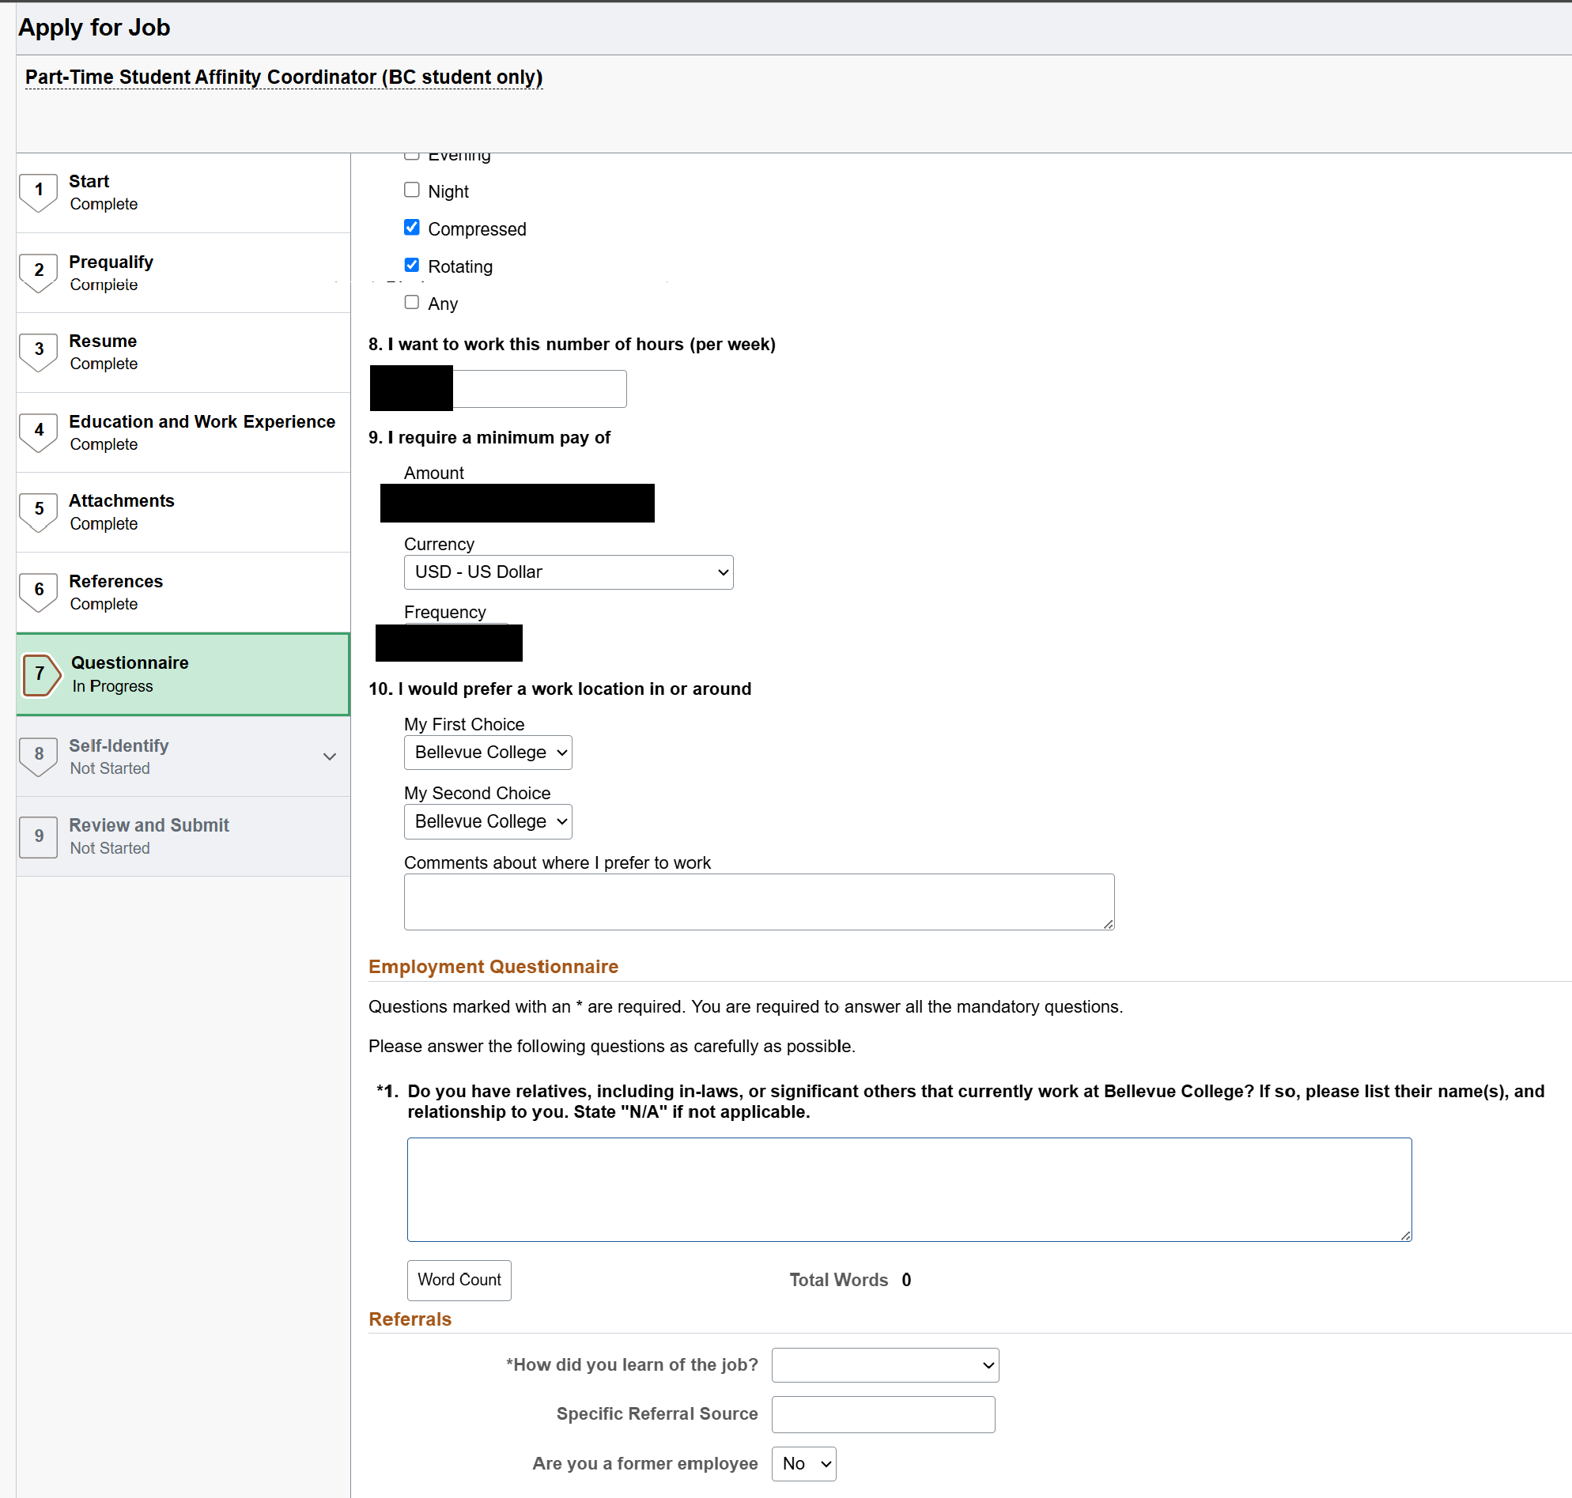

Step 8
You will be asked several questions that are voluntary self-identification, which we encourage and appreciate when you choose to answer them. These answers do not affect the success of your application.
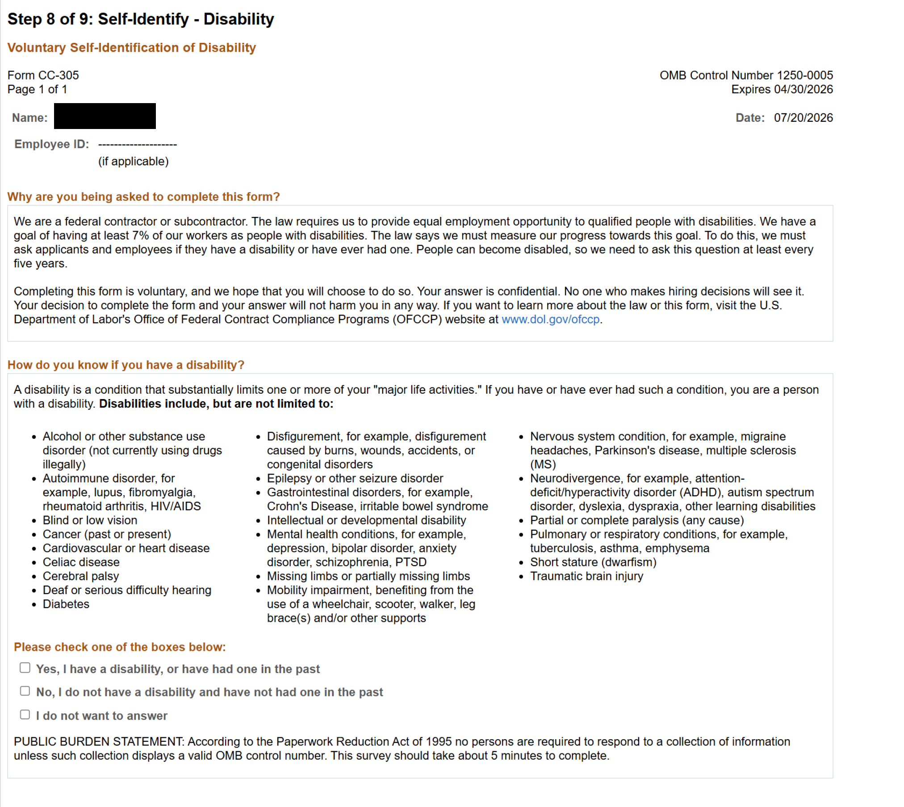

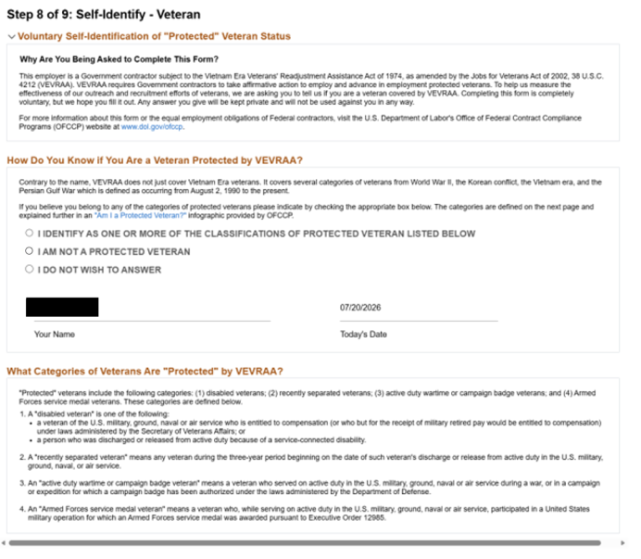

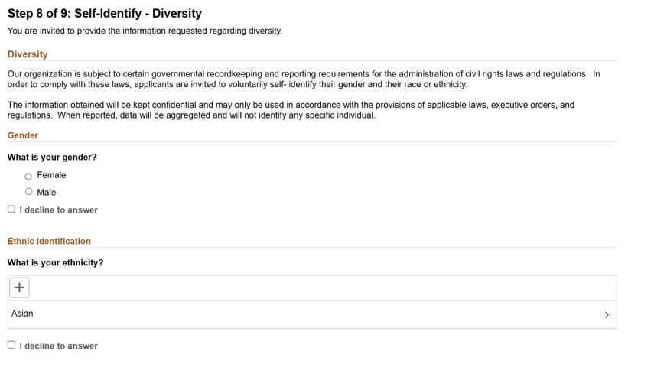

Step 9
- Review your application carefully, confirm that your contact information is spelled correctly without any typos. Then click Submit button on the top right of the page.
- Once you have hit “Submit,” the application cannot be modified. If you need to revise something in an application that you have already submitted, you will need to withdraw your application and resubmit a new one or contact HR directly at jobs@bellevuecollege.edu for assistance.
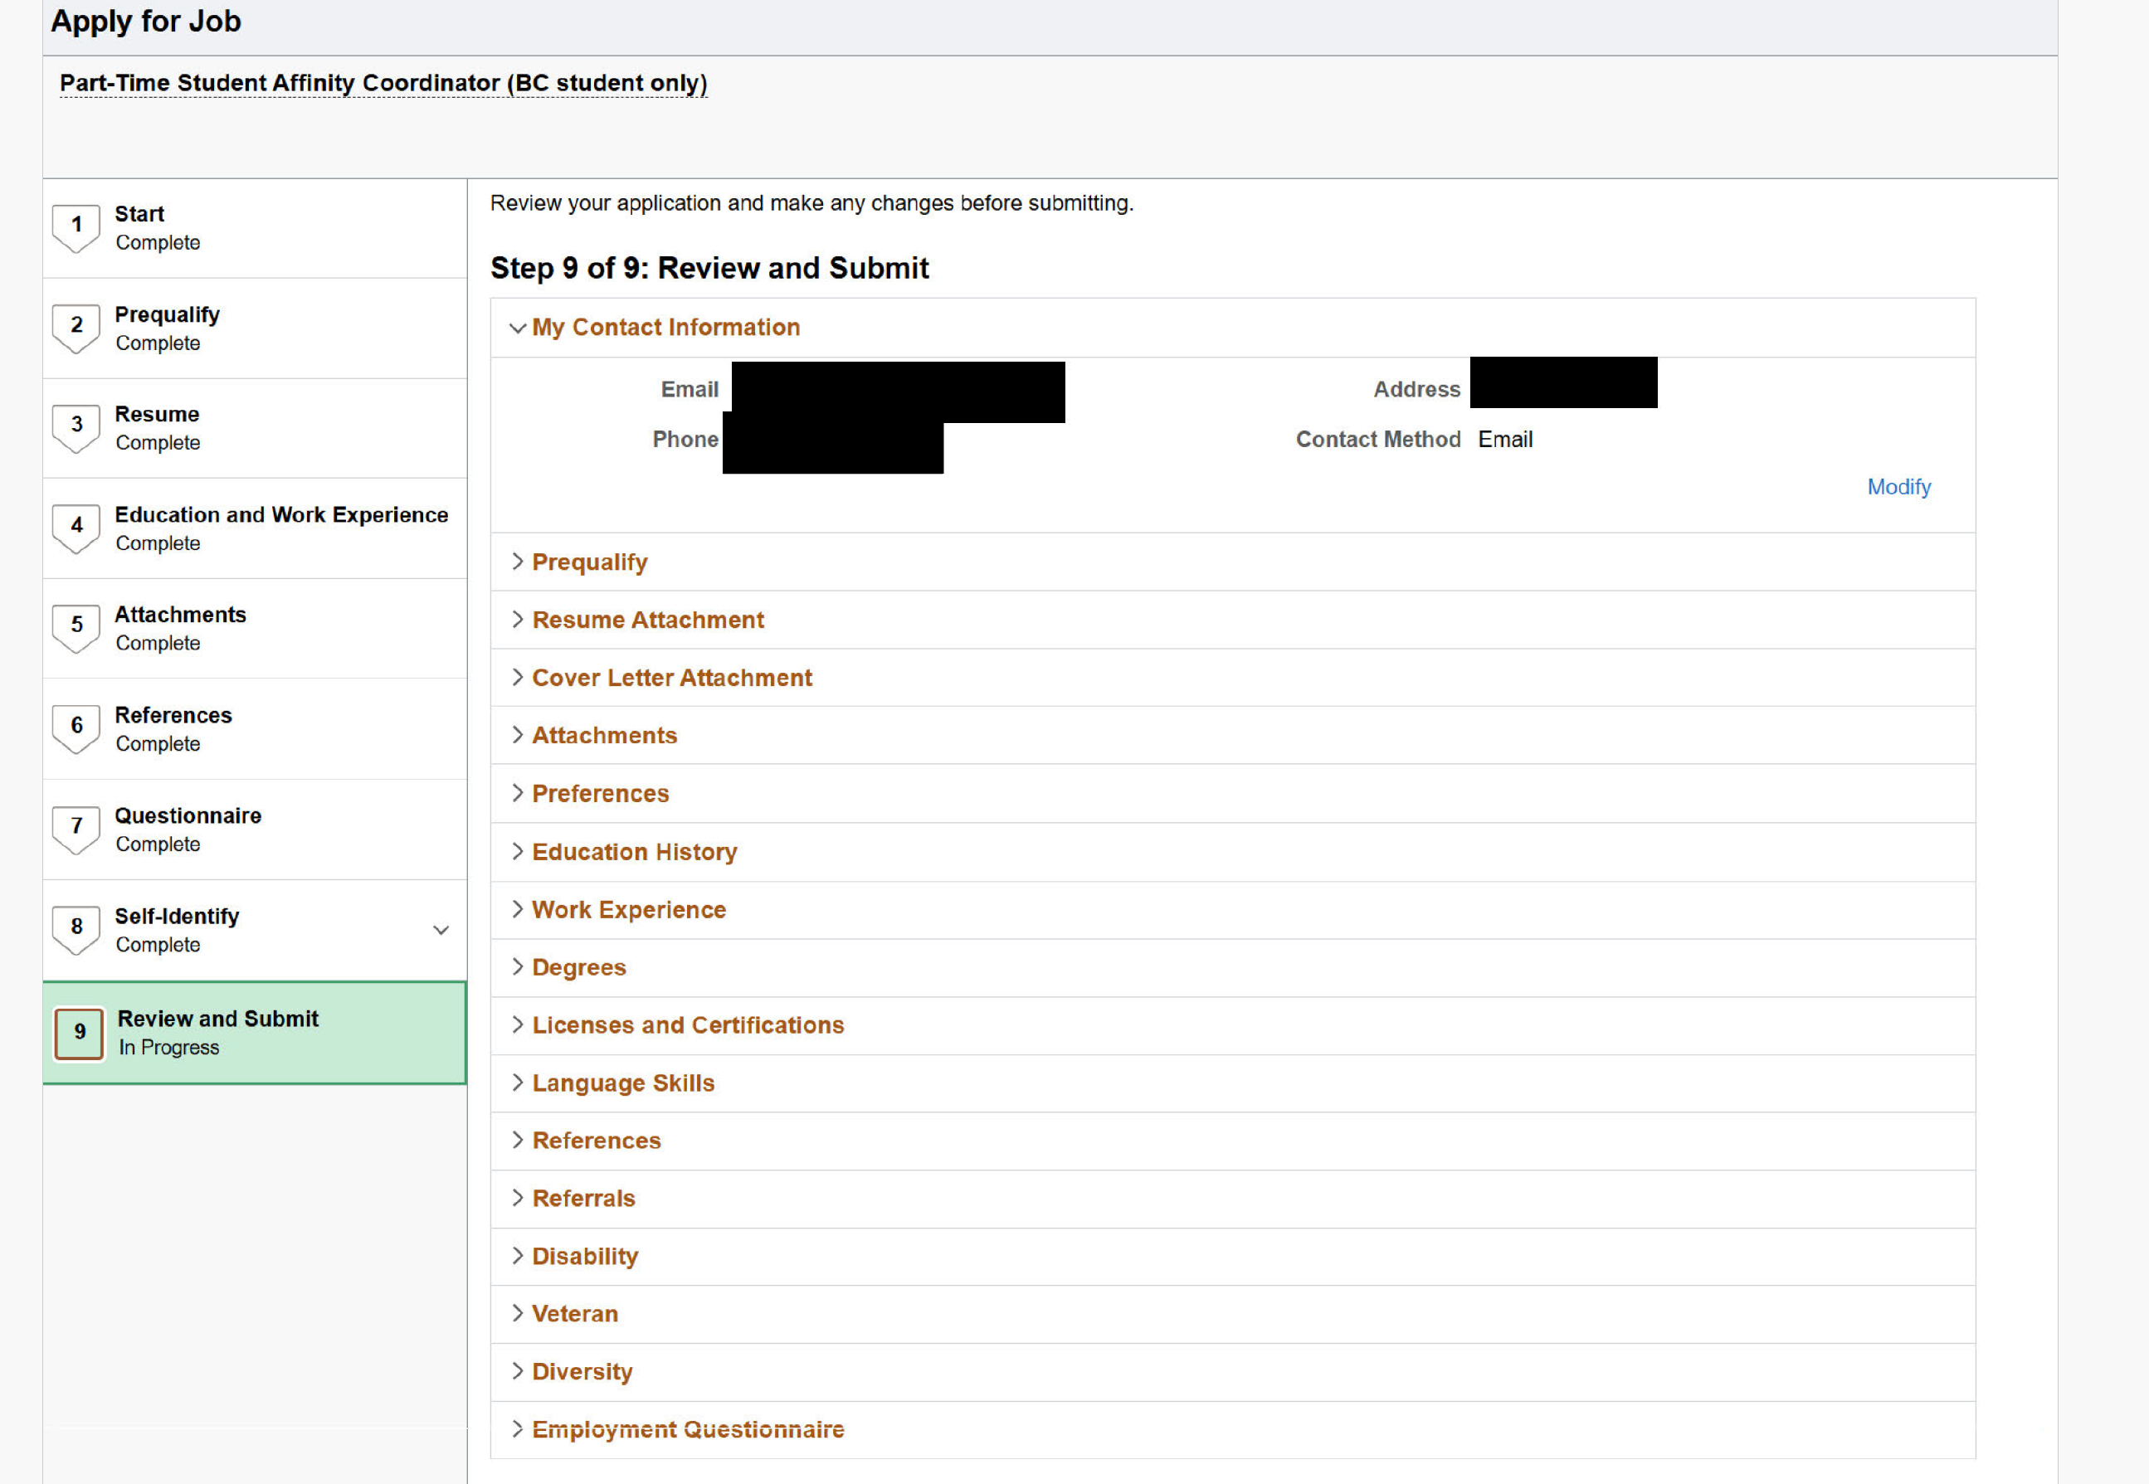

- If your application is submitted successfully, then you will see a popup dialog screen stating Application Confirmation with your submitted application information.

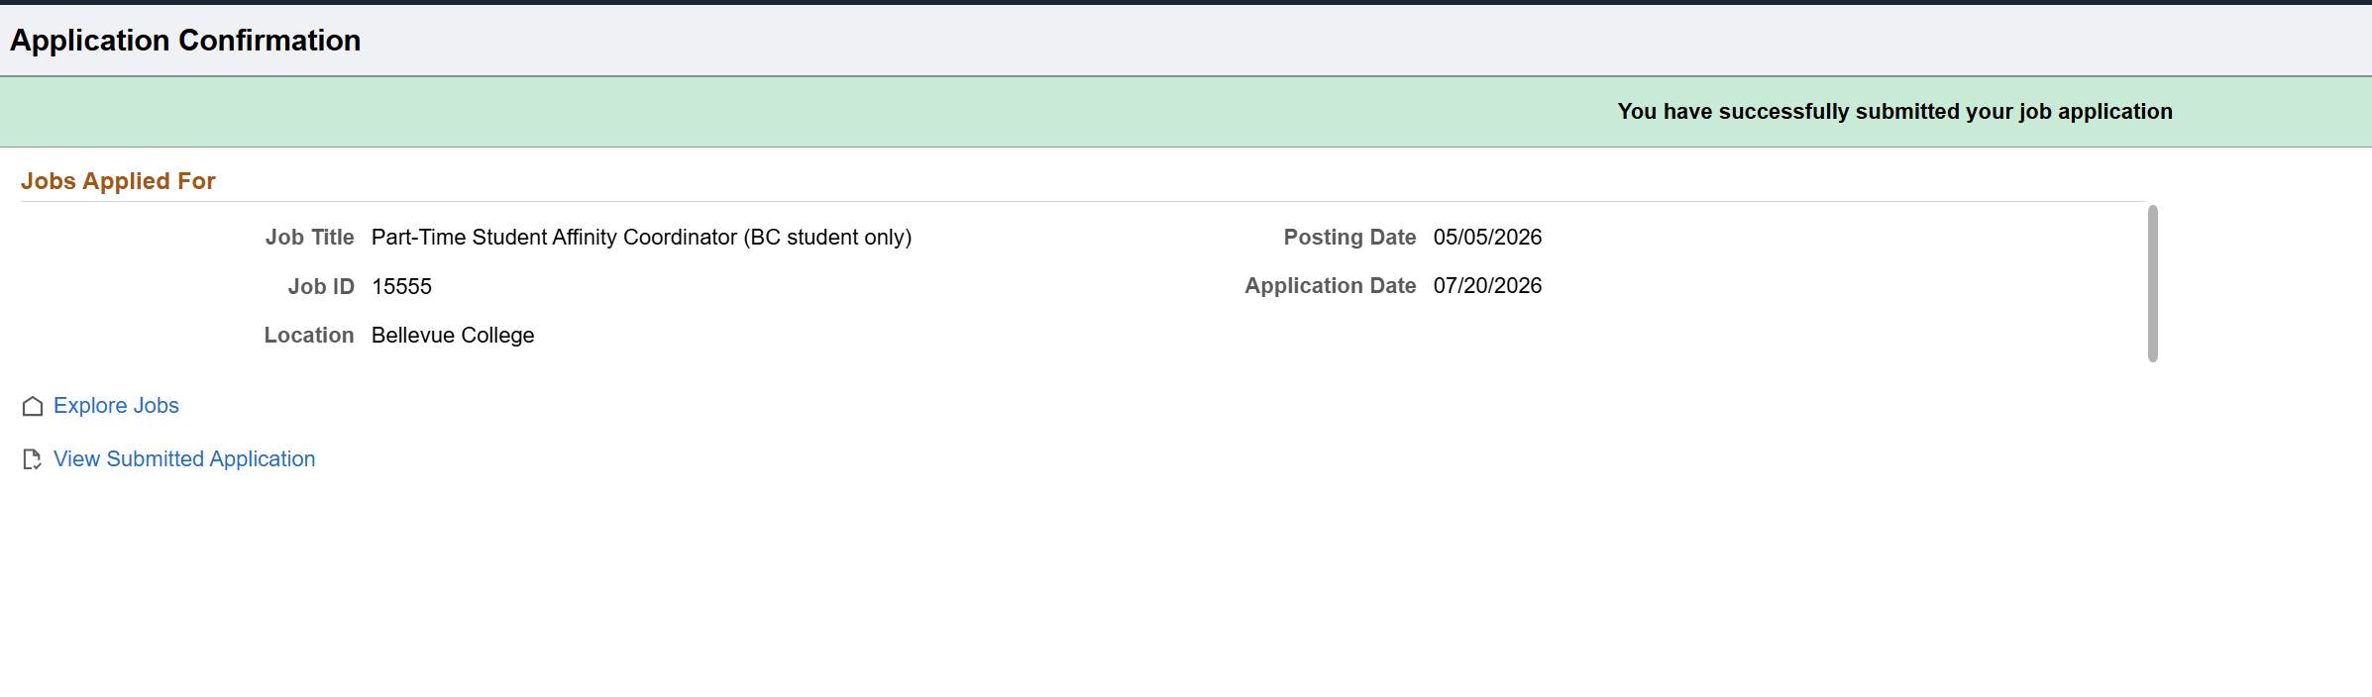
- To review the positions you have applied for, go to My Job Applications section on the Explore Jobs page
