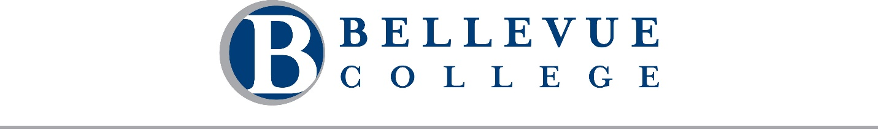
A regular meeting of the Board of Trustees of Community College District VIII, 3000 Landerholm Circle SE, state of Washington, will be held on Wednesday, January 21, 2026. The business session will begin at 9:00 AM. This meeting will be conducted both in-person at Cedarbrook Lodge - Spruce Studio 2, SeaTac, WA and remotely via Zoom. A telephone line will also be available. Pradnya Desh, Chair, will preside.

Meeting Call in Details
Join Business Session [Zoom]
Dial in by telephone: +1 253 215 8782
Webinar ID: 874 9382 2087

Meeting Agenda

Business Session
- Call to Order Chair Pradnya Desh
  - Approval of Agenda and Minutes
    - Agenda for January 21, 2026

  - Public Comment
Students, faculty, staff, and community members may provide public comment to the Board during this portion of the meeting. Comments are limited to 2 minutes per individual. There will be a total of 45 minutes scheduled for public comment. Public comments may be provided in one of three ways:
    - In-person: Sign up on the public comment sheet located at the entrance to the meeting room.
    - Remote: Use the "Raise Hand" feature in Zoom to indicate your intent to speak. If joining by phone, press *9 to raise your hand.
    - Written: Submit your comment by emailing boardoftrustees@bellevuecollege.edu.

Executive Session
The Board will convene in executive session under RCW 42.30.110(1) for the following purpose(s): (i) To discuss with legal counsel representing the agency litigation or potential litigation. No final action will be taken during this executive session.

Business Session
- Call to Order Chair Pradnya Desh

- Accreditation
Dr. Jess Clark

- Introduction of Vice President Sean Marsh
Sean Marsh

- External Partnerships
Dr. David May

Break for Lunch 12:00 – 1:00 PM

Business Session
- Call to Order Chair Pradnya Desh

Executive Session
The Board will convene in executive session under RCW 42.30.110(1) for the following purpose(s): (g) To review the performance of a public employee. No final action will be taken during this executive session.

Business Session
- Call to Order Chair Pradnya Desh

- Budget and Finance
Dr. David May and Dr. Jorge de la Torre

- Board Policy & Governance Manual
Dr. Alicia Keating Polson

Adjournment
Please note: Time and order are estimates only and are subject to change.

