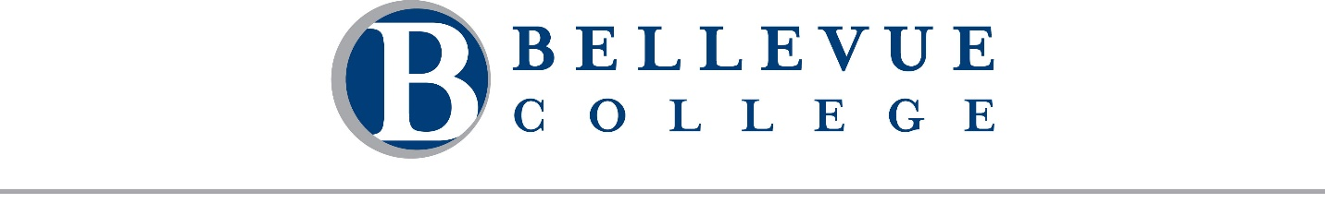
A regular meeting of the Board of Trustees of Community College District VIII, 3000 Landerholm Circle SE, state of Washington, will be held on Wednesday, May 27, 2026. The business session will begin at 2:00 PM. This meeting will be conducted both in-person in B201 and remotely via Zoom. A telephone line will also be available. Pradnya Desh, Chair, will preside.

Meeting Call in Details
Join Business Session [Zoom]
Dial in by telephone: +1 253 215 8782
Webinar ID: 874 9382 2087

Meeting Agenda

Business Session
- Call to Order Chair Pradnya Desh
  - Welcome and Introductions
  - Approval of Agenda and Minutes
    - Agenda for May 27, 2026
    - Minutes for April 22, 2026

- Recognition of 2026 ACT Faculty Member of the Year Awardee Sara Farag

- Constituent Reports
  - Student Alarick Alfredo-Sorto
  - Classified Valencio Socia
  - College Assembly Michael Broome
  - Faculty Dr. Lindsay Haney
  - Foundation Chelle Chase

- Public Comment
Students, faculty, staff, and community members may provide public comment to the Board during this portion of the meeting. Comments are limited to 2 minutes per individual. There will be a total of 45 minutes scheduled for public comment. Public comments may be provided in one of three ways:
  - In-person: Sign up on the public comment sheet located at the entrance to the meeting room.
  - Remote: Use the "Raise Hand" feature in Zoom to indicate your intent to speak. If joining by phone, press *9 to raise your hand.
  - Written: Submit your comment by emailing boardoftrustees@bellevuecollege.edu.

- Quarterly Reports
  - Enrollment
Dr. Judith Hernández Chapar and Steve Downing
  - Finance & Budget
Dr. Jorge de la Torre and Ty Bergstrom

- First Read
  - Off-Cycle Tenure
Dr. Ben Pryor

- Action
  - Revision of Policy 6720: Bookstore
Dr. Lori Keller
  - Revision of Policy 3655: Use of Human Participants in Research Activities
Dr. Lori Keller

- Reports
  - President’s Report Dr. David May
  - Board Report Pradnya Desh

Executive Session
The Board will convene in executive session under RCW 42.30.110(1) for the following purpose(s): (g) To review the performance of a public employee; and (i) To discuss with legal counsel representing the agency litigation or potential litigation. No final action will be taken during this executive session, but action may be taken upon the Board’s return to open session.

Adjournment
Please note: Time and order are estimates only and are subject to change.

