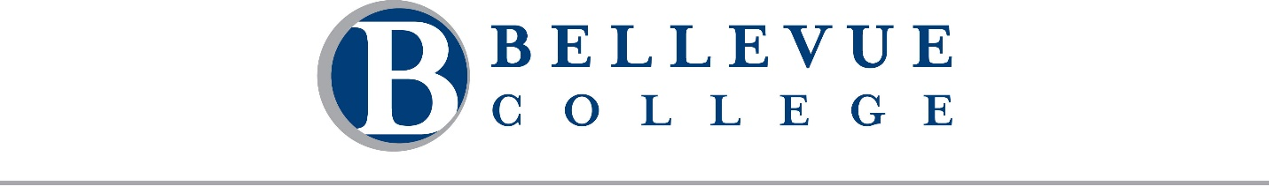
A regular meeting of the Board of Trustees of Community College District VIII, 3000 Landerholm Circle SE, state of Washington, will be held on Wednesday, August 19, 2026. The business session will begin at 9:00 AM. This meeting will be conducted both in-person at Cedarbrook Lodge at 18525 36th Ave S, Seattle, WA 98188 and remotely via Zoom. A telephone line will also be available. Rich Fukutaki, Chair, will preside.

Meeting Call in Details
Join Business Session [Zoom]
Dial in by telephone: +1 253 215 8782
Meeting ID: 862 8596 0395
Passcode: 856690

Meeting Agenda

Business Session
- Call to Order Chair Rich Fukutaki
  - Approval of Agenda and Minutes
    - Agenda for August 19, 2026
    - Minutes for June 17, 2026 and June 24, 2026

- Public Comment
Students, faculty, staff, and community members may provide public comment to the Board during this portion of the meeting. Comments are limited to 2 minutes per individual. There will be a total of 20 minutes scheduled for public comment. Public comments may be provided in one of three ways:
  - In-person: Sign up on the public comment sheet located at the entrance to the meeting room.
  - Remote: Use the "Raise Hand" feature in Zoom to indicate your intent to speak. If joining by phone, press *9 to raise your hand.
  - Written: Submit your comment by emailing boardoftrustees@bellevuecollege.edu.

- Strategic Leadership & Institutional Effectiveness
Dr. David May, Dr. Jess Clark, Frances Dujon Reynolds, Dr. Ben Pryor, and Jill Lane

Closed Session
The Board will meet in closed session to discuss collective bargaining negotiations. Pursuant to RCW 42.30.140(4)(a), these matters are not subject to the Open Public Meetings Act. No final action will be taken during this closed session, but action may be taken upon the Board’s return to open session.
Break for Lunch: 12:00 – 1:00 PM

Business Session
- Call to Order Chair Rich Fukutaki

- Fiscal Stewardship & Institutional Governance
Dr. David May, Dr. Jorge de la Torre, Ty Bergstrom, Sharon Kussy, Dr. Alicia Keating Polson, and Dr. Lori Keller

Adjournment
Please note: Time and order are estimates only and are subject to change.

