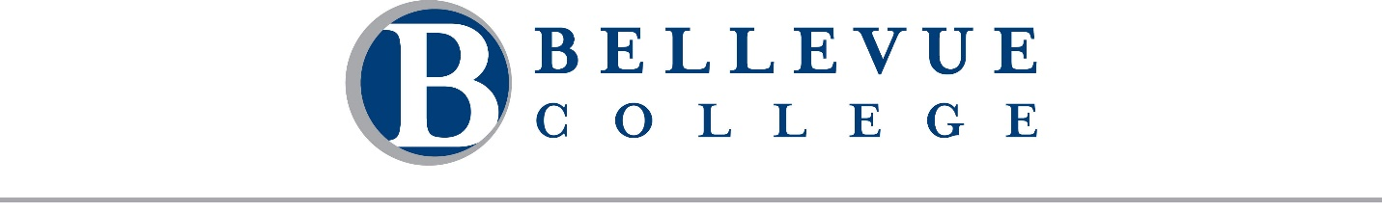
Meeting Agenda: September 28, 2026
A regular meeting of the Board of Trustees of Community College District VIII, 3000 Landerholm Circle SE, state of Washington, will be held on Monday, September 28, 2026. The business session will begin at 2:15 PM. This meeting will be conducted both in-person in B201 and remotely via Zoom. A telephone line will also be available. Chair Rich Fukutaki will preside.

Call in Details
Join Business Session [Zoom]
Dial in by telephone: +1 253 215 8782
Webinar ID: 874 9382 2087

Business Session
- Call to Order Chair Rich Fukutaki
  - Welcome and Introductions

- Public Comment
Students, faculty, staff, and community members may provide public comment to the Board during this portion of the meeting. Comments are limited to 2 minutes per individual. A total of 30 minutes is reserved for public comment. Public comments may be provided in one of three ways:
  - In-person: Sign up on the public comment sheet located at the entrance to the meeting room.
  - Remote: Use the "Raise Hand" feature in Zoom to indicate your intent to speak. If joining by phone, press *9 to raise your hand.
  - Written: Submit your comment by emailing boardoftrustees@bellevuecollege.edu.

- Constituent Reports
  - College Assembly
Alicia Ferguson
  - Bellevue College Association of Higher Education (BCAHE)
Dr. Lindsay Haney
  - Washington Federation of State Employees (WFSE) – Bellevue College
TBD
  - Washington Public Employees Association (WPEA) – Bellevue College
Paige Spicer
  - Associated Student Government of Bellevue College (ASGBC)
Aizada Gapyrova
  - Bellevue College Foundation (BCF)
Maria Villa-Wigfall

Executive Session
The Board will convene in executive session under RCW 42.30.110(1) for the following purpose(s): (g) To review the performance of a public employee; (i) To discuss with legal counsel representing the agency litigation or potential litigation. The Board will also meet in closed session to discuss collective bargaining negotiations. Pursuant to RCW 42.30.140(4)(a), these matters are not subject to the Open Public Meetings Act. No final action will be taken during this executive session or closed session, but action may be taken upon the Board’s return to open session.
- Program Highlight: Title II Digital Accessibility
Marisa Hacket, Dr. Natalie A. Martínez, and Taija Tevia-Clark

- Consent Agenda
  - Minutes of the August 19, 2026 Board retreat
  - Minutes of the August 20, 2026 Board retreat

- Action Items
  - Resolution Authorizing Individual Defense and Indemnification

- Information Items
  - Housekeeping and Minor Edits to Policy Library
Dr. Lori Keller

- Reports
  - President’s Report
  - Board Report

- Guided Tour

Adjournment
Please note: Time and order are estimates only and are subject to change.

