
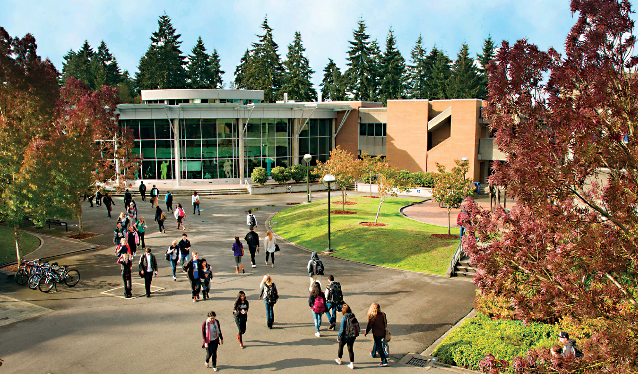
Board of Trustees
Community College District VIII

September 28, 2026
  - Regular Meeting

Contents
Meeting Agenda: September 28, 2026 3
Program Highlight: Title II Digital Accessibility 5
Consent Agenda 6
Minutes: August 19, 2026 7
Minutes: August 20, 2026 10
Resolution Authorizing Individual Defense and Indemnification 13
Housekeeping and Minor Edits to Policy Library 15

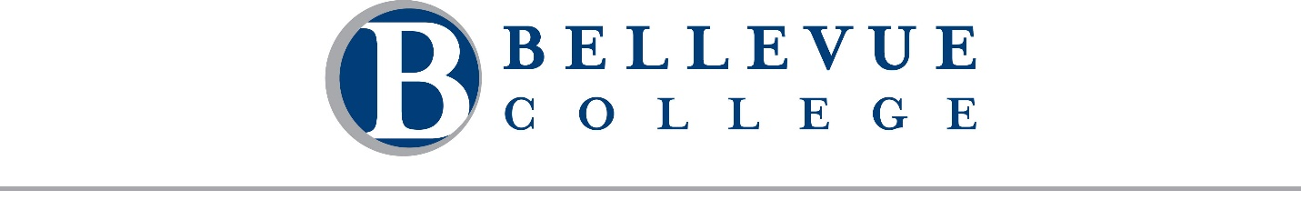
Meeting Agenda: September 28, 2026
A regular meeting of the Board of Trustees of Community College District VIII, 3000 Landerholm Circle SE, state of Washington, will be held on Monday, September 28, 2026. The business session will begin at 2:15 PM. This meeting will be conducted both in-person in B201 and remotely via Zoom. A telephone line will also be available. Chair Rich Fukutaki will preside.

Call in Details
Join Business Session [Zoom]
Dial in by telephone: +1 253 215 8782
Webinar ID: 874 9382 2087

Business Session
- Call to Order Chair Rich Fukutaki
  - Welcome and Introductions

- Public Comment
Students, faculty, staff, and community members may provide public comment to the Board during this portion of the meeting. Comments are limited to 2 minutes per individual. A total of 30 minutes is reserved for public comment. Public comments may be provided in one of three ways:
  - In-person: Sign up on the public comment sheet located at the entrance to the meeting room.
  - Remote: Use the "Raise Hand" feature in Zoom to indicate your intent to speak. If joining by phone, press *9 to raise your hand.
  - Written: Submit your comment by emailing boardoftrustees@bellevuecollege.edu.

- Constituent Reports
  - College Assembly
Alicia Ferguson
  - Bellevue College Association of Higher Education (BCAHE)
Dr. Lindsay Haney
  - Washington Federation of State Employees (WFSE) – Bellevue College
Travis Sage
  - Washington Public Employees Association (WPEA) – Bellevue College
Paige Spicer
  - Associated Student Government of Bellevue College (ASGBC)
Aizada Gapyrova
  - Bellevue College Foundation (BCF)
Maria Villa-Wigfall

Executive Session
The Board will convene in executive session under RCW 42.30.110(1) for the following purpose(s): (g) To review the performance of a public employee; (i) To discuss with legal counsel representing the agency litigation or potential litigation. The Board will also meet in closed session to discuss collective bargaining negotiations. Pursuant to RCW 42.30.140(4)(a), these matters are not subject to the Open Public Meetings Act. No final action will be taken during this executive session or closed session, but action may be taken upon the Board’s return to open session.
- Program Highlight: Title II Digital Accessibility
Marisa Hacket, Dr. Natalie A. Martínez, and Taija Tevia-Clark

- Consent Agenda
  - Minutes of the August 19, 2026 Board retreat
  - Minutes of the August 20, 2026 Board retreat

- Action Items
  - Resolution Authorizing Individual Defense and Indemnification

- Information Items
  - Housekeeping and Minor Edits to Policy Library
Dr. Lori Keller

- Reports
  - President’s Report
  - Board Report

- Guided Tour

Adjournment
Please note: Time and order are estimates only and are subject to change.

Program Highlight: Title II Digital Accessibility
  - Information

Description
In anticipation of the Americans with Disabilities Act Title II Digital Accessibility enforcement deadline in April 2027, Bellevue College formed the Digital Accessibility Task Force in April 2025. The Task Force launched trainings, secured remediation tools, completed assessment, and updated a college-wide policy. Remaining work includes process, staffing, and additional resource recommendations to ensure the college achieves legal compliance and fulfills its mission to remove barriers for all students.

Prepared by:
- Marisa Hackett (she/her), Director, Disability Resource Center
- Natalie A. Martínez, PhD (she/they), English Co-Chair, Full Professor
- Taija Tevia-Clark (he/him), Director, IT Services Integration Team

Consent Agenda
  - Action

Description
The consent agenda allows the Board to approve routine items together in a single action. Any trustee may request that an item be removed from the consent agenda for separate consideration.
The September 28, 2026 consent agenda includes:
- Minutes of the August 19, 2026 Board retreat
- Minutes of the August 20, 2026 Board retreat

Recommended Action
Approve the consent agenda as presented.

Prepared by: Alicia Keating Polson, Executive Director of the President’s Office

Board of Trustees
Community College District VIII
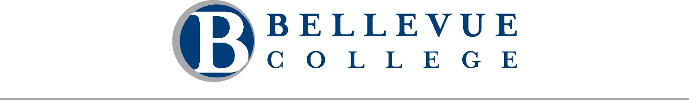
Bellevue, Washington

Minutes: August 19, 2026
A regular meeting of the Board of Trustees of Community College District VIII, 3000 Landerholm Circle SE, state of Washington, was held on Wednesday, August 19, 2026. Rich Fukutaki, chair, presided. This meeting was held in Cedarbrook Lodge at 18525 36th Ave S, Seattle, WA 98188 and on Zoom. A telephone line was also available.
Chair Fukutaki called the business session to order at 9:07 AM.

Roll Call
A quorum of the Board was present.
Present: Chair Rich Fukutaki, Vice Chair Pradnya Desh, Trustee Richard Leigh, Trustee Greg Dietzel, Trustee Michelle Flowers-Taylor, President David May, Assistant Attorney General Tricia Boerger, and Board Secretary Alicia Keating Polson.
Absent: none.
There were 7 guests in attendance.

Approval of Agenda and Minutes
Trustee Desh made a motion to approve the agenda for August 19, 2026, and the minutes from June 17 and June 24, 2026. Trustee Leigh seconded the motion.
The motion passed unanimously.

Public Comment
There was no public comment.

Strategic Leadership & Institutional Effectiveness
The Board engaged in a discussion focused on the college's long-term strategic direction, institutional effectiveness, and the Board's governance and oversight responsibilities.
- Strategic Planning and Divisional Planning: Frances Dujon Reynolds, Vice President of Human Resources provided an update on the next phase of strategic planning, including divisional planning efforts and alignment across divisions in support of institutional priorities.
- Strategic Dashboards: Dr. Jess Clark, Provost and Vice President of Academic Affairs and Jill Lane, Executive Director of Institutional Research discussed the development and use of strategic dashboards and performance metrics.
- Accreditation Findings: Dr. Clark and Lane reviewed the outcomes of the college's recent NWCCU accreditation review, including commendations, recommendations, and next steps for continued institutional improvement.
- Governance: Dr. Clark and Dr. Ben Pryor, Associate Vice Provost discussed the respective roles of the Board, administration, governance structures, and labor organizations in institutional decision-making.

Recess
Chair Fukutaki called for a 75-minute recess at 11:45 AM for lunch.

Business Session
Chair Fukutaki reconvened the business session at 1:00 PM.

Closed Session
At 1:01 PM, Chair Fukutaki announced the Board would meet for 60 minutes in closed session to discuss collective bargaining negotiations. Pursuant to RCW 42.30.140(4)(a), these matters are not subject to the Open Public Meetings Act. No final action will be taken during this closed session, but action may be taken upon the Board’s return to open session.
At 2:00 PM, Chair Fukutaki extended the closed session by 5 minutes.
The closed session ended at 2:05 PM.

Recess
Chair Fukutaki called for a 10-minute recess at 2:05 PM.

Business Session
Chair Fukutaki reconvened the business session at 2:15 PM.

Fiscal Stewardship & Institutional Governance
The Board engaged in a discussion focused on the college’s financial framework, long-term fiscal sustainability, institutional policies, compliance, and the Board’s role in stewarding college resources.
- Finance and Budget: Ty Bergstrom, Associate Vice President of Finance and Campus Operations; Sharon Kussy, Budget Director; and Dr. Jorge de la Torre, Vice President of Administrative Services. Jorge de la Torre provided an overview of the college’s financial position, including the college’s financial model, five-year budget outlook and reserves. The Board also received an update on the college’s compliance/internal control framework.
- Policies and Procedures: Dr. Lori Keller, Director of Policies and Government Relations provided an overview of the college’s policy and procedure framework and the plan for reviewing and modernizing college policies and procedures, including the respective roles of the Board and administration.

Adjournment
There being no further business, Chair Fukutaki adjourned the Board of Trustees meeting at 5:05 PM.

Rich Fukutaki
Chair, Board of Trustees
Community College District VIII
Attest:
_________________________________________
Alicia Keating Polson
Secretary, Board of Trustees
Community College District VIII

Board of Trustees
Community College District VIII
Bellevue, Washington

Minutes: August 20, 2026
A regular meeting of the Board of Trustees of Community College District VIII, 3000 Landerholm Circle SE, state of Washington, was held on Thursday, August 20, 2026. Rich Fukutaki, chair, presided. This meeting was held in Cedarbrook Lodge at 18525 36th Ave S, Seattle, WA 98188 and on Zoom. A telephone line was also available.
Chair Fukutaki called the business session to order at 9:01 AM.

Roll Call
A quorum of the Board was present.
Present: Chair Rich Fukutaki, Vice Chair Pradnya Desh, Trustee Richard Leigh, Trustee Greg Dietzel, Trustee Michelle Flowers-Taylor, President David May, Assistant Attorney General Tricia Boerger, and Board Secretary Alicia Keating Polson.
Absent: David May
There were 3 guests in attendance.

Approval of Agenda
Trustee Leigh made a motion to approve the agenda for August 20, 2026. Trustee Dietzel seconded the motion.
The motion passed unanimously.

Public Comment
There was no public comment.

Preparing Bellevue College for the Future
The Board engaged in discussions focused on emerging opportunities and initiatives that will shape Bellevue College’s future, including institutional identity and the use of artificial intelligence.
- Branding Initiative: Sean Marsh, Vice President of Institutional Advancement & Executive Director of the Bellevue College Foundation; Ruben Escobedo, Account Manager at DH; and Michael Dean, Senior Director of Strategy at DH, provided an overview of the college’s branding initiative, including the goals of the project, progress to date, and efforts to strengthen Bellevue College’s identity and community engagement.
- Artificial Intelligence: Dr. Jess Clark, Provost and Vice President of Academic Affairs, and Dr. Ben Pryor, Associate Vice Provost, provided an overview of the use of artificial intelligence at Bellevue College, including the opportunities and considerations related to AI in teaching and learning, student success, and institutional operations.

Recess
Chair Fukutaki called for a 70-minute recess at 11:50 AM for lunch.

Business Session
Chair Fukutaki reconvened the business session at 1:02 PM.

Preparing Bellevue College for the Future
The Board continued its discussion focused on preparing for the upcoming year and strengthening Board governance practices.
- Board Calendar: Dr. Alicia Keating Polson, Executive Director of the President’s Office, reviewed the 2026–27 Board calendar with trustees. The Board discussed expectations for trustee attendance at college events and the value of conferences and other professional development opportunities.
- Board Governance Practices: The Board engaged in discussion regarding selected Board governance practices, including public comment, constituent reports, and meeting procedures. The Board agreed to allocate 30 minutes for public comment and requested that written public comments be acknowledged upon receipt and distributed to trustees weekly. The Board reaffirmed the five-minute timeframe for constituent reports and that reports focus on matters within the Board’s governance responsibilities. Constituent reports will also be identified on future agendas by the name of the organization providing the report. The Board Chair will communicate expectations to constituent representatives prior to the first meeting. The Board also agreed to begin using a consent agenda for routine business at future meetings.

Executive Session
At 2:55 PM, Chair Fukutaki announced the Board would convene for 65 minutes in executive session under RCW 42.30.110(1) for the following purpose: (g) To review the performance of a public employee. Chair Fukutaki announced that no final action would be taken during the executive session.
At 4:00 PM, Chair Fukutaki extended the executive session by 15 minutes.
The executive session ended at 4:14PM.

Business Session
Chair Fukutaki reconvened the business session at 4:15 PM.

Action

President Contract

Motion 25.26
Trustee Desh moved that the Board of Trustees of Community College District VIII approve an amendment to the President’s contract that extends the contract period by an additional year, provides a general living wage increase of 2% effective July 1, 2026, resulting in an annual salary of $335,457, and provides deferred compensation of $16,444 to be paid by September 30, 2026, to an approved deferred compensation program. Trustee Flowers-Taylor seconded.
The motion passed unanimously.

Executive Session
At 4:25 PM, Chair Fukutaki announced the Board would convene for 20 minutes in executive session under RCW 42.30.110(1) for the following purpose: (g) To review the performance of a public employee. Chair Fukutaki announced that no final action would be taken during the executive session.
The executive session ended at 4:43 PM.

Business Session
Chair Fukutaki reconvened the business session at 4:45 PM.

Adjournment
There being no further business, Chair Fukutaki adjourned the Board of Trustees meeting at 4:45 PM.

Rich Fukutaki
Chair, Board of Trustees
Community College District VIII
Attest:
_________________________________________
Alicia Keating Polson
Secretary, Board of Trustees
Community College District VIII

Resolution Authorizing Individual Defense and Indemnification
  - Action

Relevant Statute

RCW 28B.10.842 provides, whenever any action, claim, or proceeding is instituted against any employee of an institution, arising out of the performance or failure of performance of duties for the institution, the Board of Trustees may grant a request by such person that the attorney general be authorized to defend the claim, suite, or proceeding, and the costs of defense of such action shall be paid as provided in RCW 4.92.130.

The Board must first make a finding and determination by resolution that such employee was acting in good faith in the performance of their duties for the institution.

Recommendations
The Board of Trustees should find and determine, by resolution, that the individual designated within acted within the scope of their authority and in good faith with regard to the conduct alleged by the Plaintiff to be wrongful. The Board should authorize individual defense and indemnification by the State pursuant to RCW 28B.10.842

Justification

An employee of Bellevue College, designated within, has been named individually in a lawsuit for actions performed in the course and scope of their duties for the College and has requested that the Board of Trustees authorize their and indemnification defense pursuant to RCW 28B.10.842.

The Board should find and determine that the designated individual was acting in good faith in the performance of their duties.

Recommended Motion
That the Board of Trustees of Community College District VIII approve Resolution 309: Authorizing individual defense and indemnification

RESOLUTION NO. 309
A RESOLUTION of the Board of Trustees of Bellevue College of Community College District VIII authorizing individual defense and indemnification.
WHEREAS, a legal action, as designated below, has been commenced involving this institution of higher education; and
WHEREAS, an employee of the institution designated below has been named individually in the legal action and has requested the Board to authorize his defense and indemnification pursuant to RCW 28B.10.842; and
WHEREAS, the Board has determined that the designated individual was acting in the performance of his duties and in good faith;
NOW, THEREFORE, IT IS RESOLVED, that the Board of Trustees hereby specifically finds that the individual designated below acted within the scope of his authority and in good faith with regard to the conduct alleged by Plaintiff to be wrongful, and the Board specifically authorizes his defense and approves his indemnification by the State pursuant to RCW 28B.10.842.
Done in Open Meeting on this 28th day of September 2026.
BOARD OF TRUSTEES
Bellevue College
By: ________________________________________
Rich Fukutaki, Chair of the Board
Title of Legal Action:
Feliciano v. Bellevue College, et al.
King County Superior Court, Cause No: 26-2-231727-1 SEA
Individual Indemnified:
David May
I, the below-named Assistant Attorney General assigned to the College, have reviewed the facts and circumstances involving the request for indemnification and I concur in the determination by the Board of Trustees.
Dates this 28th day of September 2026. _______________________________________
Tricia Boerger, Assistant Attorney General

Housekeeping and Minor Edits to Policy Library
  - Regular Meeting Agenda Item: Information

Description
Bellevue College’s policy library is consistently reviewed as part of an ongoing quality review process. Minor, or housekeeping edits, such as corrections of grammatical errors, updated hyperlinks, or updated job titles are often necessary. Housekeeping edits are proposed to College Assembly and President’s Cabinet without the full creation, revision, deletion policy and procedure process. This takes place during a ten-day review period wherein Cabinet or Assembly may request a full review.

Analysis
The following policies have been updated in September 2026. Future revisions will be shared with the Board as informational items during ten-day review period. Policies with minor or housekeeping edits have been reviewed by the policy contact. Any member of the Board of Trustees may request a full review.
- 2100 Hazing​: Title change, resource links updated
- ​2100P Hazing (procedures)​: Title changes
- 2020 Electronic Communication With Students​: New student email domain effective September 2026.
- ​2250P Registration​​​(procedures): Title changes, format.
- ​2300P Establishing Residency for Tuition & Fees (procedures): Title changes.
- ​2350 Tuition and Fees​​​: Website references in body of policy and reference format.
- ​2350P Tuition and Fees (procedures)​: Remove out of date WAC reference, BOT approval.
- ​2600P FERPA (procedures)​: Spelling, titles, outdated references.
- ​4350 Honoraria​: Titles, genders.
- ​4350P Honoraria (procedures)​: Titles, genders, grammar & terminology.
- ​4750P Classified Staff Evaluation​ (procedures): Evaluation date change per CBA, genders, removal of outdated reference (2nd line supervisor).
- ​6430P Missing Student Notifications​ (procedures): Office/team titles, update "BC" references, grammar.
- ​6450 Food and Drink in Classrooms​: removal of Cabinet approval; review only.

Recommended Motion
No action is required unless the Board would like to request a full review of any of the above-mentioned policies.

Prepared by: Dr. Lori McRea Keller, Director of Policies & Government Relations loreen.keller@bellevuecollege.edu

