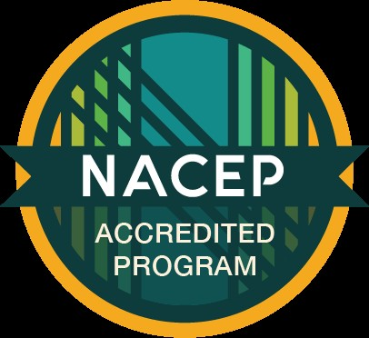
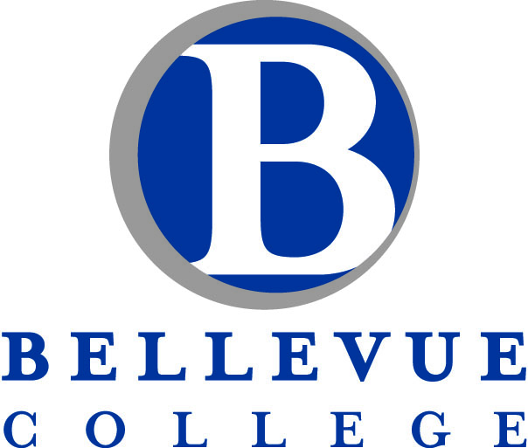

Bellevue College in the High School Instructor Handbook
2026-27


Greetings from Our President
Thank you for working with us in the Bellevue College in the High School program. We’re thrilled to partner with you so that students can earn college credit while simultaneously completing their high school graduation requirements. Bellevue College in the High School offers students the chance to save time and money on their academic and career goals.

I helped launch a College in the High School program at my previous university, so I know how powerful these dual-credit opportunities are for students who are uncertain about what they want to do after high school. College in the High School is a “game changer” that helps them realize that their dream of earning a college degree is attainable. The Bellevue College in the High School program helps us fulfill our shared mission to expand educational and economic opportunity for the people of our region.

We applaud your commitment and dedication to the success of these students as they face the rigor of college-level work. You are making a lasting impact on their future.
Best regards for a successful academic year. Dr. David May
President, Bellevue College

Thank you for being a part of our Bellevue College in the High School team!
Bellevue College in the High School provides opportunities for motivated high school students to accelerate their education and earn college credit while completing their graduation requirements— and without sacrificing their high school experiences. Thank you for collaborating with our college and our faculty to bring the college experience to your students! We are excited to have you on board. We could not offer this program without you!



What Is Bellevue College in the High School?
Bellevue College in the High School (BCHS) is a concurrent enrollment program that expands education options for high school students. This partnership between local school districts and Bellevue College (BC) provides students with the opportunity to simultaneously earn college credit from Bellevue while fulfilling high school requirements. Students do this by applying for admission to BC, enrolling in BCHS classes, and completing the college coursework that is taught by qualified high school instructors.

The BCHS program operates under the standards of the National Alliance of Concurrent Enrollment Partnerships (NACEP). NACEP “works to ensure that college courses taught by high school teachers are as rigorous as courses offered on the sponsoring college campus. As the sole accrediting body for concurrent enrollment partnerships, NACEP helps these programs adhere to the highest standards so students experience a seamless transition to college and teachers benefit from meaningful, ongoing professional development.”
On May 29, 2026, we were granted accreditation by NACEP.

The program is governed by an interagency agreement between the college and the school district that outlines the roles and responsibility of each party. The agreements are renewed annually.

Why BCHS Matters: Benefit to Students
- College in the High School programs significantly boost college attendance and completion rates. CHS students are more likely to attend and complete college—and the benefits are especially powerful for students of color, first-generation students, and low-income students.
- In contrast to Advanced Placement courses, all students who successfully complete a BCHS class earn credit on an official BC transcript.
- Students can transfer their BC credits to other colleges and universities (although they should always check with the institution receiving the credits about its policies on transfer credit.)
- BCHS students can use BC resources such as the Library, Academic Success Center, Advising, and Center for Career Connections.
- Many high school students are not able to participate in Running Start because of family obligations, or work—or because they simply do not want to miss out on activities, clubs, and athletics. BCHS gives such students an opportunity to earn BC credit.
- Students and parents save money! BCHS is 100% free for students and families.
- Communicate benefits of the program to students and parents and let them know about the opportunity to earn college credit in high school.

Benefit to Teachers
High school teachers benefit from the experience of teaching a college course and helping students transition into and through higher education. Each participating teacher works with a discipline-specific Bellevue College (BC) Faculty Coordinator who provides an overview of the college course and specific details around course curriculum development, objectives and outcomes, assessment standards, pedagogy and philosophical orientation of the sponsoring division. BCHS is the only dual- credit/concurrent enrollment program at the college that provides opportunities for high school and college instructors to work side-by-side on curriculum and course development and participate in joint professional development. Unlike other dual-credit programs, BCHS also compensates high school instructors for their time.

Teachers have access to the Bellevue College Library and Faculty Commons for other training if desired. You need to create a Net ID to use college resources

NACEP Standard F1 (Faculty)
All concurrent enrollment instructors are approved by the appropriate college/university academic leadership and must meet the minimum qualifications of the college adjunct faculty.

Approved BCHS instructors work closely with their discipline-specific Faculty Coordinator(s) to ensure the work the students perform in the BCHS class is equivalent to the course offered on the college campus.

IMPORTANT NOTE: BCHS Courses Must Be Taught by Approved Instructors
NACEP standards do not allow for “instructor of record” models. These standards mean that BCHS instructors must take extra care with extended leave or student teaching situations.
When a BCHS instructor goes on leave (planned or unplanned) for more than 10 consecutive instructional days, their high school is responsible for notifying the BCHS office in a timely manner. Approved BCHS teachers can cover the leave; qualified substitutes may apply for BCHS approval; or the college may be able to help the district locate a BC faculty member to serve as a sub during the leave. The college is responsible for determining an acceptable arrangement and conveying this to the high school, even if it means that the students would have to be administratively withdrawn from the BC course because no acceptable arrangement for a substitute instructor can be made.
Student teachers are not approved to deliver instruction on an extended basis in BCHS classes. Student teachers may observe BCHS courses and teach an occasional lesson under the guidance of an approved BCHS instructor. However, if a student teacher is assigned to teach more than 10 consecutive days in a BCHS class, approval is rescinded and BC must withdraw students from the class.

Application and Approval Process for New Teachers and any Substitute
- Check the BC hiring requirements for adjunct instructors
- Complete the application packet:
  - Application
  - Resume or CV
  - Unofficial college transcripts
  - Principal Recommendation Template
  - Current syllabus which will be reviewed. Once approved the coordinator will work with the instructor to create a BC formatted syllabus for students Enrolled in CHS
- Email documents to: cihsprograms@bellevuecollege.edu. Once received, the application packet is sent to the appropriate Faculty Coordinator
- Once these materials have been reviewed and approved, you will:
  - Receive a copy of your approval letter
  - Complete the following two forms:
    - Paraprofessional form (That is just the name HR gave the form)
    - W-9 form
  - You can send the forms to susan.hampson@bellevuecollege or email me if you would like a secure OneDrive folder to upload the forms

Teacher Responsibilities

Training
  - Attend new teacher BCHS program orientation by BCHS Staff (August)
  - Attend a discipline/course-specific training session with your program coordinator.

NACEP Standard F2 (Faculty)

Faculty Liaisons provide all new concurrent enrollment instructors with course specific training in course philosophy, curriculum, pedagogy and assessment prior to the instructor teaching. (August or September)

  - Participate in annual professional development activities. Faculty Coordinators in conjunction with the BCHS staff will work with instructors to develop a plan to meet the annual professional development requirements. The BCHS program is required to supply evidence of this PD.

NACEP Standard F3 (Faculty)
Concurrent enrollment instructors who participate in college/university provided annual discipline specific professional development and ongoing collegial interaction to further enhance instructors’ pedagogy and breadth of knowledge in the discipline. (October)

Paired Syllabi and Assessments
The Faculty Coordinator will share the college course syllabus and some of the course assessments with you. (syllabus template) It is expected the BCHS syllabus will hold certain elements in common with the on-campus sections, including course title, number of credits, objectives and outcomes, BC grading standards, and student academic integrity expectations. The BCHS program is required to supply evidence of these items.
Your faculty coordinator will discuss the college course description and provide the outcomes to you.
**The syllabus should be posted on your class site so enrolled students can have access.

NACEP Standard C2 (Curriculum)
The college/university ensures the concurrent enrollment courses reflect the learning objectives and the pedagogical, theoretical and philosophical orientation of the respective college/university discipline. (Paired syllabus)

NACEP Standard A1
The college/university ensures concurrent enrollment students’ proficiency of learning outcomes is measured using comparable grading standards and assessment methods to on campus sections (paired assessment/BC grading policy)

Classroom Site Visits
New BCHS teachers will receive a classroom visit by the BC Faculty Coordinator during their first and fourth years of teaching the course. After that, classroom visits are scheduled for a four-year rotation
Before the visit, BCHS instructors should be prepared to share: the course syllabus; teaching materials prepared for that class, such as handouts, assignments and homework due that day; teaching notes; slides or lesson/unit plans; and samples of assignments and graded student work with personal information removed.

NACEP Standard C3 (Curriculum)
Faculty Liaisons conduct site visits to observe course content and delivery, student discourse and rapport to ensure the courses offered through the concurrent enrollment program are equivalent to the courses offered on campus

Other Responsibilities

  - Communicate about the admissions and registration processes and key dates and deadlines to students and assist as necessary.
    - We are going to try and send the automated messaging to students in the following districts: Bellevue Renton, Lake Washington, Issaquah, Snoqualmie Valley, Highline and Tacoma. These messages would go to their student email.
    - HOWEVER, when a student applies, the “welcome email” will be sent to the email they include on the application.
    - We will also use automated messaging to send out class numbers and permission codes.
      - They always need to check the “junk” folder too.
  - Fill out the placement/prerequisite grid (more information below).Th
  - Submit grades via the ctcLink system at the end of the term.
  - Remind students to complete and submit their end-of-course evaluations. This information is kept in the teacher's file and available upon request.

NACEP Standard E1 (Evaluation)
The college/university conducts end-of-term student course evaluations for each concurrent enrollment course to provide instructors with student feedback.

  - Participate in program review or accreditation process as necessary.

Grading
BCHS instructors enter letter grades at the end of the term using the BC Grading Criteria. It is important to note that BC has different grading criteria than some of our partner school districts. When awarding Bellevue College grades, BCHS instructors must use the College’s grading scale, which awards grades A-F with assigned decimal values used in calculating BC students’ GPA. This means that it is not unusual for a BCHS student to earn a different grade on their BC transcript than on their high school transcript for the same coursework.

Bellevue College Grading Standards
Outstanding Achievement  A = 4.0 points per credit A- = 3.7-points per credit | High Achievement  B+ = 3.3 points per credit B = 3.0 points per credit B- = 2.7 points per credit
Satisfactory Achievement  C+ = 2.3 points per credit C = 2.0 points per credit C- =1.7 points per credit | Poor Achievement  D+ = 1.3 points per credit D = 1.0 points per credit  F = 0.0 points per credit
Student Withdrawal
A withdrawal is initiated by the student no less than two weeks after the registration deadline Grade = W, no decimal value and no impact on GPA

Placement and Prerequisites
BCHS students are required to meet the same course placement and prerequisite requirements that all Bellevue College students meet. BCHS instructors are responsible for working with their districts to verify that both placement and/or prerequisite requirements have been met. Instructors may perform the verification or ask their registrars, counselors, or principals for assistance.

Placement: After students are admitted to the college, their readiness to enroll in college-level math and English courses may be determined through a placement process such as placements tests, previous academic achievement.
Prerequisite: A prerequisite is a course that is taken (often with a certain minimum grade) or a skill that must be demonstrated before a student can enroll in a more advanced course.

The following are methods that can satisfy placement and prerequisite requirements:
- A review of previous academic achievement:
  - High school transcripts indicating success in prerequisite courses
  - Smarter Balanced Assessment results
  - AP/IB test scores
- Transcripts and assessment records from another high school or college
- Instructor permission
- Taking the ACCUPLACER assessment (English) or ALEKS assessment (Math) at BC. If a placement test is necessary, the high school teacher will notify the student and the BCHS office. We DO NOT require students to come to campus to do the placement testing.

Process for completing the Placement/Prerequisite Roster

This year we will be placing the placement/prerequisite grids in our OneDrive file and sharing the links to those files with you. They will be by discipline with teacher names on tabs on the bottom in alphabetical order. We will have all the information filled in; you just need to complete the “prerequisite met” column. We will also make if a student is ready to enroll, i.e., their application is complete, set for correct term and holds removed.

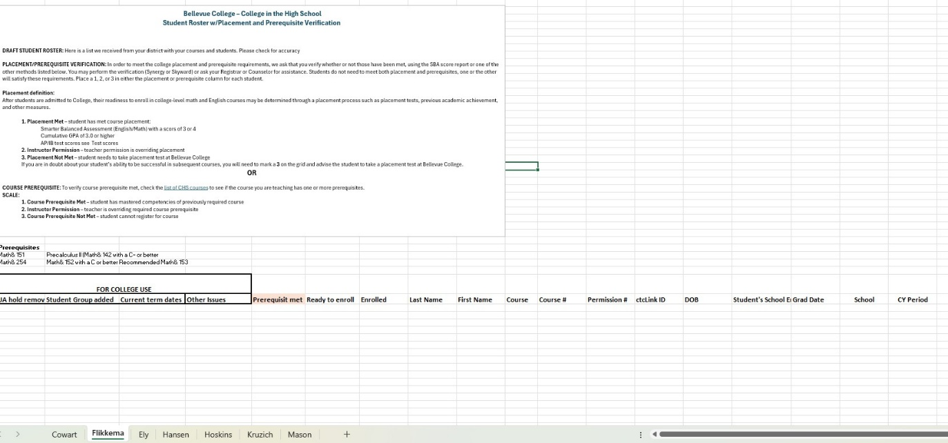

Student Admission and Enrollment Processes

We will provide you with a packet of information you can place on your class site to include your CHS version of your syllabus, the how-to guides, and application and enrollment dates.

Students new to Bellevue College in the High School are required to apply for admission to BC.
- If students have previously taken BCHS courses or have earned college credit at BC through Running Start, DO NOT need to apply for admission again.
- Students who have taken courses at another college, need to apply to Bellevue also, they will be assigned the same ID number.
- BCHS staff will make sure instructors are aware of all admissions deadlines, and instructors will need to remind their students about these deadlines.
- BCHS staff has “how-to” guides for each step of the process. These guides are also available on our website. Under Important enrollment Information or see links below.

Admissions—How to Guides Admissions
Students complete a two-part application
- They should save their username and password so if there are any issues or they apply to another college, they can use that information.
- They apply as a College in the High School student.
- It can take up to a week for the application to be processed. Enrollment services sends out their student ctcLink ID to the email address they used in the application.
- There may be some holds that the CHS office needs to remove:
  - Every term, students under 18 years of age get an underage hold.
  - Once a student turns 18, they get a Financial Acceptance hold. They are NOT charged fees, they just need to accept and submit.

Account Activation—How to Guides Account Activation
Once they receive their ctcLink ID, they will need to activate their ctcLink ID. They should save the password, because it is very hard to retrieve. They can take a picture if they can have their phone in the classroom or take a screenshot and later take a picture.

Enrollment-How to Guides Enrollment
Once you complete your placement/prerequisite grid, we will add the class numbers and permission codes for the students. We will send automated messaging with the enrolment information to students in the districts we have data sharing agreements. You will also have the information as a back-up to our automated messaging.
Automated messaging will go to their HIGH SCHOOL EMAIL ADDRESS.
The student will need the following information to enroll for classes:
  - Their ctcLink ID number and password
  - The 5-digit class number
  - Their course permission number

NOTE: BCHS courses are governed by BC policies. Students must enroll for college credit during the approved timeframe. The College is unable to enroll students or award college credit retroactively. The only grace period is between the day we have listed in the student timeline for the end of enrollment and the day the permission codes expire. Therefore, it is very important for the BCHS instructor to remind their students about enrollment deadlines.
To check enrollments, you can access your class roster by signing in to your ctcLink account.

If a student is having a problem with any of the above processes, they need to email cihs@bellevuecollege.edu right away and include their full name, ctcLink ID, or date of birth and what they are having trouble with—a screenshot is always helpful. The more we know, the quicker we can resolve issues.

Disability Accommodations and Modified Curriculum
In general, accommodations in dual-credit classes work similarly to how they do in regular high school courses. Instructors in BCHS courses assist BCHS students in accessing the accommodations put into place in their 504 Plan or Individualized Education Plan, just as they would in any other class.

However, there is one very important exception to this general approach: colleges and universities cannot approve modifications that fundamentally alter the curriculum. If a student’s 504 Plan or IEP establishes a modified curriculum, a student has three primary options when taking a BCHS class:
- They can decide to use the modified curriculum to earn high school credit but not college credit;
- They can choose to do the unmodified curriculum and enroll in the BCHS class; or
- They (and possibly their family members if a FERPA waiver is in place) can have a conversation with staff from BC and their high school to investigate whether additional accommodations or supports might allow them to access the unmodified curriculum and earn college credit.
If you, your students and/or their families, or your case managers have questions, they can contact me at susan.hampson@bellevuecollege.edu and I will put them in contact with the correct person.

Educational Planning
The BCHS website provides many useful resources for students in this section: Plan Your Education Pathway.

Transfer Credit
Completed BC credit can be applied towards a degree or certificate at BC or transferred to other institutions. Depending on the institution and the student’s program choice, credits may transfer as direct equivalents, as general electives, or they may satisfy a prerequisite for a required course.

Each public university in Washington maintains a website that documents how BC courses transfer into their institution, and you can find links to these guides on the BCHS website.
You can read about the rights and responsibilities for students transferring credits within our state at the website of the Washington Student Achievement Council.

Students planning to attend an out-of-state college/university should speak to the college/university admissions office to clarify how BCHS transfer credits will be accepted. Although it is uncommon for BCHS credits not to transfer, students should be aware that some institutions do not accept any transfer credit at all.

If students are considering attend Bellevue College after graduating from high school, encourage them to attend an information session to learn more about BC’s certificates and degrees. Check out the Welcome Center to take a campus tour, attend an information session and much more.

Compensation
We recognize that teaching a BCHS class entails more work than a typical high school course. Some of this work goes above and beyond instructors’ regularly contracted school district workday. Because we value our instructors’ contributions and because this work is vital to the success of the program, BC budgets for additional compensation to BCHS instructors.

The method for distributing this compensation varies from district to district. Some districts ask BC to handle additional compensation for the BCHS instructors. In such cases, we pay stipends based on the number of BCHS classes prepared and number of students enrolled; instructors receive a check at the end of the academic year. If the stipend was over $600, instructors will also receive an IRS 1099 form shortly after the end of the calendar year.

Other districts request to handle the compensation themselves. The policies regarding BCHS instructor compensation are specified in the interagency agreements between BC and the districts. If you would like a copy of the policies for your district, feel free to Director, Susan Hampson at susan.hampson@bellevuecollege.edu. In all cases, additional compensation is contingent upon completing 100% of the NACEP program standards and required.

Noncompliance
If a Faculty Coordinator or BCHS staff member has concerns about whether a course is being taught with fidelity to BC standards, an additional classroom site visit may be scheduled. Some concerns go deeper and may become noncompliance. Noncompliance is defined as prolonged failure or refusal to act in accordance with the requirements of the BCHS program and/or NACEP standards. Approved BCHS teachers who fail to fulfill responsibilities for teaching the college class will become ineligible to receive a BCHS stipend and may ultimately be suspended from the program. When noncompliance is noted, the teacher will be contacted by either the Faculty Coordinator or BCHS staff to discuss the situation and the consequences of non-compliance. If requested improvement is not forthcoming, a corrective action plan will be developed by the BC Faculty Coordinator and the BCHS office. The plan will include details for meeting specific requirements within a certain timeframe and will be submitted to the instructor and their principal.
If improvement action is not taken within the stated time period, the BCHS instructor will be suspended from the program for the following year and the school district and high school will be notified that the BCHS course will not be available for that instructor in the upcoming year.

College Resources
BCHS students are official Bellevue College students and have access to the same college resources as on-campus students. They will need to create a NetID.

Educational Planning: Advising and Career Services
Students who are considering attending BC after high school graduation are able to connect with an advisor from Academic Advising. All BCHS students can get help with career planning at the Center for Career Connections, which is also a great resource for students looking for internships or summer jobs.

Online Advising for BCHS Students

Email: susan.hampson@bellevuecollege.edu to set up an appointment.
Our BCHS advisers are available to chat with students, answer general questions, assist with planning college classes, and work with students to create an educational plan at BC while fulfilling their high school graduation requirements. These advisers also work with Running Start students, so if you student has also taken Running Start coursework or plans to in the future, they will be able to work with all the student’s credits taken at BC regardless of the program.

Academic Success Center
The Academic Success Center offers free in-person and online tutoring help to BC students in a variety of subjects. There are also dedicated labs for reading, writing, and math assistance.

BC Library BCHS students and instructors may borrow materials from the BC Library. If the BC Library does not have the item, it may be able to obtain it via interlibrary loan. The Library also maintains subscriptions to many research databases that are not commonly available in high schools; these databases are open to all BCHS instructors and students. Please see the BC Library website for more information.

Bellevue College Affirmation of Inclusion and Non-Discrimination Policy
Bellevue College is committed to maintaining an environment in which every member of the campus community feels welcome to participate in the life of the college, free from harassment and discrimination. We value our different backgrounds at Bellevue College, and students, faculty, staff members, and administrators are to treat one another with dignity and respect.
Bellevue College is an Equal Opportunity Employer in accordance with applicable federal and state laws and regulations. Bellevue College does not discriminate on the basis of race or ethnicity; creed; color; national origin; sex; marital status; sexual orientation; age; religion; genetic information; the presence of any sensory, mental, or physical disability; or veteran status in educational programs and activities which it operates. Bellevue College is prohibited from discriminating in such a manner by college policy and by state and federal law. All college personnel and persons, vendors, and organizations with whom

the college does business are required to comply with applicable federal and state statutes and regulations designed to promote affirmative action and equal opportunity.
This policy applies to all programs and facilities, including, but not limited to, admissions, educational programs, and employment.
Coordination of the compliance efforts of BC with respect to equal opportunity and disability accommodation regulations is under the direction of the Vice-President of Human Resources Telephone: 425-564-2274
Email: hr@bellevuecollege.edu.
Any person can file a complaint on campus, off campus, or online. File a complaint.

Have Questions about Bellevue College in the High School?
Email: susan.hampson@bellevuecollege.edu or chsprograms@bellevuecollege.edu.

