OAAP Forgot Username
Purpose: Use this document as a reference to retrieve your OAAP Username.
Audience: Students and Staff

Link to video of the process, but there is no audio on the video: Forgot User name

Welcome! Online Admissions Application Portal (OAAP)
- Access the Welcome to Online Admissions Application Portal screen.
- Click on the Existing Users Login button.
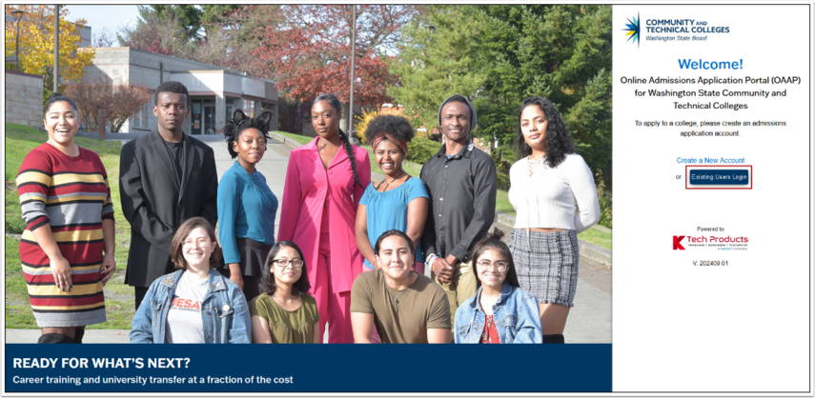

Forgot Username
- On the login page, click the Forgot my Username link.
- Enter Required Information on the Forgot Username page.
  - Email Address: Use the email associated with your OAAP account.
  - First Name
  - Last Name
  - Date of Birth
- Submit the request by clicking the Submit button.
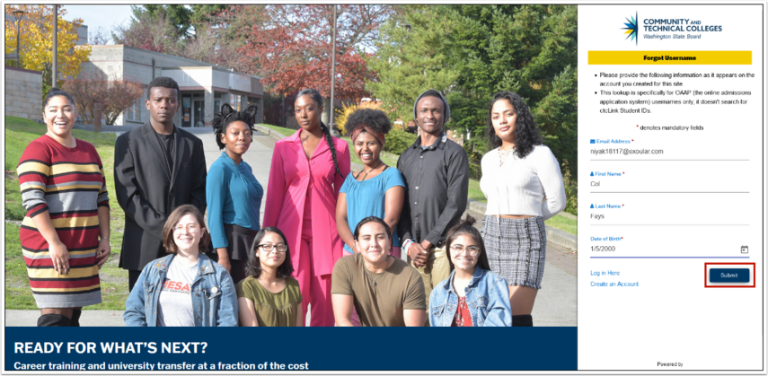

Confirmation Message
- If the information is correct, a confirmation box will appear, stating that your Username has been sent to your registered email address.
- Click the Log in Here button in the message box.
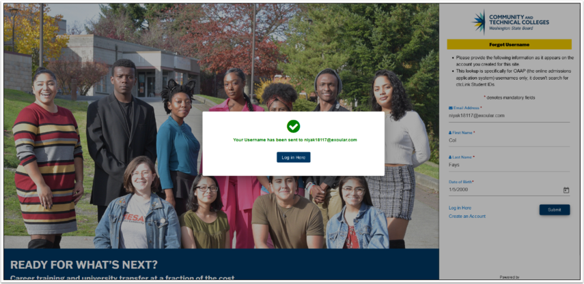

Retrieve Username and Log In
- Access your email account.
- Look for the Forgot Username Request email from the SBCTC system. The email will include your Username.
- Log in.
  - Use the Username you retrieved to log in to your OAAP account.
- Process complete.

