How to Accept the Financial Agreement
NOTE: This hold is placed on a students’ account once they turn 18. College in the High School Students will not be charged any fees for their classes. Just follow the directions below to accept the agreement.

Step1.
Go to CtcLink and log in.

Step 2.
Go to the my Information drop down menu on the left side of the screen and select holds.
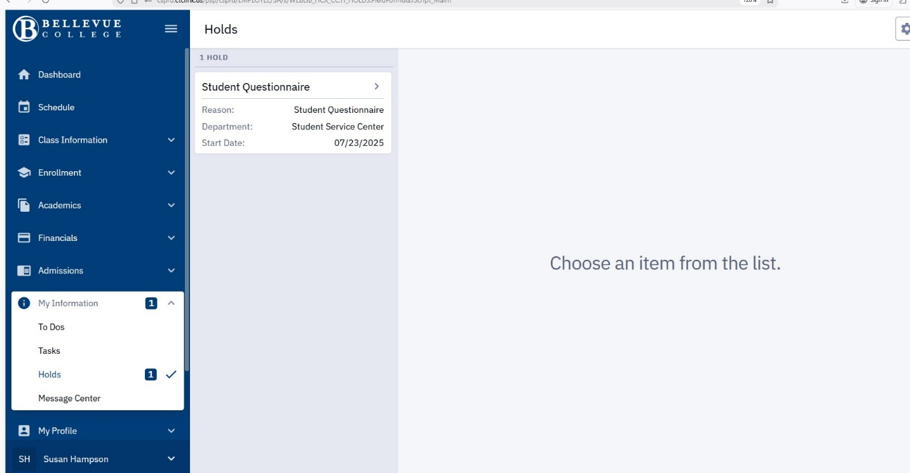

Step 3.
You will get a list of your holds, click on the right arrow on the right hand side of the list to bring up the agreement.
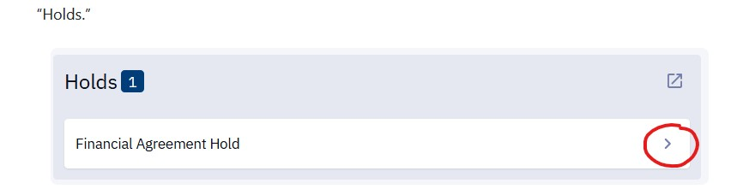

Step 4.
There should be an accept button, click on that button.

Step 5.
Log out of your account and back in to finish clearing the hold.

