Sign up for important updates from Ms. Kepler.
Get information for Bellevue College right on your phone—not on handouts.
Pick a way to receive messages for Running Start Student Remind Text Group:
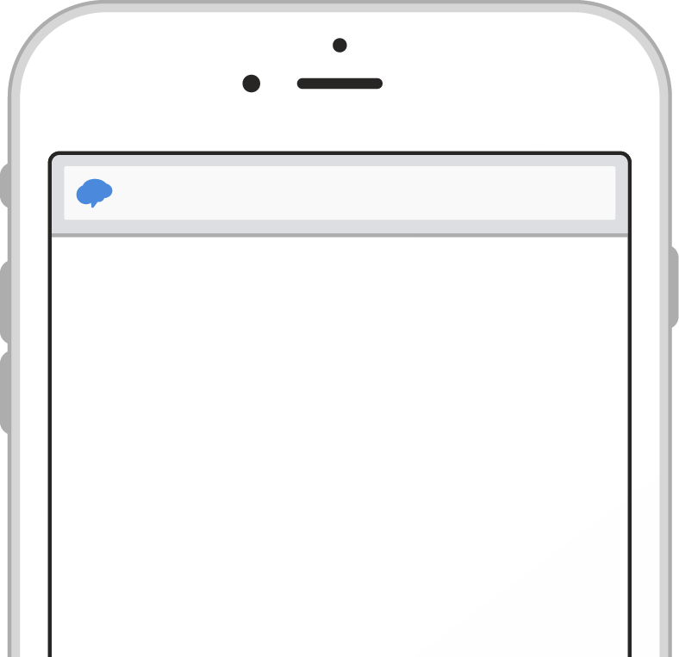
A
If you have a smartphone, get push
notifications.
On your iPhone or Android phone,
open your web browser and go to
the following link:
rmd.at/dced6
h
Follow the instructions to sign up
for Remind. You’ll be prompted to
download the mobile app.
rmd.at/dced6
h
Join Running Start Student
Remind Text Group
Full Name
First and Last Name
Phone Number or Email Address
(555) 555-5555
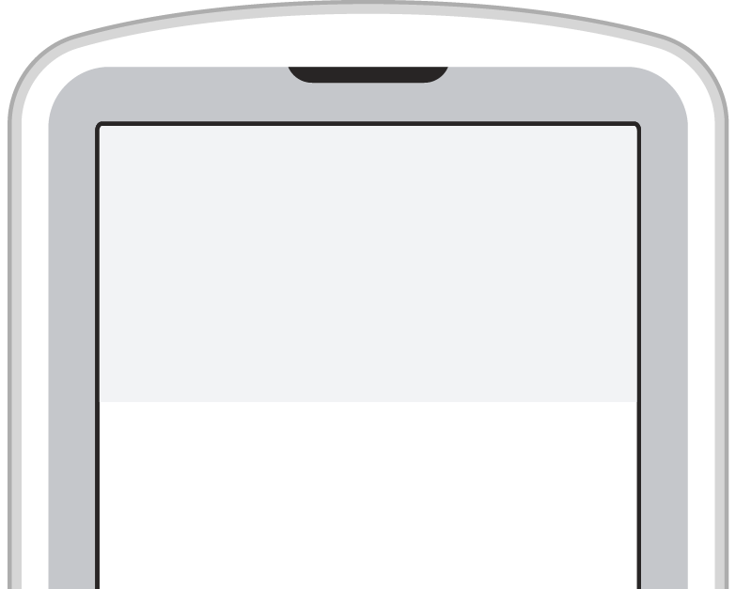
If you don’t have a smartphone, get text notifications.
To
81010
Message
@dced6h
B
Text the message @dced6h to the number 81010.
If you’re having trouble with 81010, try texting @dced6h to (425) 947-2430.
* Standard text message rates apply.
Don’t have a mobile phone? Go to rmd.at/dced6h on a desktop computer to sign up for email notifications.

