How to Add/Drop A Class

The following steps are provided as a guideline to successful add/drop a class at Bellevue College.

Step : Go to Bellevue College Website  www.bellevuecollege.edu  - Click on [Classes Button] | 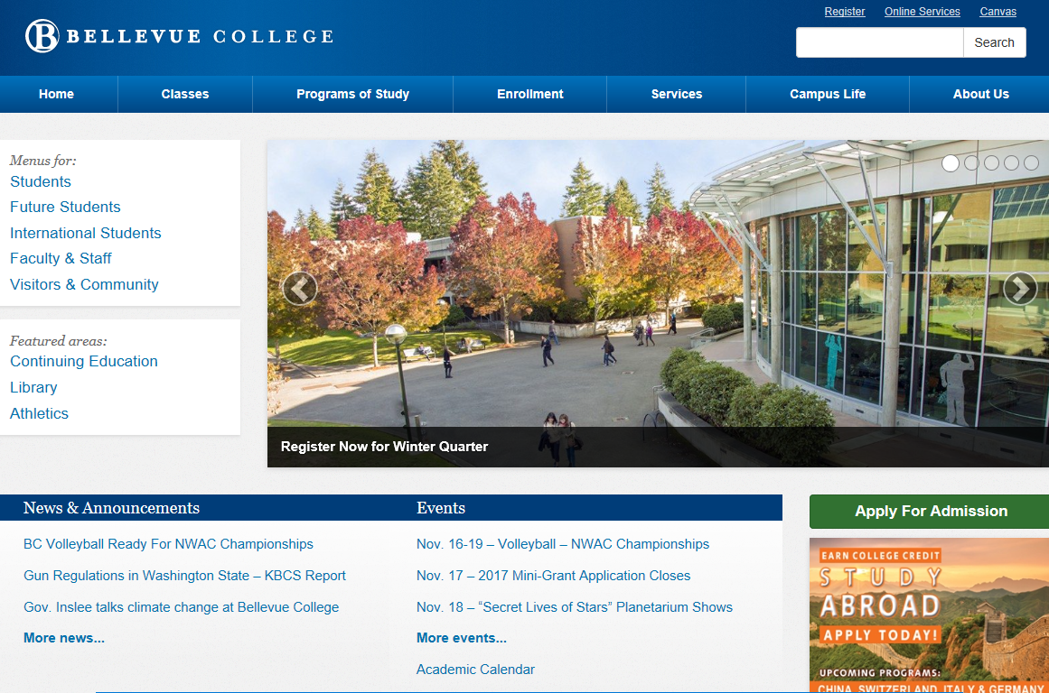
Step 2: Go to Register  - Click on the word [Register] | 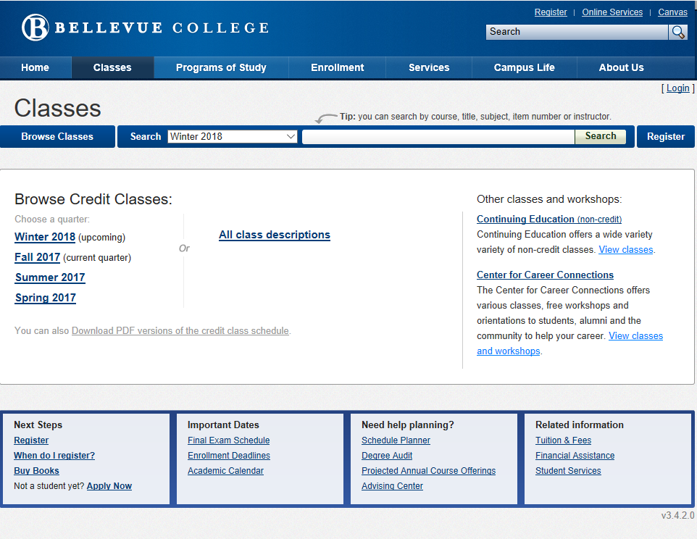
Step 3: Click Main Campus Credit Classes  - Click on Register for Main Campus Credit Classes Icon | 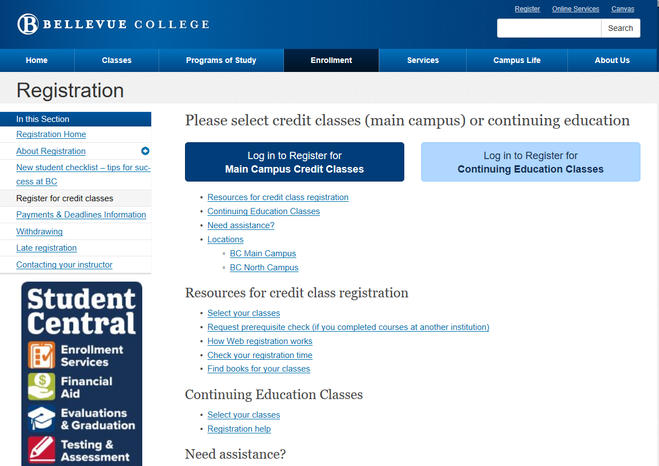
Step 4: Complete Pre-Registration Survey  - Click on [Submit] button after completing survey | 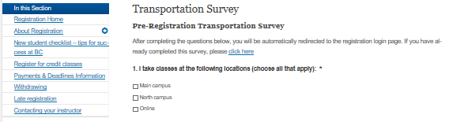  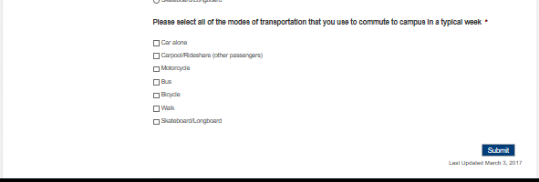

Step 5: Registration Login Screen  - Enter your Student Identification Number  - Student Pin (MM/DD/YY)  - Select the quarter you wish to add classes  - Click on [Agree to terms and login to register] | 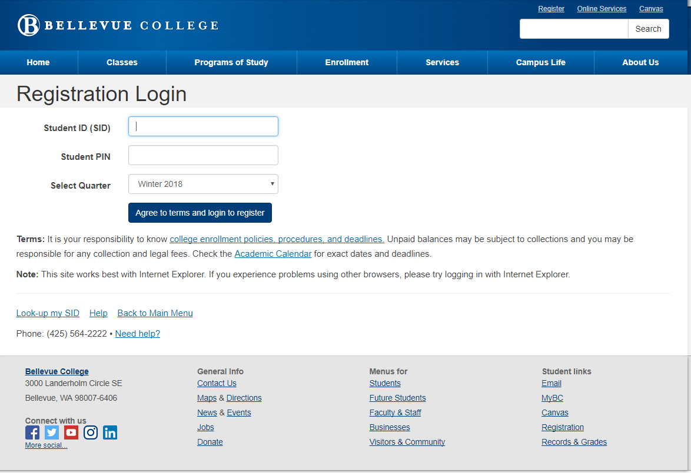
Step 6: Go to Register  - Click on the [Continue] Button | 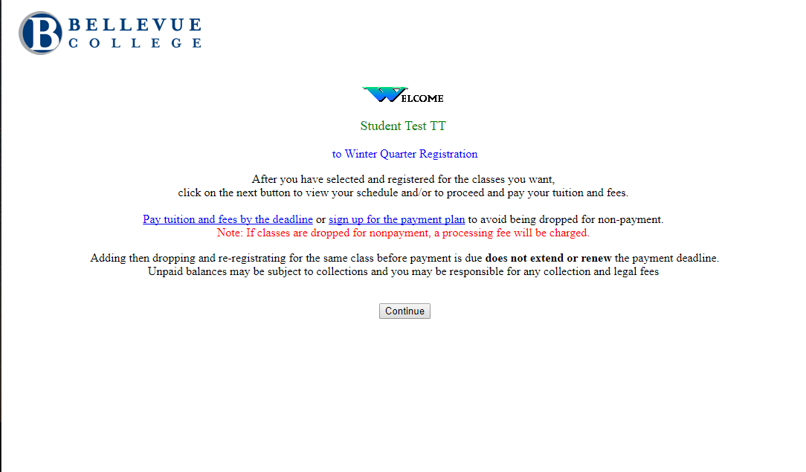
Step 7: Enter 4 Digit Item Number  - Enter a class Item Number for each class within each box  - Click on [Submit Add/Drop] Button | 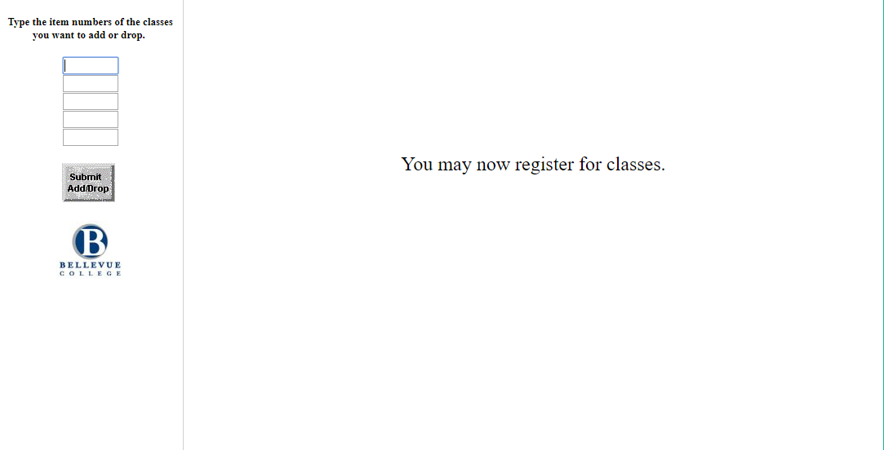
Step 8: Verify Class Added  - If you are unable to add a class a reason is given at the top of the screen  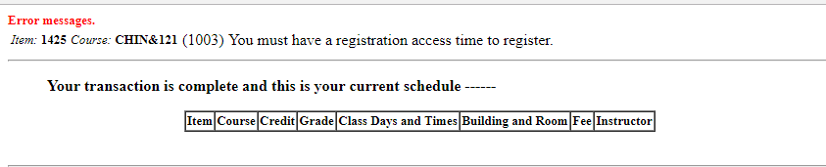  - Classes are displayed at the top to verify enrollment  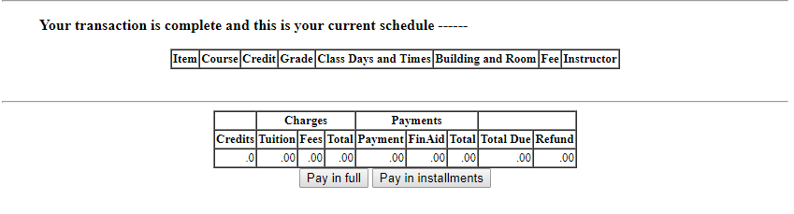  - Fees are provided for the cost of the class(es) added. | 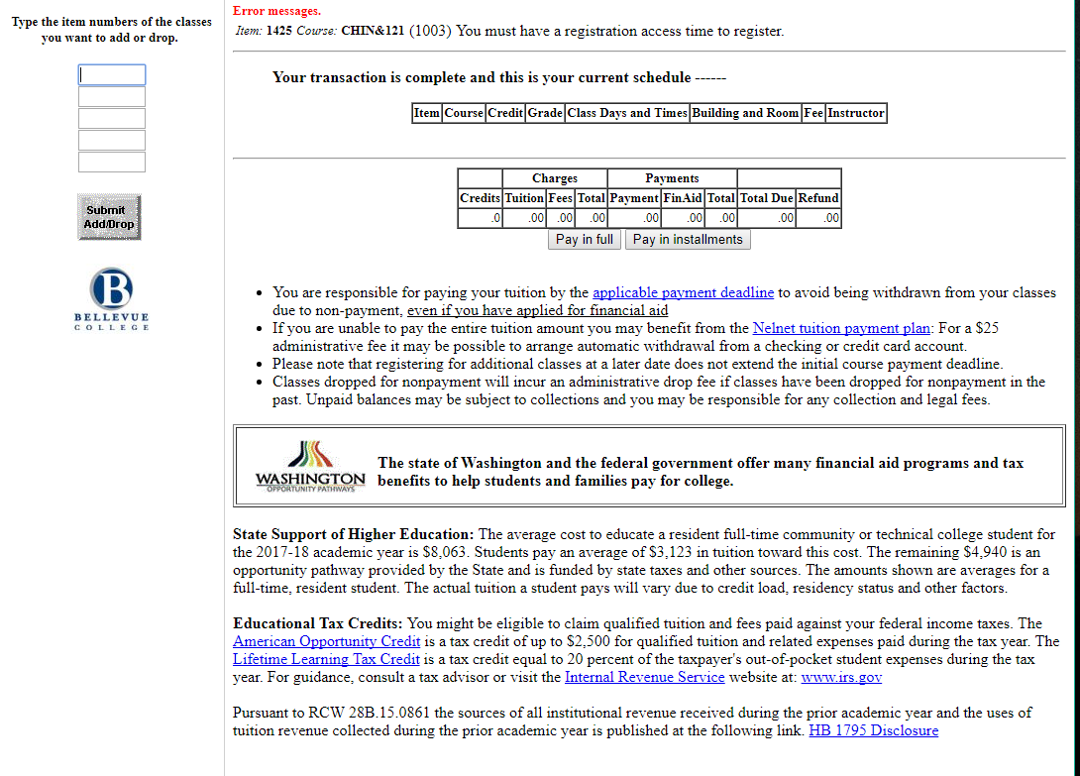
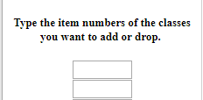
Step 9: Dropping a Class
Repeat Step 7
- Type 4 digit class to drop
- Click Submit [Add/Drop] Button

