How to Run a Degree Audit

The following steps are provided as a guideline to view the satisfaction of required courses and identify courses remaining to satisfy your degree/program at Bellevue College.

Step 1: Go to Bellevue College Website  www.bellevuecollege.edu  - Click on the [Online Services] link | 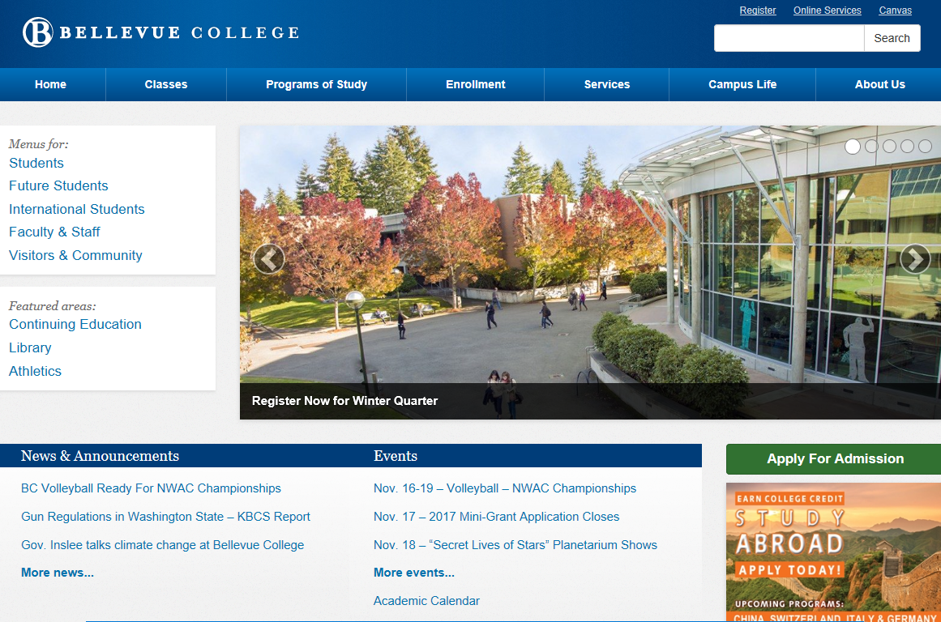
Step 2: Go to the Degree Audit  - Click on the word [Degree Audit] 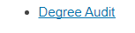 | 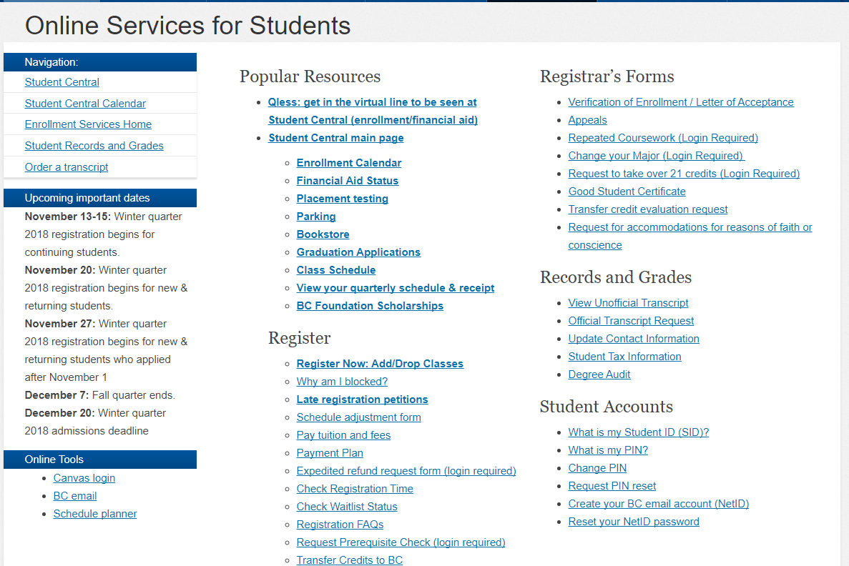
Step 3: Click Main Campus Credit Classes  - Click on [I’m a Student] Icon | 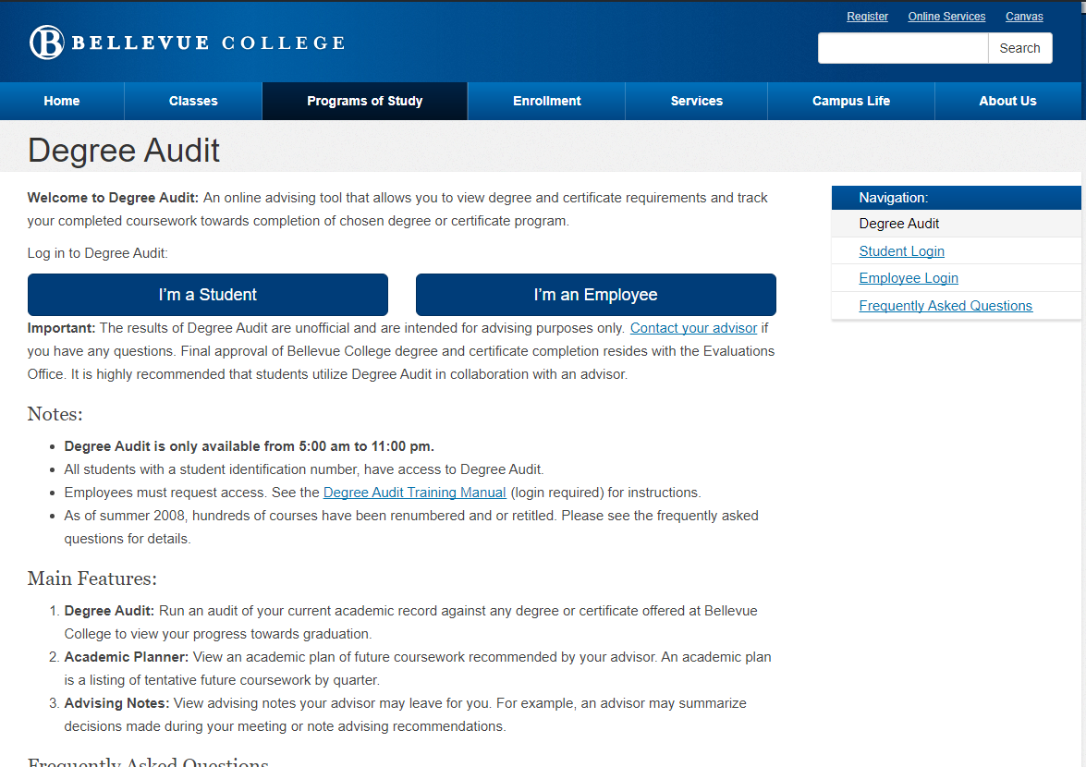
Step 4: Complete Pre-Registration Survey  - Enter your Student Identification Number  - Enter your Pin Number  - Click on Login | 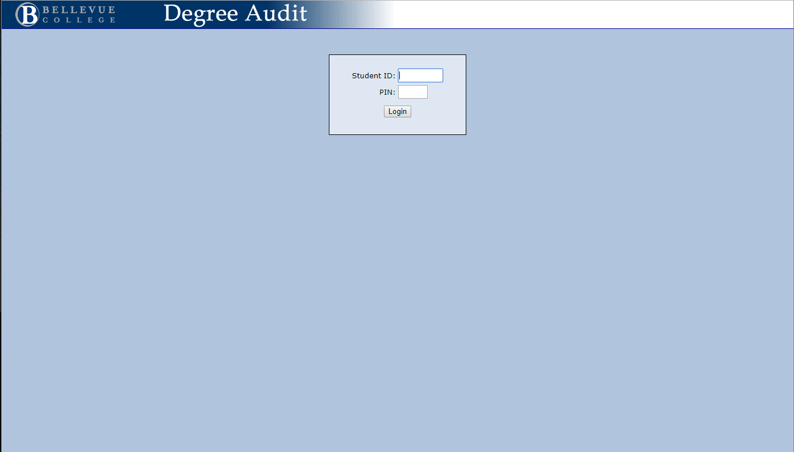

Step 5: Select Your Degree/Program  - Select which Degree/Program you are pursuing from the top of the screen  - Make sure you select the appropriate year  (the most recent year)  - Click on [Agree to terms and login to register] |  | 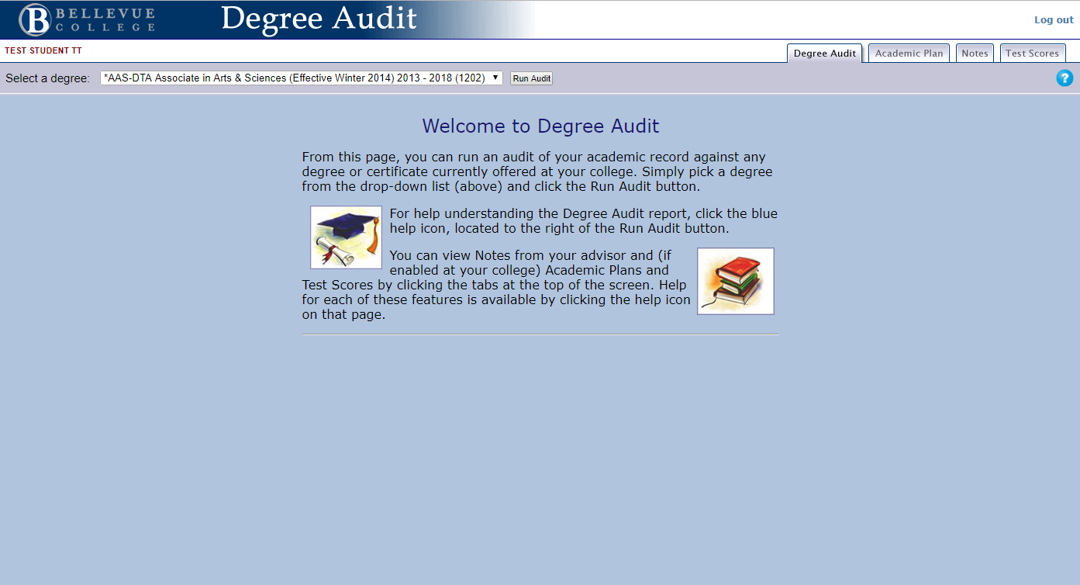
Step 6: Review Requirements and Applied Credits  - The total credits required for the degree/program are identified at the top  - Your program GPA is located at the top (these are credits that are used in your program and excludes classes and grades that aren’t used)  - Any classes previously taken or transferred in will appear as a class with the grade TR  - All classes taken will impact your College Grade Point Average, this grade is located at the bottom of your report. | 