How to Search for a Class

The following steps are provided as a guideline to successfully search for a class at Bellevue College.

Step 1: Know the Class Title and Classification  - College Classification Name (MATH 099)  - Title of Class (ex. Intermediate Algebra) |  | 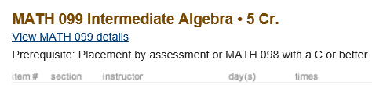
Step 2: Go to Bellevue College Website  www.bellevuecollege.edu  - Click on [Classes Button] |  | 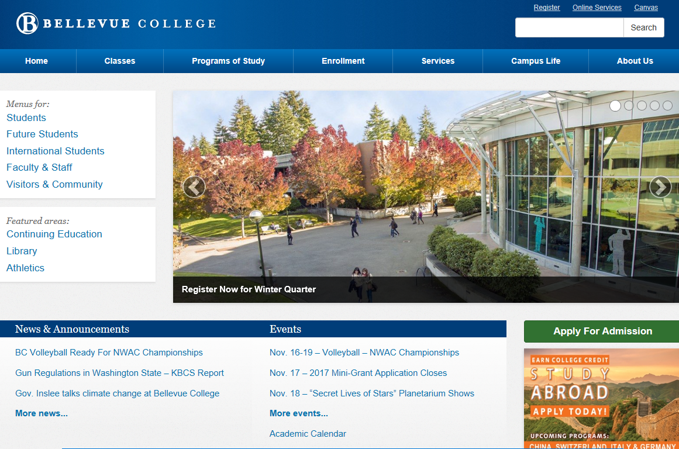
Step 3: Go to Quarter  - Click on the quarter you wish to take the class |  | 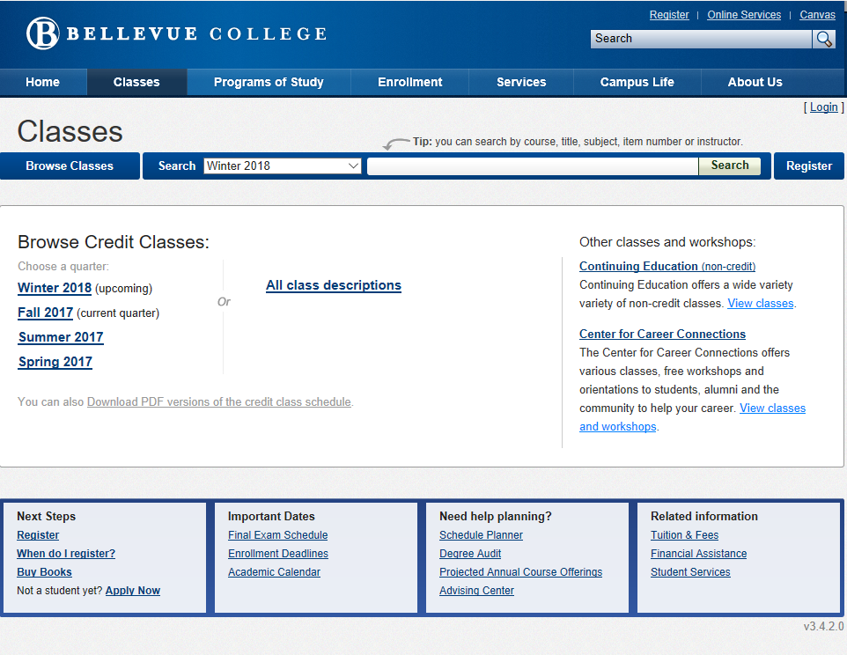
Step 4: Click on the Classification Name  - Click on the Alphabet Index  for the classification name  or  - Scroll down to the classification name |  | 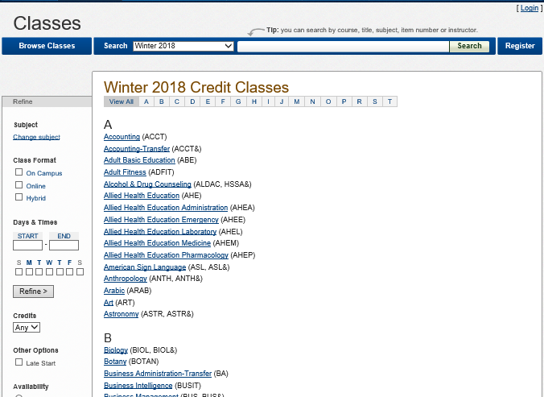
Step 5: Filtering to a Class
- Class Format
- Identify how you best learn
  - Face to face
  - Online
  - Hybrid
- Days & Times
- Identify when you are available for classes
  - Build travel time when considering classes
  - Select a time you could start a class
  - Select a time you would want the class to end
- Identify dates that you would like to attend classes
- Credits
- Search for a specific amount of credits
- Late Start
- Classes that begin after the quarter started are all within this category
- Availability
- All means both seats available and full classes
- Open are for classes without a waiting list

Step 6: Items to Review for Selecting a Class

- Item Number
- Used to enroll, write this number down
- Seats Available
- It counts down to show seats in class are still available
- Instructor
- Name of instructor for the class
- Click on name to obtain email of instructor, phone, or office
- Room
- Letter represents building, number is the room. (1st floor start with 1, 2nd floor with 2, etc.)
- Books
- Links to Bookstore to search for books required for the class

