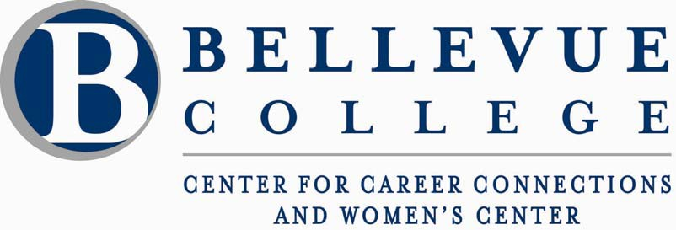
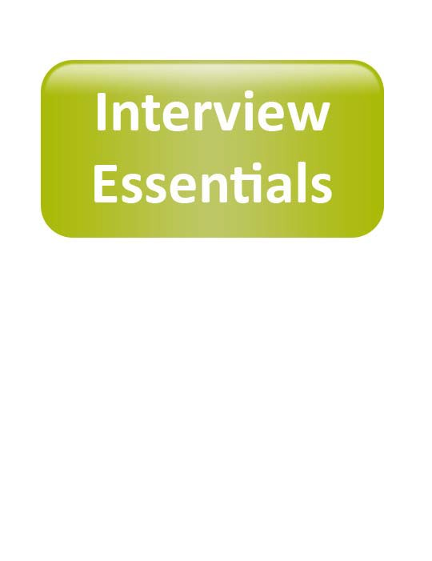

Twitter: BellevueCCC

LinkedIn: Bellevue College Community Group

Facebook Page: Center for Career Connections at Bellevue College

Center for Career Connections: http://bellevuecollege.edu/careers | Bellevue College: http://bellevuecollege.edu
Phone: (425) 564‐2279 | Email: careers@bellevuecollege.edu
Schedule an appointment (on-line system for video or phone appointments)

Bellevue College does not discriminate on the basis of race, color, national origin, language, ethnicity, religion, veteran status, sex, sexual orientation, including gender identity or expression, disability, or age in its programs and activities. Please see policy 4150 at www.bellevuecollege.edu/policies/. The following people have been designated to handle inquiries regarding non-discrimination policies: Title IX Coordinator, 425-564-2641, Office C227, and EEOC/504 Compliance Officer, 425-564-2178, Office R130.

This publication is funded in part by the Carl. D. Perkins Act.

Table of Contents
What Employers Look For………………….................. Page 1
Before the Interview .............................................. Page 2
Research & Practice ............................................... Page 3
Typical Interview Questions................................... Page 4 Interview Types...................................................... Page 5
During the Interview .............................................. Page 6
Questions to Ask the Employer .............................. Page 7 After the Interview................................................. Page 8
Illegal Interview Questions .................................... Page 8
Additional Resources ............................................. Page 9

Introduction
If you cannot interview well, you will lose many job opportunities. The interview is the most important part of any job search. If you are serious about your job search, you need to put effort into interviewing. When you interview, there are two key things to be aware of: the company’s needs and your value.

The Company’s Needs

When you interview for a position, it is because the company has a need. They either have problems that need to be solved, work that needs to be completed, or customers who need to be served. When you interview, your goal is to understand the company’s needs so that you can show them how you are qualified to fill those needs. You will be hired based on your ability to meet the company’s needs and help them perform better.

Your Value

Everybody has a unique set of knowledge, skills and abilities. Your value to an employer is based on the knowledge skills and abilities that you have developed through college classes and prior employment as well as internship and volunteer experiences. In an interview, employers will evaluate your value to their company based on how you answer interview questions. During the interview you must be able to highlight the value you bring and show how your value will fill the needs of the company.

What Employers are Look For
- Your level of experience and skills – are you qualified?
- Your willingness and ability to learn
- A sense of your personality, professionalism, and commitment
- An indication of how you would fit into the organization
- Answers to specific questions, especially about things on your resume
- Knowledge / interest in the company & position
- Critical thinking skills

Before the Interview

- Voicemail: Check your voicemail and make sure your greeting is professional. Be careful how and when you answer the phone – it’s better to call an interviewer back than to sound unprofessional, tired, or under‐prepared. If you have a ring‐back tone on your phone, make sure you change it to a neutral sounding ring.

- Email / Spam: Check your email and spam filters frequently. Many recruiters won’t make phone calls and conduct most of their business online.

- When & Where? Confirm the time, date, location, and expectations for the interview (dress code, length of time).

- Research: Before you interview, make sure you conduct in‐depth research on the company and learn about their needs. Find out about their history, culture, mission, etc. and be prepared to talk about how you can contribute. Research will help you know how to answer interview questions. See page 3 for more tips on researching a company.

- Prepare: Try to anticipate what they will ask. Then practice answering the questions out loud with a Career Specialist in the Center for Career Connections, a friend or family member. The more you practice, the more comfortable you will become. When you’re prepared, there will be fewer awkward silences and it won’t sound like you’re reciting your responses. In other words, don’t try to memorize answers word for word.

- Who are you? Prepare a brief introductory speech that will quickly answer the inevitable question, “Tell me about your background and experience as it relates to this position.” This is sometimes referred to as the 60‐second sell or the elevator speech. Be sure to mention the knowledge, skills and abilities that meet the employer’s needs.

- Dress to Impress: First impressions make a difference. An interview is your time to shine. It is always better to dress up than to not dress nicely enough. Dress conservatively which means plain clothing, no hats, and little jewelry so the interviewer pays attention to what you say, not how you are dressed. Even if the organization has a casual dress code, dress more professionally for the interview than you will on the job.
Doing so shows the employer you are serious about the job.

- Be Early: Arrive at least 20 minutes early. Plan for traffic and unexpected delays. Print out directions so you don’t get lost. If you are running late, call the interviewer as soon as possible to give them notice.

- Arrive Alone: The employer wants to see you, not your friends or family.
If you get a ride, have them wait in the car until you come out.

- Polite & Courteous: Behave courteously to everyone on the day of your
interview. Introduce yourself in a friendly and confident manner to the receptionist. Tell the receptionist
the name of the person you wish to see, the time of your appointment, and the job for which you’re interviewing.
You don’t know who the real decision makers will be, so act friendly and considerate to all personnel you meet
throughout the entire process. The interview is not over until you leave the parking lot; don’t go smoke in your car.

- Firm Handshake: When introduced to the interviewer, smile and shake hands firmly (but not too firmly). Practice shaking hands with friends or colleagues. Greet the interviewer by name and introduce yourself. Remain standing until you are invited to sit.

- Extra Resumes: Always bring at least 6 copies of your resume, since you never know how many people will attend the interview. You always want to have a copy for yourself so that you can refer to it in your interview. Also bring: a list of references (with contact information), the job description, and information about the company (for your reference), a pen, and a notebook. You can bring other materials as well, such as a portfolio, recommendation letters, and examples of your work.

- Contact Your References: Let your references know you are looking for a job and to expect contact.

Research & Practice

A successful interview begins with preparation and practice. These are the two most important things you can do.

Research
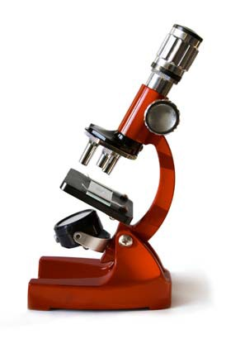
Spend as much time as possible learning the needs of the company so that you can understand what they are looking for.

Analyze the Job Posting: Nearly every position has an official job posting or job description.
If you do not have the job description, ask the company for one. Use the job description to determine the top 5 qualifications they seek. Highlight any words or phrases that seem important for the function of the job. This is your first clue about the company’s needs.

Research Online: Most companies have an “About Us” page on their website which talks about their products/services, mission, and values. Spend some time becoming familiar with the entire website, and make sure you know what the company does. Google the company or look them up in a local business journal. If you’re well informed, you will sound much more credible and knowledgeable when you step into the interview. If you aren’t well informed, you will seem uncommitted and unmotivated.

Speak to Former or Current Employees: The best information about a position or company comes from the people who work there. It may take a bit of work to find someone, but if you can speak to a current or former employee, you will gain incredible insight into what the company is looking for. Be considerate– repetitive emails and phone calls are not appropriate.

Get Creative: There are many creative ways to research a company. For example you can talk with competitors or clients, or contact a journalist who wrote an article about the company. Get creative in your quest for information. The more you know, the more you can show your value be able to describe solid reasons for them to hire you.

Practice
Practice makes perfect! You should never “wing it” in an interview. Once you have done considerable research, you should have an idea about the needs of the company. Based on your research, identify questions that you think you may be asked and begin practicing your responses. Here are a few tactics to consider:

Be on S‐A‐R: This is one of the most useful acronyms that you will use in an interview. S‐A‐R stands for Situation, Action, Result. Often employers will ask behavioral interview questions, such as “Tell me about a time when you worked in a team.” As you explain your past experiences, describe the situation or challenges that you faced, detail the actions that you took, and highlight the positive results. The SAR approach helps you tell your stories effectively. Stories are a good way to vividly describe what you have done in prior jobs, internships, and volunteer experiences that demonstrate your knowledge, skills and abilities.

Practice Interview: One of the best ways to get comfortable answering questions in an interview is to participate in one or more practice or “mock” interviews with a Career Specialist at Bellevue College’s Center for Career Connections, or with a friend who is experienced in hiring. Before your practice interview, provide a list of common interview questions (see page 4) and a job description to whoever is going to conduct the interview. For more information about the services offered by the Center for Career Connections, view our web site: http://bellevuecollege.edu/careers.

Typical Interview Questions

Below is a list of common interview questions. Interview questions vary widely depending on the interviewer and the situation. It is a good idea to practice responding to common questions. Remember, try to answer questions with a relevant and succinct story using the S‐A‐R system (see Page 3).

  - Tell me about yourself. (The 60‐second elevator speech)
  - Explain why this position would be the logical next step in your career’s progression.
  - What college did you attend (are you attending) and why did you choose it?
  - What is your greatest weakness?
  - Where do you see yourself in 3 / 5 / 10 years?
  - What motivates you?
  - Why are you interested in this particular field of work?
  - How do you define success in your job?
  - Describe your ideal job.
  - What is your greatest achievement?
  - Do you prefer working in a team or on your own?
  - Why should we hire you?
  - Why do you want to work here?
  - Why did you leave (or why are you leaving) your last job?
  - What do you like most about your current (or last) position?
  - What do you like least about your current (or last) position?
  - How would you describe your previous manager/boss/supervisor?
  - How would your co‐workers describe you?
  - What would your current (or last) manager say are your strengths?
  - What would your current (or last) manager say are your weaknesses?
  - What have your past jobs taught you?
  - Tell me about the most difficult situation you have faced.
  - How do you typically deal with conflict? Give me an example.
  - Tell me about a time when you worked with people of different backgrounds.
  - Give me an example of a time when you motivated others.
  - Describe a time when you anticipated potential problems and developed preventive measures.
  - Give me an example of when you showed initiative and took the lead.
  - Give me an example of a time when you used your fact‐finding skills to solve a problem.
  - Tell me about a recent situation in which you had to deal with a very upset customer or co‐worker.
  - Tell me about a time when you had too many things to do and you were required to prioritize your tasks.
  - Tell me about a time when you had to go above and beyond the call of duty in order to get a job done.
  - Give me an example of a situation where you faced conflict or difficult communication problems.
  - Give me an example of when you had to meet an unreasonable deadline or were faced with a huge challenge.
  - Describe a situation in which you were able to use persuasion to successfully convince someone to see things your way.
  - Tell me about a time when you had to be resourceful.
  - Describe a time when you were faced with a stressful situation that demonstrated your coping skills.
  - Give me an example of a time when you set a goal and were able to meet or achieve it.
  - Give me an example of a time when you had to make a split-second decision.
  - What is the first thing you would change if you were to start work here?

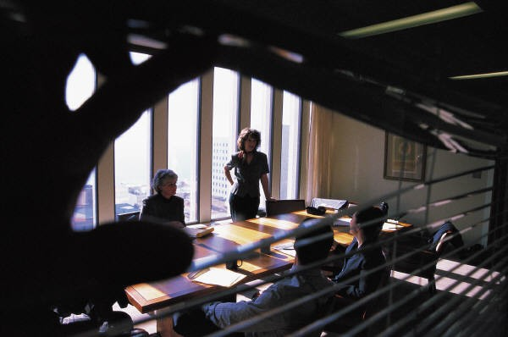
Interview Types

One-on-One Interview
If there is just one interviewer, it is usually the direct supervisor
of the position for which you are interviewing. In large companies
your first interview may be with someone from the Human
Resources Department whose task is to determine if you are
appropriate for a second interview.

Panel Interview
This involves you and two or more interviewers. Panel are used because 1) they allow various representatives of the hiring organization to reach a consensus before making a hiring decision, 2) they gage your ability to withstand intense pressure, and 3) they give the organization an understanding of your communication skills and professionalism.

Group Interview
In a group interview, several applicants interview at the same time with either an individual or a panel of interviewers. Usually, each interviewer asks questions that each applicant takes a turn answering. This quickly draws comparisons between applicants and their ability to provide a unique or more complete answer. You want to stand out by giving unique answers to the questions, instead of just saying “Me too.” Some group interviews require you to work with other applicants and are a way to determine your ability to lead a group and/or get along well with others.

Screening Interview
A telephone interview is an example of a screening interview. It aims to “screen out” applicants and “screen in” people who are appropriate to move on to the next level of the interview process (such as an in‐person interview). This saves the employer time, especially if the interview process is long and involves sequential and/or panel interviews.

Sequential Interview
This is a series of interviews (either in the same day or over the course of a few days), often including several supervisors, managers, and/or peers. Each person may cover the same material, or each may focus on a particular aspect of your qualifications.

Social Interview
These can take place in a variety of non‐traditional settings (lunch, cocktail party, career fair, office tour). It can resemble a traditional interview or it can seem very informal. If the interviewers are acting casually, it’s okay to be a little less formal. Behave at all times as if everyone you meet is evaluating you.

Confrontational / Stress Interview
Seemingly unrelated or emotionally charged questions are asked in order to gauge whether you are informed and can communicate effectively under pressure. Essentially this is an attempt to unnerve you. Your objective is to remain calm and focus on communicating your strong points.

During the Interview

- Body Language: Act naturally, and be pleasant, friendly, and businesslike in words and manners. Maintain eye
contact without staring, lean slightly forward, and smile frequently. Show that you’re engaged in the conversation. Don’t fidget with your clothes, hair, or jewelry.

- Take Notes: Taking notes shows you’re alert and helps you prepare questions that you will want to ask at the end.

- Speak from Experience: Use actual experiences to answer interview questions. You will be more memorable if you have a story to tell rather than stating how you think you might handle a situation. Use the S‐A‐R method: a) explain a situation you encountered, b) tell what action you took, and c) describe the result.
- Avoid Salary Discussions: Don’t discuss salary, benefits, time off, flexibility, or promotion during the first interview unless they bring it up first. Try to avoid discussing salary before you are offered the job.

- Talk the Talk: Gain credibility by using the language of your discipline such as customer service or computer software.

- Nothing Personal: Avoid getting too personal in your responses.
Off limit topics include marital status, religion, ethnicity, nationality, whether or not you have children, sexual orientation, and age. See page 8 for information about illegal interview questions. Keep your responses relevant to a professional work environment and no not talk about any personal conflict, past drug problems or hardship.

- Positive and Upbeat: Smile and speak positively and enthusiastically about the job, the company, the interviewer, yourself, and your past. Never complain about a past job or employer; never use slang or profane language; and don’t talk about your troubles.

- Keep it Cool: Do not beg for a job or appear desperate. No employer likes a desperate employee; they want a confident and capable individual. Express interest in the job without sounding needy.

- Confidence: If you are confident (yet humble) about your ability to perform the job well, they will feel confident in their decision to hire you. If you have concerns about your past or your lack or experience, don’t let those insecurities show. If the interviewer asks you about knowledge or experience which you lack, be sure to put a positive spin on it by explaining that you learn quickly or by outlining what you will do to gain the skills needed.

- Ask Questions: At the end of most interviews, you will be given a chance to ask questions. Always have a few questions prepared in advance and ask questions which require more than a “yes” or “no” answer. Ask specific questions that will help you understand the job and decide if this is the right job for you. Do no ask questions that you should already know the answers to from viewing the company website. Ask about job responsibilities, employer expectations, company values, work climate, and training. See page 7 for ideas.

- Ending the Interview: At the very end, thank the interviewers and tell them that you are interested in the job and look forward to hearing from them. Ask politely when you can expect to hear back from them. For example, ask, “What is the next step in the interview process?” Write this information down and let them see you doing it. Get a business card for contact information, if possible. Use this information to send a thank you note immediately.

Questions to Ask the Employer

You should ALWAYS ask questions in an interview. You will usually be asked if you have any more questions. This is your time to shine. No matter how well or poorly your interview has gone, asking good questions can turn the tide. If you have thoroughly researched the company and position, you should have some very good, intelligent questions to ask. Asking good questions shows that you are prepared and that you are serious about the position. Have at least five questions to ask the employer. You can also use this opportunity to address any questions they asked you that you think you may have answered poorly or incompletely.

Here are some sample questions you can use, but be sure to create your own based on your research.

About the Organization

  - What do you like best about working here? What project are you most excited about right now?
  - What kind of person is most successful in this environment?
  - What is your ideal employee like? Can you describe the type of employee who works well with you?
  - What do you see for this company’s growth in the next 5 years?
  - How would you describe the company culture?

About the Job

- Is this a new position? How long has this position existed?
- What would be a typical first assignment?
- What do I need to accomplish in the first 6 months for you to consider me a great hire?
- How would describe a typical day in this position?
- What are the most important qualities for someone to excel in this job?
- Was the last person in this job promoted? What contributed to his or her advancement?
- What are the most challenging aspects of this job?
- What are the priorities in this role?
- What have been identified as the areas for change and improvement in this role?
- How often would my performance be reviewed?
- To whom would I be reporting?

General

- Is there anything in my background that I can explain further?
- Would there be anything I could do to prepare for the first day on the job?
- May I contact you if I think of any other questions?

After the Interview

- Send a thank you note or email to each interviewer the next day, reiterating your interest in the position. Some experts say a hard copy note sent by regular mail is better than email because it is so easy for someone to ‘delete’ an email before reading it. People almost always open letters sent via the post office. Or, you can deliver it in person.

- If they’ve told you to expect an answer by a certain date and you have not heard from them by that date, don’t despair. Sometimes people just get really busy. Send them an email (or give them a call) politely asking whether they have made a decision yet.

- Don’t be too persistent. If they don’t call or email you back after two tries, that means you did not get the job.

Illegal Interview Questions

Some employers are not well trained in conducting interviews. As a result, they may ask
inappropriate questions. There is a fine line between an illegal and a legal question.
Federal and state laws prohibit employers from asking certain questions that are not related to the job for which they are hiring. Questions should be job‐related and not used to find out personal information.

Employers should not ask about the following:

• Race • Age • National origin or birthplace
• Gender • Religion • Sexual orientation
• Marital/family status • DisAbility • Ethnic background

If you are asked an illegal question, remain polite and professional. Employers often ask inappropriate questions because they have a genuine business need but don’t ask the right question. A good way to help the interviewer is to try and guess what information they may be seeking and ask about it. For example, an employer might ask if you have children when they are trying to find out if you can stay late with little notice. You could say “I’m wondering if you would like to know if I can stay late.” This gives the employer a way to clarify what information they are seeking and ask about it directly.

Interview Practice

The Bellevue College Center for Career Connections offers options to help you improve your interviewing skills.

- Interview Coaching and Interview Practice Sessions: You may sign up for an individual meeting with a Career Specialist to help you hone your interviewing skills or a one‐hour practice or “mock” interview. Practice interviews are an excellent way to experience a realistic interview and receive honest feedback. You will be asked to email your resume and a job description prior to the practice interview. This is a free service to students and community members. To schedule an interview coaching session or a practice interview all the Center for Career Connections front desk at (425) 564‐2279.

- Resume & Interviewing Strategies (EXPRL 220): This class is open to the public (college admission is required) and is offered once each quarter. It’s a 2‐credit, 2‐weekend class that helps you create an effective resume and learn how to represent your best talents in an interview. Guest speakers from local companies will tell you what they really want to see on a resume and hear about in an interview, and they may conduct practice interviews with students. For course details, visit the Center for Career Connections web site: http://bellevuecollege.edu/careers.

