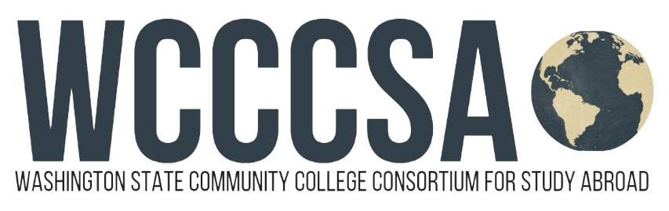

Washington State Community College Consortium for Study Abroad
Budget Request for Study Abroad
Student Name: | Student ID:
Current Email Address: | Have you been accepted into the program yet?  Yes No Not Sure
Program Name: WCCCSA  Costa Rica  Program website: www.wcccsa.com | WCCCSA Program:  2022 Summer/pre-Fall Quarter Costa Rica Program  In partnership with ICLC

Top of Form
Program Dates:  Start:  8 / 20 / 2022 .  month - day - year  End:  9 / 17 / 2022 .  month - day - year | Circle Term(s) You Will Be Abroad:  Summer or Fall Credit  (determined by student’s institution)  Circle Term(s):  Quarter Semester  Academic Year | OFFICIAL USE ONLY  All boxes have been completed  OIE Staff Initials:  date stamp here

To expedite your request, please provide as much of the following information as possible:
Program Fee: includes 4 weeks of accommodation in a local homestay family including all breakfast and dinners, on-site orientation, group activities, onsite liability insurance and medical insurance. | $2.961.00
Tuition for resident students (check with your campus study abroad coordinator) approx. | $500.00
Books & Materials | .00 n
Food: daily lunch approx. | $196.00
Roundtrip Airfare approx. | $650.00
Program-related Personal Expenses (laundry, telephone, daily transport to school, airport departure tax and taxi fare to airport) approx. | $400.00
Estimated Total | $4,707.00

WCCCSA - Study Abroad Campus Coordinator ________________________________________ Date_______________________

