Extra Credit in Canvas

Eight Ways
There are several ways to give students extra credit in Canvas:
- Create an Assignment worth zero points
- In the Gradebook, award extra points for an existing Assignment-- or for a Discussion or Quiz
- Add “fudge points” to a Quiz
- Use Rubric Criteria in SpeedGrader
- Manually add extra points in SpeedGrader’s Rubric
- Manually add extra points to SpeedGrader
- Use unweighted assignment groups
- Use weighted assignment groups

Assignments worth zero points
Instructors can create new assignments worth zero points. After students complete the extra credit work, these Assignments should be graded and points should be awarded-- even though the Assignment itself should stay set at 0 points.
The Assignment has to be set to zero points so that students who opt out of doing extra credit aren't penalized. The grade book automatically totals the points from all graded, published items in the course - so if a student gets a grade on a zero-point Assignment, Canvas will include it in the student’s overall grade. If they don’t get a grade on a zero-point assignment, Canvas will likewise not include it in their overall grade calculation.
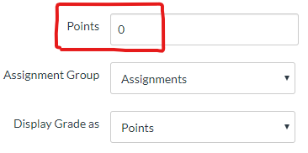

Award extra points to graded items
You can always add extra points to graded items such as Assignments, Discussions, and Quizzes in the Canvas grade book. You can do this by typing new values directly into the cells while you are looking at the overview of the grade book.
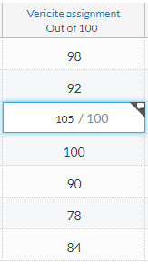

Add Fudge Points to a Quiz
For Quizzes only, you can use the Fudge Points feature in the SpeedGrader as an alternative. Be sure to click the button to update grades when issuing fudge points for a Quiz.
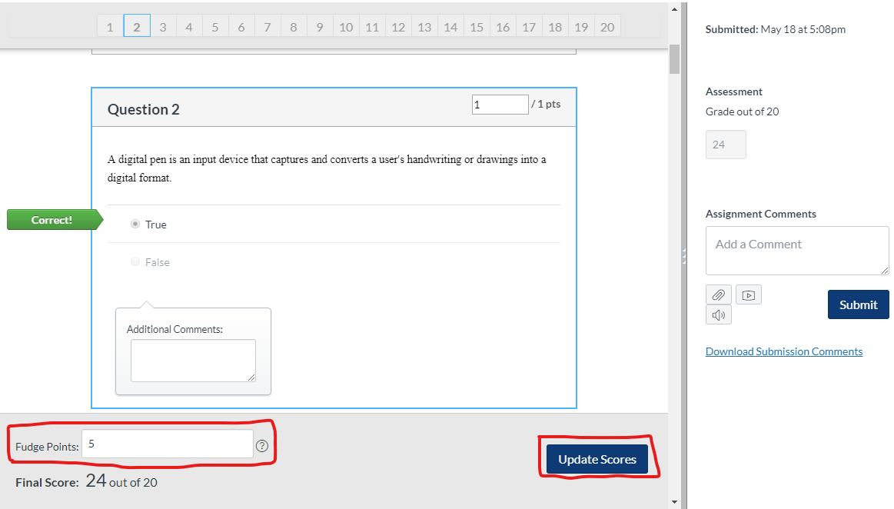

Use Rubric Criteria
In a rubric, you can create extra credit by making the rubric points add up to more than the assignment points. You could either create an addition criterion just for extra credit, or you could add a few extra points to pre-existing criteria.
When you grade the assignment in the Speed Grader, you can use the rubric to score student work. And since the total number of points available is more than the assignment is worth, students could earn extra points.
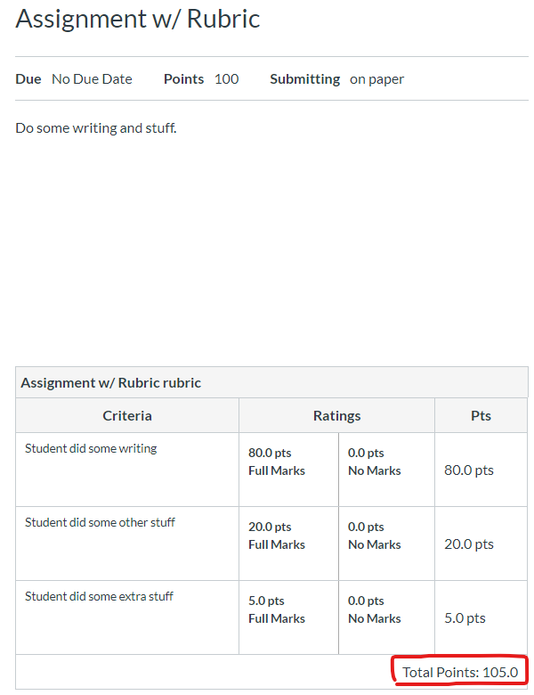

Manually Add Extra Points in a SpeedGrader’s Rubric Criteria
You can also use the SpeedGrader’s rubric to give more points to a student on one or more specific criterion.
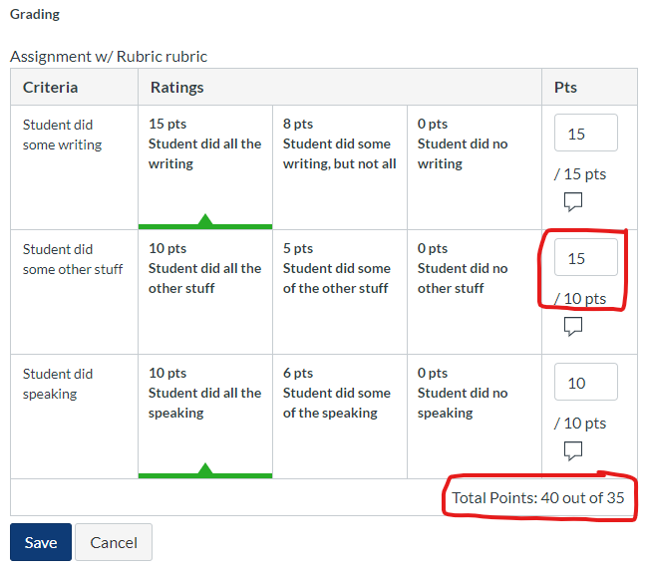

Manually Add Extra Points in SpeedGrader
You can also just type in a new grade in a student’s SpeedGrader.
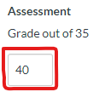

Unweighted Assignment Groups
Assignment Groups provide a means for organizing and working with multiple Assignments. You can add assignments that are worth zero points to an “Extra Credit” assignment group. This can help organize Extra Credit assignments separately than other types of assignments.
When students complete these assignments, you can grade them as usual, or add points directly in the Gradebook.
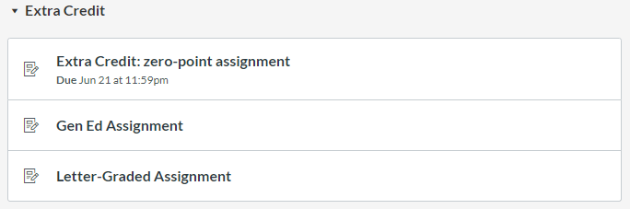

Weighted Assignment Groups
Not only can instructors use Assignment Groups to weight the final grade, but since the total percentage of all assignment groups can be set above 100%, it's possible to create an Assignment Group that houses extra credit Assignments.
The Canvas Guides explain the ins and outs of using this approach here.
In addition, if you use Assignments that are worth zero points, and you place them in a weighted Assignment Group, any points earned on those assignments will calculate into students’ overall grades. That is, extra credit assignments don’t necessarily need to be housed in an “Extra Credit” Assignment Group.

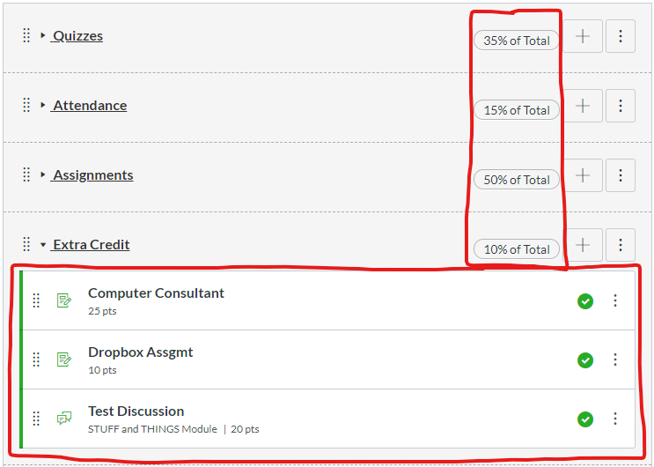

Credits
- Canvas Guide: How do I give extra credit in a course?
- Gabrielle Orsi, PhD

