Early Alert Spring Survey Results

Common Themes
The majority of responses came from General Population students. The data below reflects all students who responded.
Question 1: Are you aware of what Early Alert is?
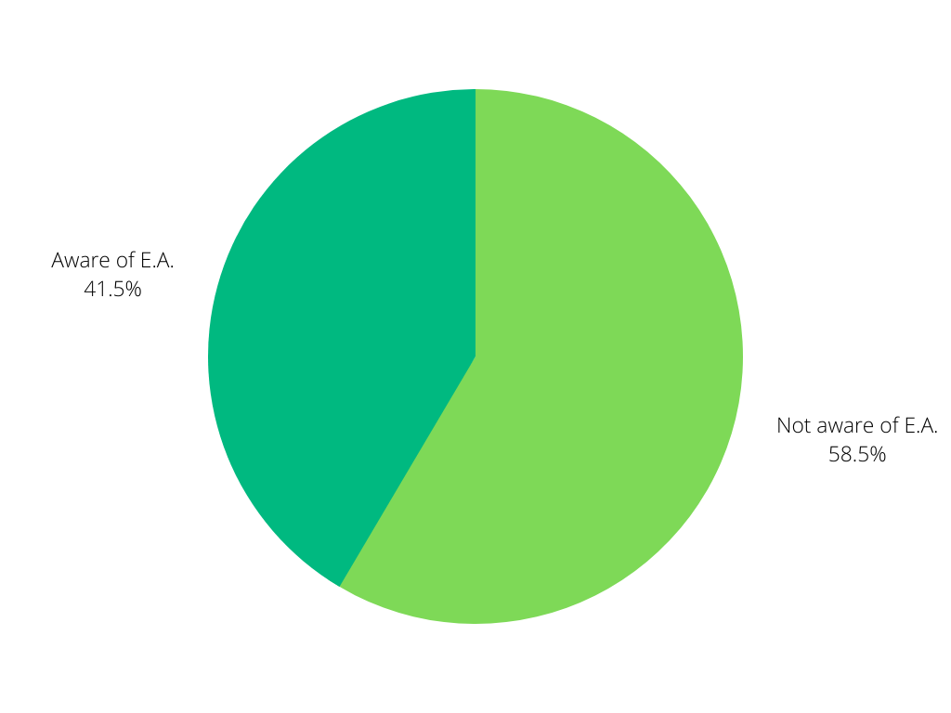
Question 2: What do you think of when you hear Early Alert?
Most students view E.A. as some type of intervention or program to help them before it’s “too late”
-too late to raise their grades
-too late to reach out for help
-too late to attend tutoring or submit late assignments
Many students also thought of E.A. as a program that helps you and shows someone cares about you.
Question 3:
Students who remember receiving an E.A. call gave positive feedback, felt like they were cared for, appreciated someone reaching out. Most students who recall receiving a call and follow-up found the information helpful and expressed it helped them get back on track in their classes.
Students felt supported.
Question 4: We’re interested in what actions you took after receiving Early Alert outreach. Did you
- Reach out to your instructor
- Start attending/logging into class (Null)
- Drop your class
- Submit missing work
- Connect with/utilize one or more of the services recommended
- Combination of these
- None of these

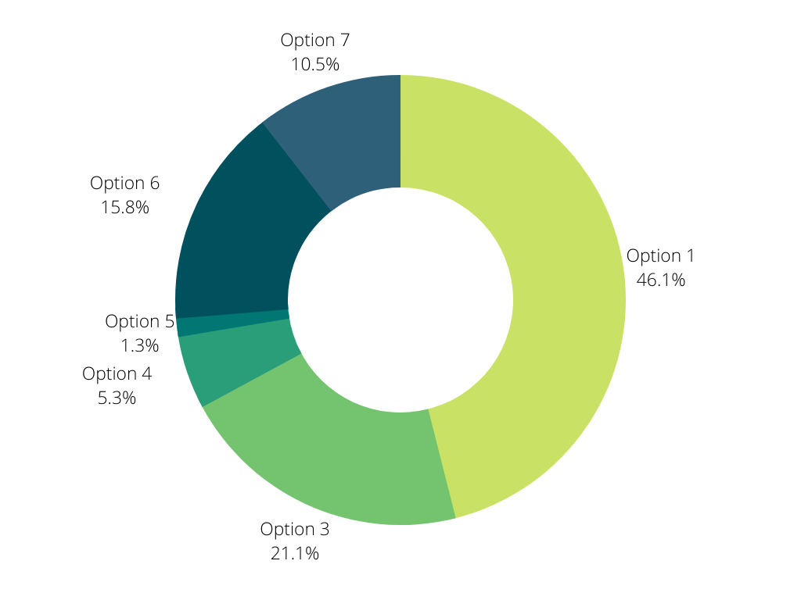

Question 5: Do you recall other offices reaching out to you during this quarter as well?
15% of students recall TRIO, Tutoring, Advising, and DRC reaching out during spring Q
Question 6: Success looks different for each student, and it is unique given your goals and circumstances. How do you define success for yourself?
Success for many students is achieving their goals no matter how small, passing their classes, starting their career, graduating, and prioritizing their mental health.

Question 7: On a scale of 1-5, did Early Alert make you more aware of campus resources, with 1 being “definitely no” to 5 being “definitely yes”
Nearly 37% of students said the E.A. calls and emails made them more aware of campus resources
Question 8: What recommendations do you have for increasing awareness of this program? (General Population responses)
43% said instructors should talk about it in class/add in syllabus/email students about it @ beginning of Q, 43% said no idea, 13% said to add to BC website
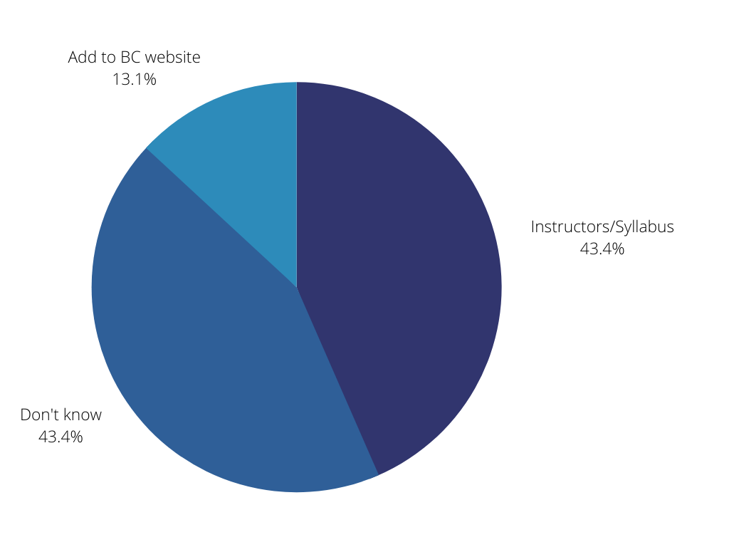

Question 9: What is the biggest take-away you have from this program?
Students said Early Alert is intended to support and help students
Question 10: Is there any addition feedback you’d like to provide?
More than half of general population students said no (63%), but those who did answer expressed wanting things to go back to normal.
The other students in RS, IE, WE, IBIT did not have any feedback to provide.

