Innovative ways to upcycle involving the community
Social change in America

Upcycling, also known as creative reuse, is the process of transforming by-products, waste materials, useless, or unwanted products into new materials or products perceived to be of greater quality, such as artistic value or environmental value.

https://www.organicauthority.com/live-grow/5-companies-with-upcycling-ideas-that-work
https://recoverbrands.com/blogs/sustainability-tips
https://diyvinci.com/upcycling-history-trend-lifestyle/
https://upcycleinnervation.wordpress.com/diy-ideas-2/stats-info-to-upcycling/

Erin’s video:
https://bellevuec-my.sharepoint.com/:v:/r/personal/erin_ciliv_bellevuecollege_edu/Documents/Microsoft%20Teams%20Chat%20Files/My%20Movie%203%201.MOV?csf=1&web=1&e=9MP6w0

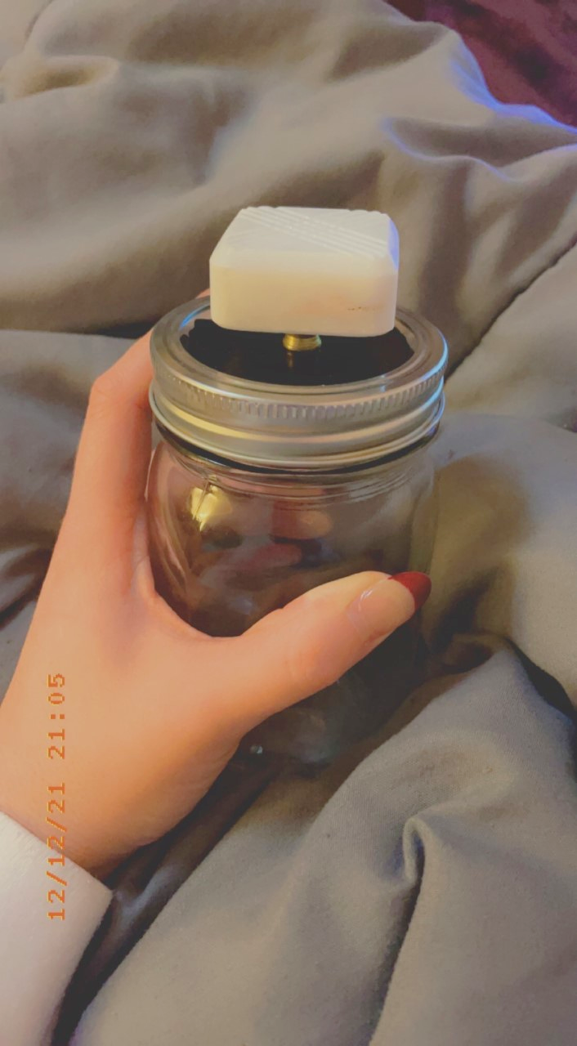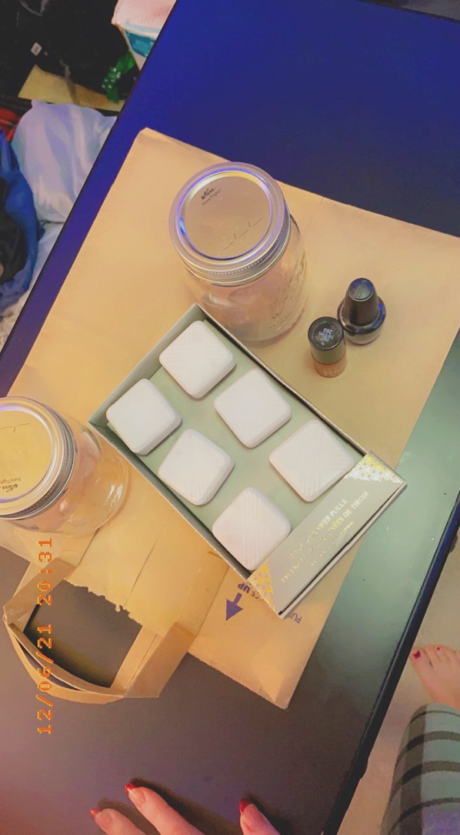

5 businesses that have upcycling techniques
- Terracycle- Organic fertilizer used in bottles
- Recyclebank- Online portal for rewards if you recycle
- Playback clothing- Clothing out of garbage goods
- Hipcycle- Upcycle goods to create home decor and jewelry
- Preserve- recycled toothbrushes, and kitchenware

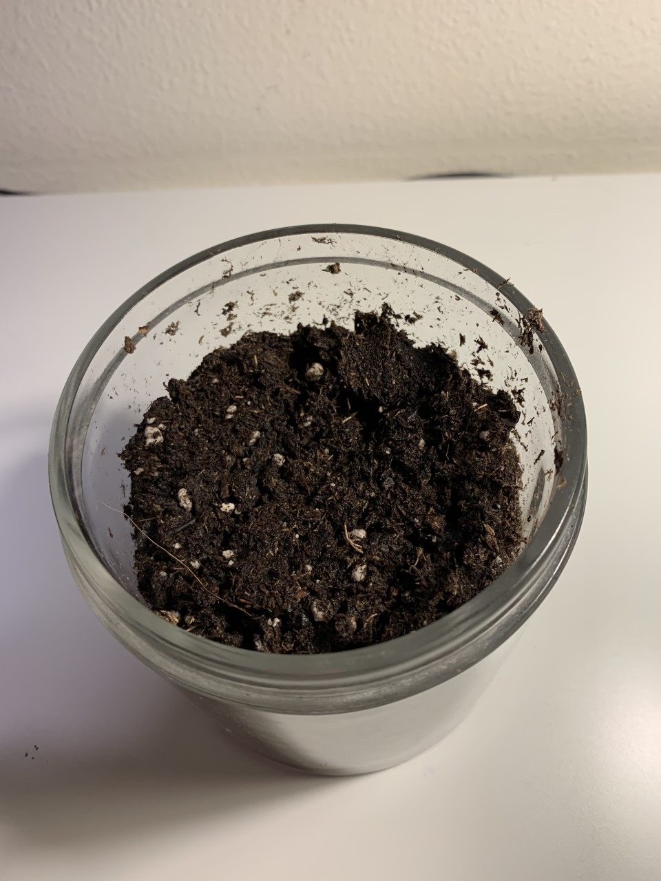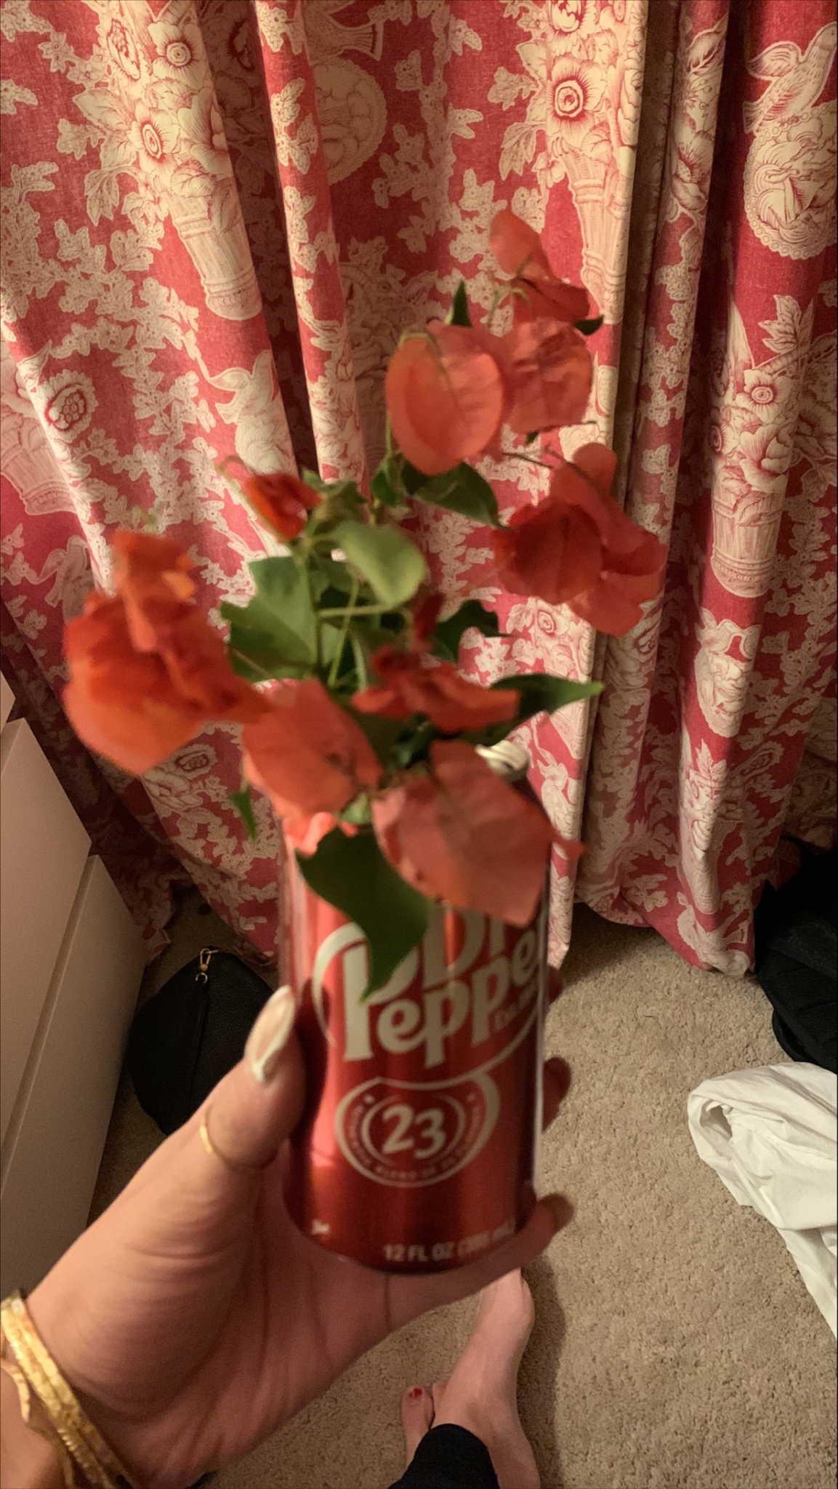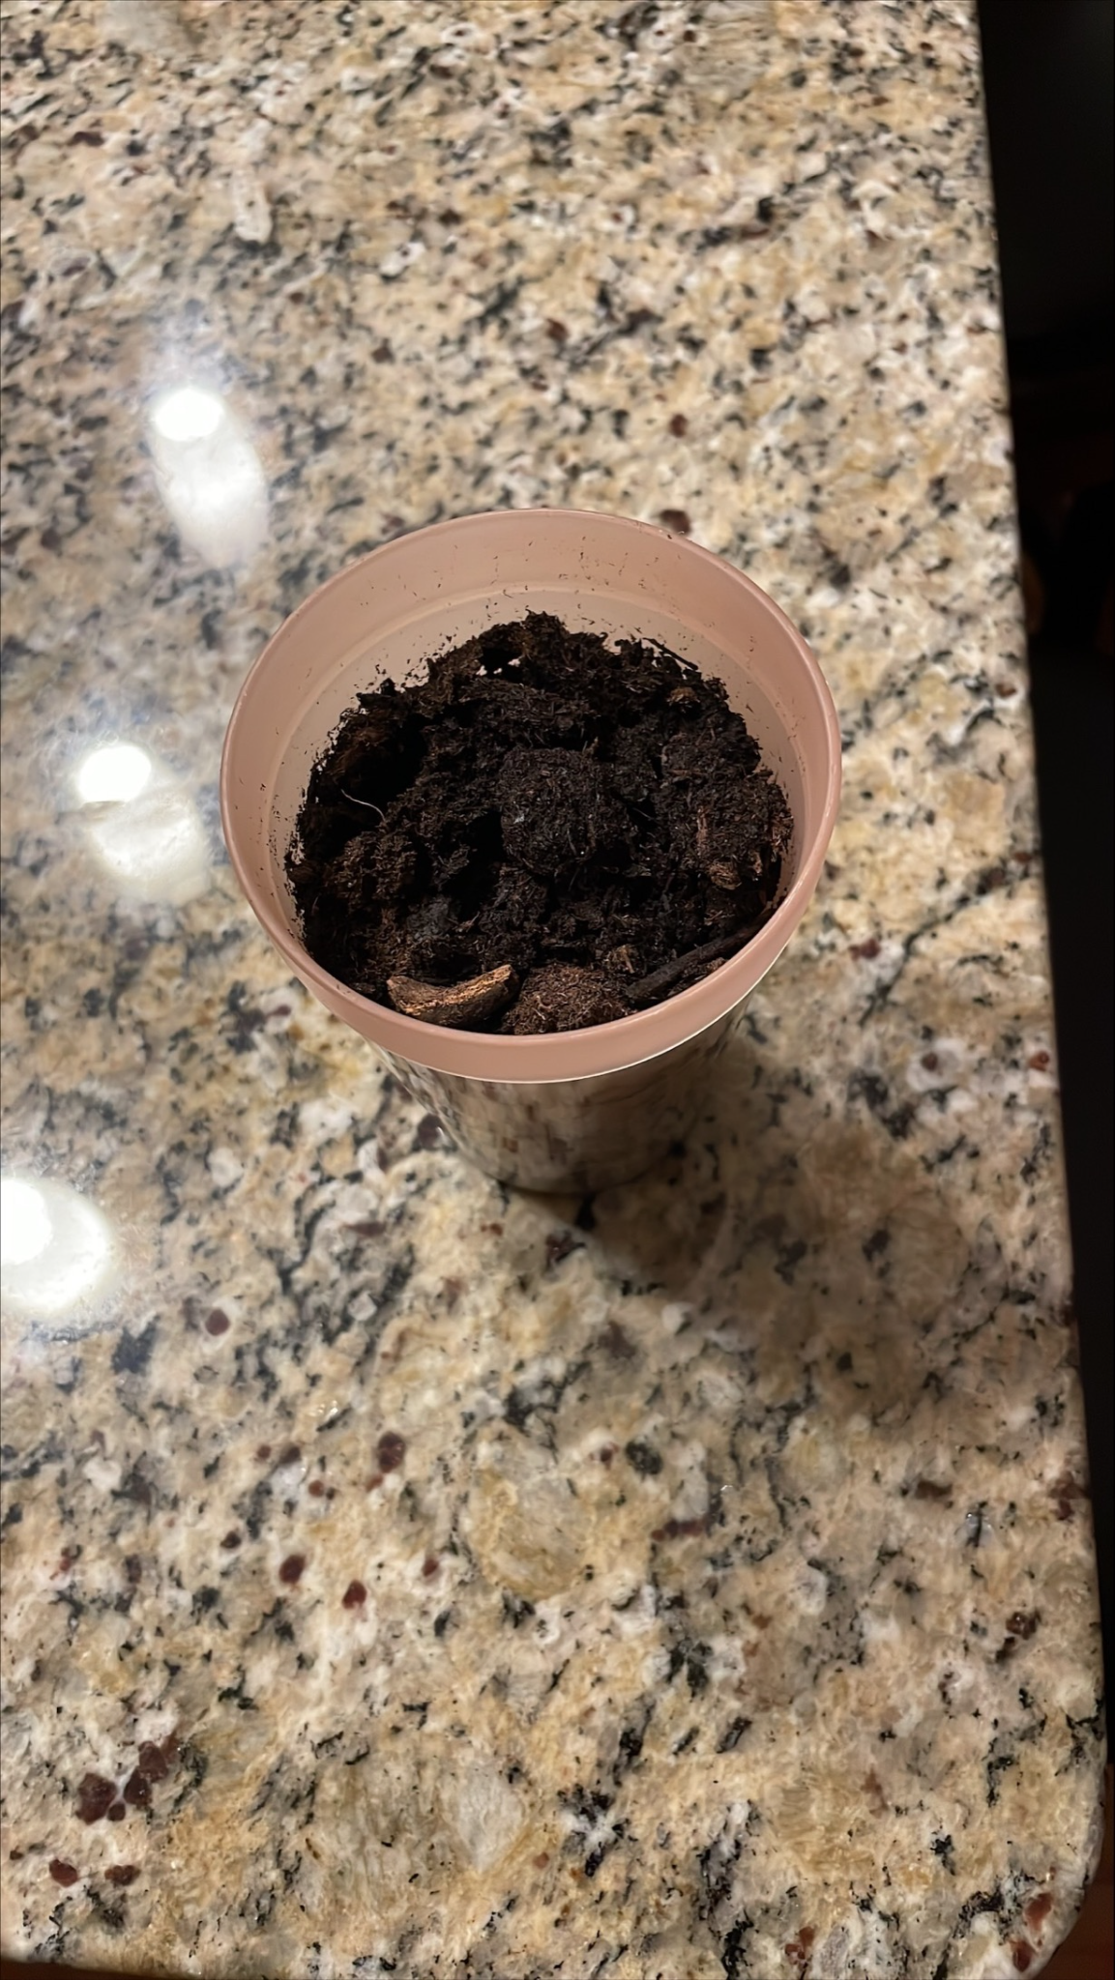

Upcycling statistics
- Upcycling existing resources means that we don’t have to use any new raw materials in the production process. Did you know that it takes 2,700 liters to produce the cotton needed to make a single t-shirt?
- Statistics show that 21% of Americans upcycle clothing, boxes, and goods regularly – reducing the need for the production of new goods.
- According to the World Bank, 17-20 percent of industrial water pollution is due to textile dyeing and treatment.
- Approximately 3-4 pounds of CO2 are saved for every 1 pound of clothing that is spared from disposal
- Americans throw away almost 9 million tons of glass. That amount could fill enough tractor trailers to stretch from New York to Los Angeles and back

How do we benefit from upcycling
- Upcycling benefits the environment by reducing the pollutants of air, land and water in the processing of new goods – as well as preventing additional natural resources from being used. It also reduces the amount of excess waste which would otherwise end up in landfills.
- Conserves the environment- reduces amount of waste dumped in landfills, helps with water pollution, solid waste can cause air pollution, so upcycling makes air pollution less
- Conserves limited resources- A Lot of value is in waste that's dumped, reuse it to make new precious items, use raw material
- Reduces the cost of production
- Upcycling reduces the strain on valuable resources such as fuel, forests and water supplies and helps safeguard wildlife habitats.

Helpful upcycling videos
- https://youtube.com/watch?v=C4-hFSw3NaY&feature=share
- https://www.youtube.com/watch?v=C4-hFSw3NaY
- https://www.youtube.com/watch?v=OsfG7i8Lyf8
- https://youtu.be/NDfrgC-FQuI
- https://www.youtube.com/watch?v=fGqfWvm4TnQ
“If it can’t be reduced, reused, repaired, rebuilt, refurbished, refinished, resold, recycled, or composted, then it should be restricted, designed or removed from production.”
– Pete Seeger, Folk Singer & Social Activist

