Class Supply List

Course Title: Intro to Watercolor
Instructor Name: Stacey Almgren
Instructor Contact for Inquires: stacey.almgren@hotmail.com or 425.233.4825
Date Updated: Monday, June 15, 2020

Supplies can be found at Michaels. Order online or pick up.

Watercolor Pan Set Fundamentals™ by Artist's Loft™
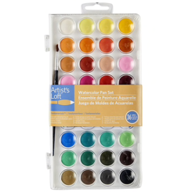$5.99

Watercolor Pad by Artist's Loft™, 9" x 12"
Or any watercolor pad 9”x12” the thicker (140lb.) the paper, the better results
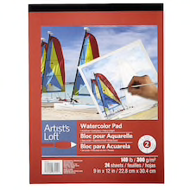$5.99

Bring this list to the art store, they can be very helpful and often times there may be a 10% discount at some stores if you are a BC student as well. Also, all basic materials are available at the BC main campus bookstore (TEL: 425-564-2285 or check out the website for store hours: http://bcc.collegestoreonline.com/).

