Test Proctoring Form

Disability Resource Center
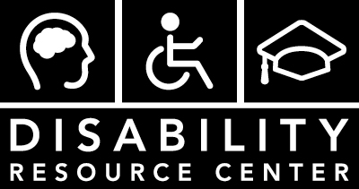
http://www.bellevuecollege.edu/drc
drc@bellevuecollege.edu
Main Campus, B132
Phone: 425-564-2498
Fax: 425-564-4138
TTY: 425-564-4110
Skype for ASL: DRCatBC

Student Section
Step 1: fill out the Student Section and provide this sheet to your instructor 2 weekdays before the test is scheduled in class. Reminder: if you have a notecard accommodation, provide the notecard as well.
Step 2: contact the DRC 2 weekdays before the test is scheduled to set up a Test Appointment (this form does not count). Reminder: if you need Kurzweil, Dragon, a scribe, or a computer for your test, include this info when making a Test Appointment. Final Exams require Test Appointments be made 4 weeks in advance.
Today’s Date: ____________________________ Student ID: ______________________________
Name: ____________________________________________________________________________
Class Name: _____________________________ Instructor Name: __________________________
Class Date and Time for Test: _________________________________________________________
Alternative Test Appointment Date and Time (if different): __________________________________
If you would like to schedule a test in the DRC after the date and time the test is scheduled for class, Instructor permission is required.
Student Signature: __________________________________________________________________
Remember Step 2: contact the DRC 2 weekdays before the test is scheduled to set up a Test Appointment (this form does not count).

Instructor Section
Fill out the Instructor Section and deliver this form, along with the test, to the DRC by 8AM the day the student is scheduled to take the test. The term ‘test’ refers to any test, exam or quiz.
Would you like the DRC to copy these Test Instructions to a MyDRC Test Proctoring Form for use by all DRC students in this course for the rest of the quarter? Yes No

Test Instructions
Open Book: Yes No Scantron required: Yes No
Open Note: Yes No Blue Book required: Yes No
Calculator: Yes No
Total test time given to class: _________________________________________________________
Test must be completed no later than (if applicable): _____________________________
Other instructions: __________________________________________________________________
Returning the Test Preference
I will pick up at the DRC: Yes No
Campus Mail to Room: ________________________ Scan and Email: _________________________
All tests returned via Campus Mail will also be scanned to safeguard against accidental loss or damage.
Instructor Signature: _________________________________________________________________

Bellevue College does not discriminate on the basis of race, color, national origin, language, sex, sexual orientation, including gender identity or expression, disability, or age in its programs and activities. Please see policy 4150 at www.bellevuecollege.edu/policies/. The following people have been designated to handle inquiries regarding non-discrimination policies: Title IX Coordinator, 425-564-2641, Office C227, and EEOC/504 Compliance Officer, 425-564-2266, Office R130.

