How to Log In to the MyDRC System
  - A Tutorial for Bellevue College Students from the Disability Resource Center

What is MyDRC?
MyDRC is the new information system being used by the Bellevue College Disability Resource Center (DRC).
All DRC students will have an account through the MyDRC system that will allow them to do things like request accommodations or schedule appointments for exams at the DRC or DRC Testing Center. Students new to the DRC will also be able to use the MyDRC system to sign up for their Initial Access Meeting.
For more information on MyDRC, please see the MyDRC User Guide on the DRC website or contact the DRC directly.

Logging In
  - How do I access the MyDRC system and my account?
To access features available to you through the MyDRC system, you’ll first need to log in to your MyDRC account. You can access the log-in page for MyDRC in a couple of ways:
The first is by entering the URL for the MyDRC website (https://cascade.accessiblelearning.com/BellevueCollege) directly into your browser.
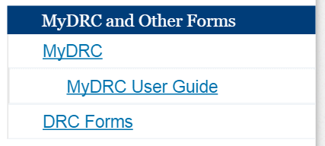
The second way to access MyDRC is through the link provided on the main DRC website (www.bellevuecollege.edu/drc). This link can be found at the top of the navigation menu on the right side of the page under the heading “MyDRC and Other Forms.” Click on “MyDRC,” which should be the first link listed under that heading.
Either method will take you to the log-in screen which looks similar to the one for logging in to Canvas or accessing your Bellevue College e-mail from the Internet.
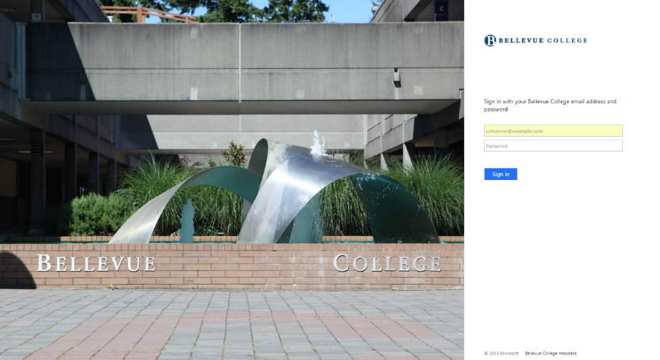
The screen instructs you to “Sign in with your Bellevue College email address and password,” so in the first text box, enter your full Bellevue College email address, including the “@bellevuecollege.edu” at the end. Your password (the same one you use for accessing Canvas, your campus email, or logging in to a campus computer) goes in the second text box.
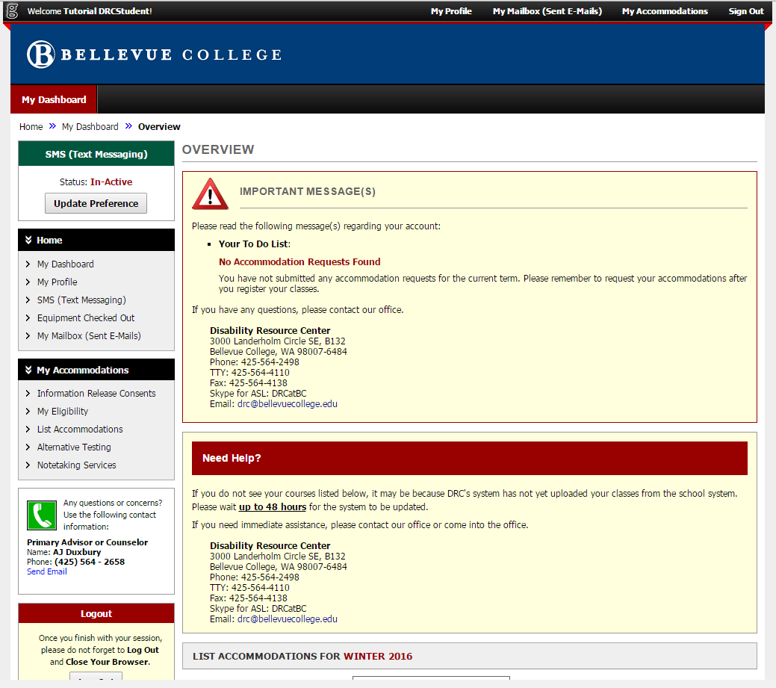
After entering your email and password, hit enter on your keyboard or click the blue Sign In button, and you’ll be taken to your MyDRC Dashboard.

The MyDRC dashboard can look a little overwhelming at first. There’s a lot of information there! So be sure to check out the MyDRC User Guide page on the DRC website for detailed tutorials on the specific features you want to use.

