Modifying and Canceling Exam Requests in MyDRC
  - A Tutorial for Bellevue College Students from the Disability Resource Center
After Submitting Exam Requests, it’s only natural to concede that one might need to modify or cancel those requests and so this tutorial aims to provide thorough instruction on how to do that via Bellevue College Disability Resource Center’s MyDRC online system. The initial step would be logging in to the MyDRC website; instructions are provided in another tutorial on the DRC’s section of the BC Website.

Viewing Exam Requests
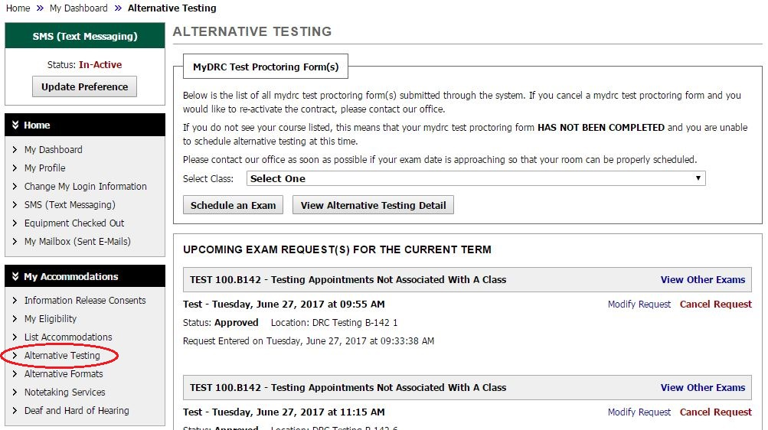
Once logged in you will want to select “Alternative Testing” from the left-hand menu (as shown below) and you should arrive at a page that looks similar to this:
This is the same page you navigate to when creating an Exam Request. Instead of dealing with the box labeled “MyDRC Test Proctoring Form(s)” however, we will be dealing with “Upcoming Exam Request(s) For The Current Term”. This lists all Exam Requests made by you or on your behalf by the DRC for the current term for all of your classes.
They are listed by date, so to find the right request you need to identify the date you made the appointment for first. This is listed in the exam detail box, which starts off with the Course Code and Name (here it’s “TEST 100.B142 – Testing Appointments Not Associated With A Class”).
If you remember what class you made the request for and only want to look through those requests, you can click the “View Other Exams” link and it will only show exam requests for that class.

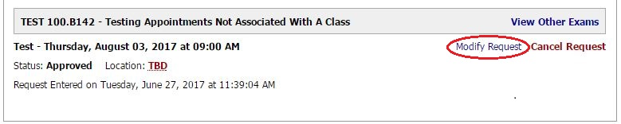
Now we’ll look a bit closer at the exam details:
Information included in the Exam Details:
- Course ID and Class Name
  - Also a link to see other Exam Requests for the same class (“View Other Exams”)
- Type of Exam (“Test”), Day, Date, and Time of Request
  - Other Types of Exam Include: Quiz, Lab, Midterm, and Final
- Request Status (“Approved”)
  - Other Statuses Include:
    - Pending: Usually occurs when a request is made late or modifications to the request are suggested by the DRC or Instructor
    - Cancelled: Usually when a student cancels a request or if the DRC cancels on the student’s behalf
    - Denied: Usually if the student requests late and the DRC cannot accommodate the request OR if the request does not meet with the Instructor’s scheduling parameters.
- Location (“TBD”)
  - Locations will usually be B-132 or B-142, which are the DRC Office and the DRC Testing Center respectively. Especially for Finals, other locations may be used as well.
  - Locations are programmed not to be shown too far in advance, as they may change.
- Date and Time Exam Request was originally made
- Links to Modify and Cancel this request
  - Each request has a modify and a cancel link that is unique to that specific request.

Modifying Exam Requests
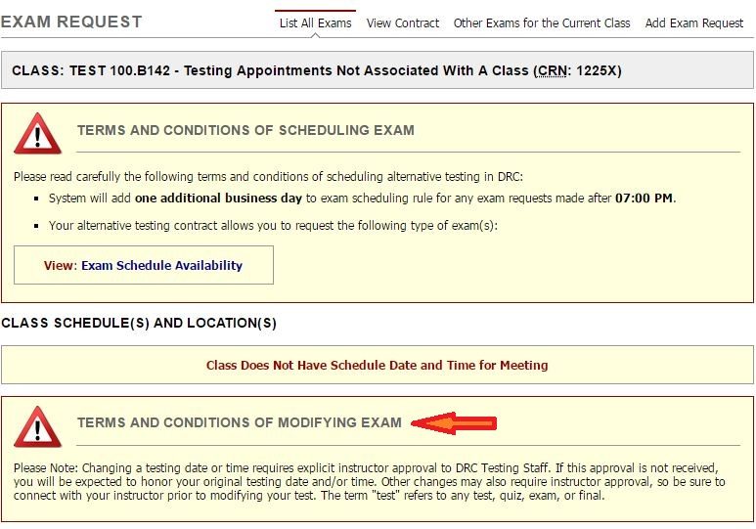
Clicking the circled Modify Request link takes you to a version of the Exam Request page. (For instructions on cancelling exams, jump ahead to the next section):

Terms and Conditions of Modifying Exam
Most of this was covered in the “Submitting Exam Request” Tutorial, but the last section is new. It informs you, the student, that any changes to the testing time or date may require explicit instructor approval to the DRC Testing Staff. Itds is the student’s responsibility to acquire or arrange for this approval to be delivered to the DRC.
If the DRC does not receive this approval from your instructor then you will be expected to test at either your originally requested time or at a time that has been approved by your instructor according to the MyDRC Test proctoring Form.

Exam Detail
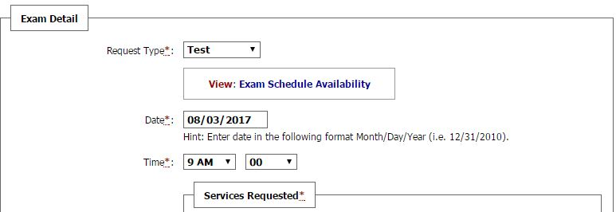
Next is the Exam Detail section:
Here you would adjust the type of test, date, or time of a request. You could also add or remove “Services Requested” (accommodations) as you felt you needed to.
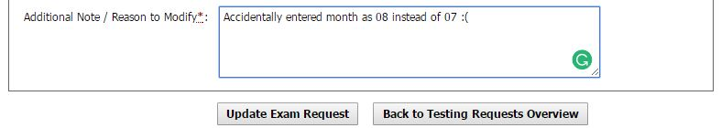
We recommend that you only request accommodations that you will need to us for any given test. For example: If you have “Computer for Essay Tests” accommodation and you know the test is all multiple choice it would be best not to select that accommodation so the Testing Staff don’t take the time to get a computer set up that you won’ need to use. If the Instructor decided to add essay questions, however, you could access your Exam Request and modify it to add that accommodation so we would know to have a computer ready for you.
The last part of the exam detail is the additional notes/reason to modify:
Here you would include any instructions to clarify why you need to modify the previously submitted exam request. Note that it is marked with a red asterisk (*) so it is a required field – something must be entered in the text box in order for the form to be accepted.
If you do not wish to make any changes, click the “Back to Testing Requests Overview” button will take you back to the previous page.
Clicking the “Update Exam Request” button will submit your changes to the DRC for approval.
Doing so takes you back to the Alternative Testing page where the above “System Update is Successful” banner will be displayed at the top of the screen.

Changes Pending Approval
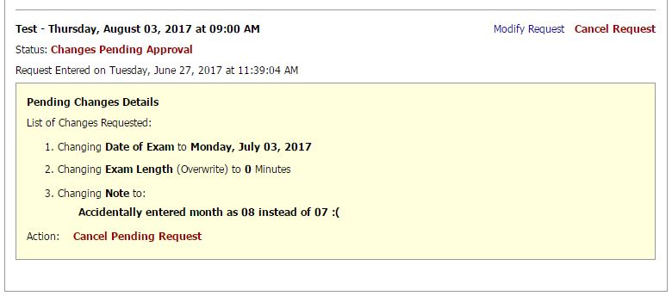
Most of the Alternative Testing screen looks the same, except for the Exam Request just modified:
You’ll notice several differences from the exam request first examined above:
- First, the status has been updated to: Changes Pending Approval
- Second, the addition of the pale yellow Pending Changes Details Box:
  - This box lists all of the changes made to the previous request. So the changes we made:
    - Changed the date from August 8th to July 8th
      - Notice we didn’t change the time so it stayed the same
    - Changed the Exam Length (we actually didn’t change anything, but since we left the field blank it reads this as a zero, which will be fixed once a test is added)
    - Added a Note explaining we accidentally entered the wrong date
- Finally, at the bottom of the Pending Changes Details box is an “Action” link to “Cancel Pending Request” which will undo all of the changes requested and reset the exam request to its prior state.
The exam request will remain in this state until a DRC Staff member approves the changes requested. Depending on the nature of the changes DRC Staff may be able to approve the request on their own or may have to wait on confirmation from the instructor that requested changes are acceptable.

Changes Approved
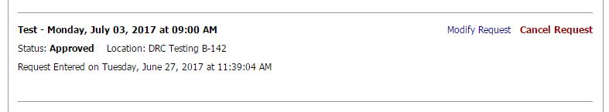
Once changes have been approved the Exam Request will return to the same formatting as the rest:
You will also receive email notification that your Modify Request was approved. The email, too, lists out the changes submitted for the exam request.
If your request is denied, it will return to its previous state before the request was submitted. You will also receive an email informing you that the Modify Request was denied and it will suggest that you contact the DRC for more information on why it was denied.

Cancelling Exam Requests
The process for cancelling a test is extremely similar to modifying one, but less involved. There are some unique concerns in this process, however. One of these concerns needs to be addressed immediately, before we go any further because it is so important you need to know about it before you know how to actually cancel an exam:

If you cancel an exam request you will NOT be allowed to make any other exam requests for that class on that day!

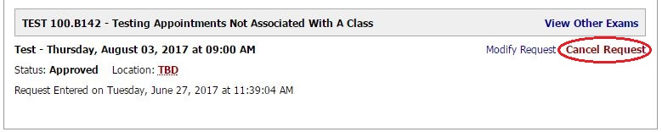
So, before cancelling any requests be doubly sure that the issue can’t be solved by modifying the request instead – this is the much safer option. To proceed with the Cancel Request process, navigate to the Alternative Testing screen and select Cancel Request option on the desired Exam Request:
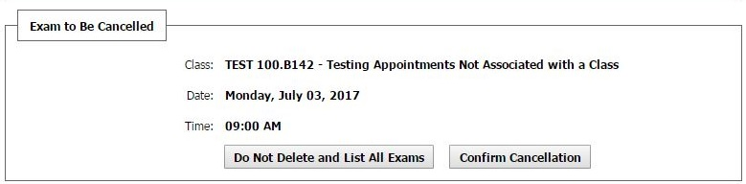
Doing so will take you to the Exam Request page, seen above in “Modifying Exam Requests” with one major difference. There is no “Exam Detail” box; instead this has been replaced with a box titled “Exam to Be Cancelled” that has all of the details of the potentially cancelled exam:
After you verify the details of the Exam, click the “Confirm Cancellation” button to cancel the exam or the “Do Not Delete and List All Exams” button to return to the Alternative Testing page.

Cancellation Pending Approval
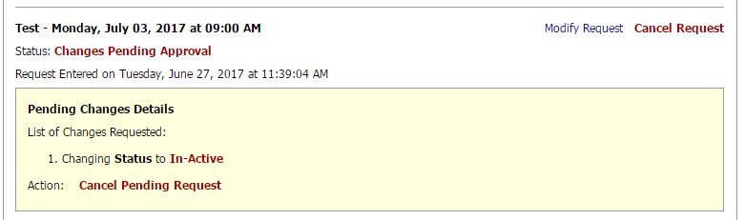
If you hit the “Confirm Cancellation” Button you will once again be redirected back to the Alternative Testing page with the “Success” banner at the top:
Scrolling down to the exam request you will find one appointment that looks different:
Like the Modifying Request, the Cancel Request has a few differences from the exam request first examined above:
- First, the status has been updated to: Changes Pending Approval
- Second, the addition of the pale yellow Pending Changes Details Box:
  - For Cancel Request, only one change is listed:
    - Changing Status to In-Active
- Finally, at the bottom of the Pending Changes Details box is an “Action” link to “Cancel Pending Request” which will undo the request to cancel this exam and reset it to its prior state.
The exam request will remain in this state until a DRC Staff member approves the cancellation. Usually the instructor is not consulted for this type of request.

Cancel Request Approved
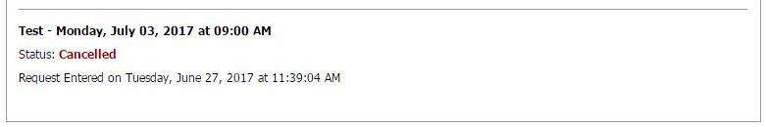
Once the Cancel Request has been approved the exam request will return to a familiar format:
You will also receive an email that the request has been cancelled, though the email wording will say that “changes have been approved”, which can be confusing. Unfortunately this wording is not part of the template that we can change so it’s best that whenever such an email is received you log-in to MyDRC and check your Alternative Testing page to see what has happened with your requests.

Summation and Questions
So in this tutorial we covered how to view your exam requests, how to modify exam requests, and how to cancel exam requests. We also discussed that modifications to time and date on exam requests may require instructor approval in order for DRC Staff to approve them Additionally, we learned that when you cancel an exam request MyDRC creates block that prevents you from making any further exam requests for that specific class on that one date, so cancel with care.
If you have any questions about anything in this tutorial, MyDRC, or anything Disability related, feel free to connect with us:
Campus Office B-132
DRC Testing B-142
Phone: 425-564-2498
Fax: 425-564-4138
TTY: 425-564-4110
Skype for ASL: DRCatBC
Email: drc@bellevuecollege.edu
https://www.bellevuecollege.edu/drc

