How to Submit an Exam Request in MyDRC
  - A Tutorial for Bellevue College Students from the Disability Resource Center

Introduction
  - How do I schedule an exam appointment at the DRC or DRC Testing Center?
The Disability Resource Center (DRC) is introducing a new feature for students who have Alternative Testing Accommodations that allow them to take exams with the DRC. These students will now be able to schedule their testing appointments online using the MyDRC system. This eliminates the need for students to fill out a green “Proctor Request Form” for every test – instead the instructor completes the MyDRC Test Proctoring Form with all of the information for their tests for the entire quarter and the student is only responsible for scheduling tests.
When the student schedules a test MyDRC will automatically send a notification to their instructor, informing them of the need to supply the DRC with a test for the student’s appointment.
This tutorial will walk you through scheduling tests - in MyDRC it is called “Submit Exam Request”.
For more information on MyDRC, please see the MyDRC User Guide on the DRC website.

The Alternative Testing Page
  - Where do I find the exam request form online?
Start off by logging in to your MyDRC account. If you are unsure how to do so, please see the tutorial on “How to Log In to the MyDRC System” available in the MyDRC User Guide.
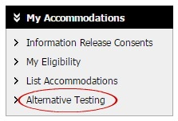
Once you have logged into your MyDRC account and arrived at your MyDRC dashboard, you will need to go to the Alternative Testing page. A link to this page can be found in the navigation menus on the left side of the dashboard; underneath the “My Accommodations” heading, you may need to click the heading to expand the menu:
Clicking on this link will take you to the Alternative Testing overview page:

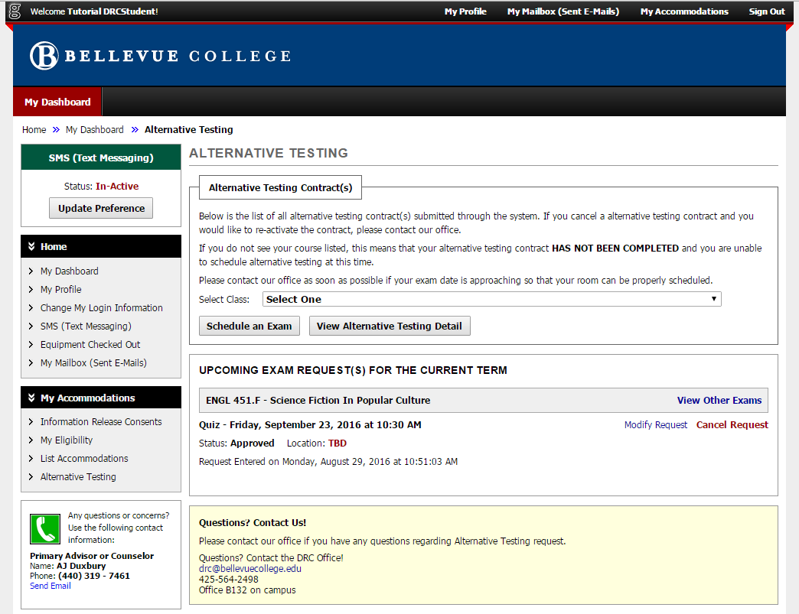
Review Your Alternative Testing Contract
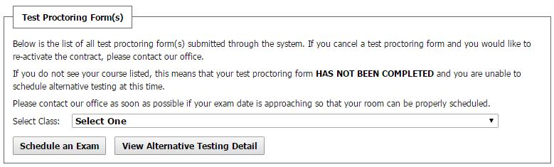
Before you submit your exam appointment request, you may want to review the information contained in the MyDRC Test Proctoring Form your instructor filed with the DRC. This information can be found by going to the box at the top of the page labeled “Test Proctoring Form(s).”
NOTE: Please read the Test Proctoring Form(s) box carefully – if a course is not listed in the “Select Class:” drop-down menu it means that your instructor has not yet completed the proctoring form for that course and you will be unable to schedule tests through MyDRC. If this is the case, please contact your instructor directly before contacting the DRC. For Winter 2017 instructors still have the option to use the Green Proctor Forms for testing with the DRC. It is up to faculty discretion, though they should take student concerns into account as well.
(If you don’t wish to review the MyDRC Test Proctoring Form, you can skip ahead to the section of the tutorial titled “Go to the Exam Request Form.”)
In the “Test Proctoring Form(s)” box, select the class you want to view the contract for from the drop-down menu, then click on the button labeled “View Alternative Testing Detail.”
This will take you to a page where you can review all the information on the proctoring form for the class, including the questions asked by the DRC and the instructor’s responses. This will include all the information about how the instructor would like their tests to be administered by the DRC including items students are allowed to use, testing deadlines, and other information.
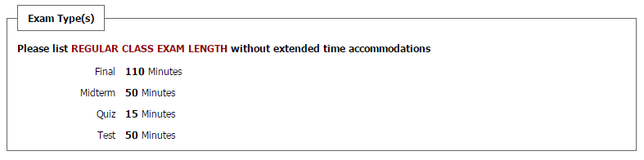
Pay special attention to the box labeled “Exam Type(s)” near the bottom of the page:
This box will list out the amount of time the instructor will give the class for each type of exam, as in the example above. The times listed are how long the class will receive and do not account for any extended time accommodations.
If you have any questions or concerns about the information provided by your instructor on the MyDRC Test Proctoring Form, please contact your instructor directly before contacting the DRC.
Once you have reviewed this information, move on to scheduling your exam appointment.

Go to the Exam Request Form
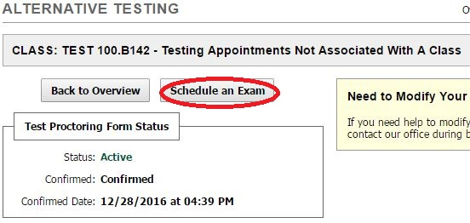
If you chose to review the MyTest Proctoring Form, there will be a button labeled “Schedule an Exam” located near the top of the page.
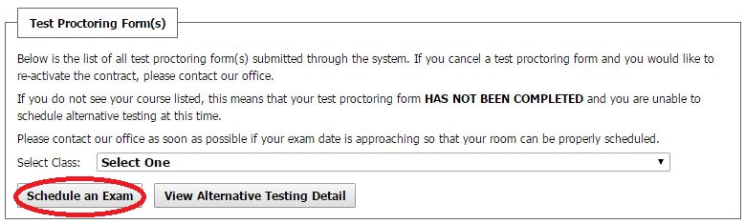
If you did not review the Test Proctoring Form, you can access the Exam Request form from the Overview page. In the box labeled “Test Proctoring Form(s),” select the class you want to schedule an exam for from the drop-down menu, then click on the button labeled “Schedule an Exam.”

Schedule an Exam
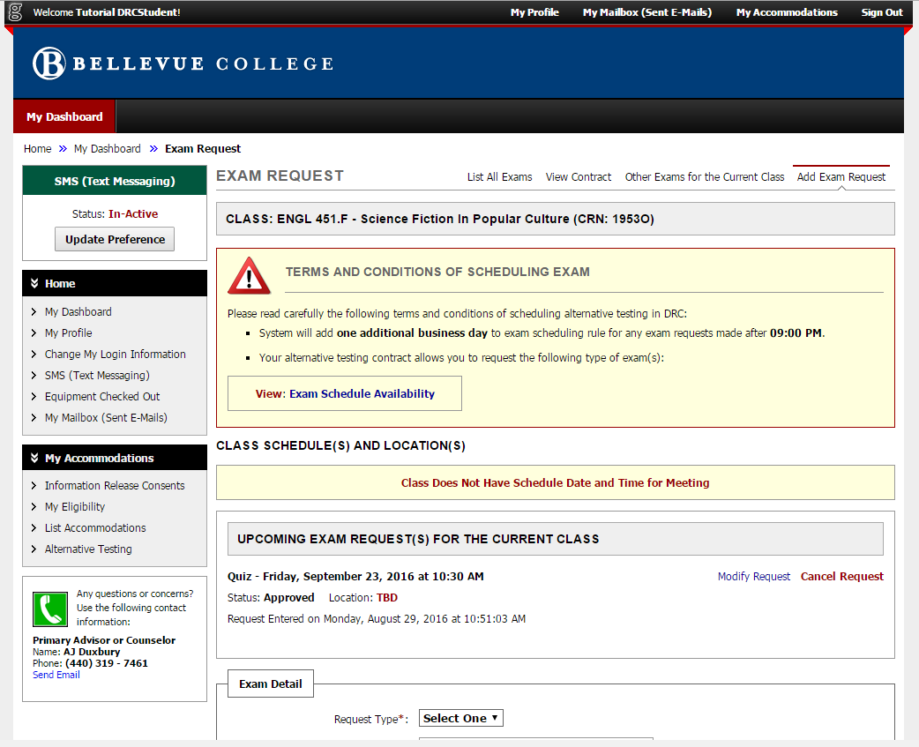
  - How do I fill out the Exam Request form?
There’s a lot of information on the Exam Request page, which might make it seem complicated and overwhelming at first. But the rest of this tutorial will walk you through the page section-by-section so that you know what each section means and how to properly fill out the form.

Terms and Conditions of Scheduling an Exam
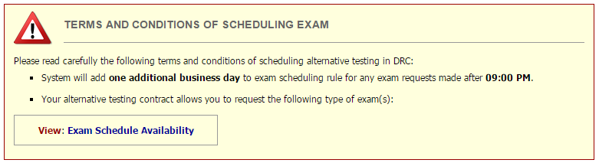
Before you get started filling out the Exam Request form, be sure to read over the Terms and Conditions section in the yellow box at the top of the page.
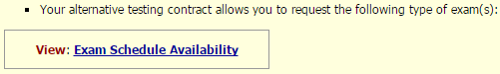
The second bullet point in the list states that you are allowed to request certain types of exams. Those exam types (e.g. final, midterm, test, or quiz) are listed in the Exam Schedule Availability table which is linked at the bottom of the Terms and Conditions box.
Click on this link, since you will need to review the table before filling out the rest of the form. It will open in a new tab in your browser.

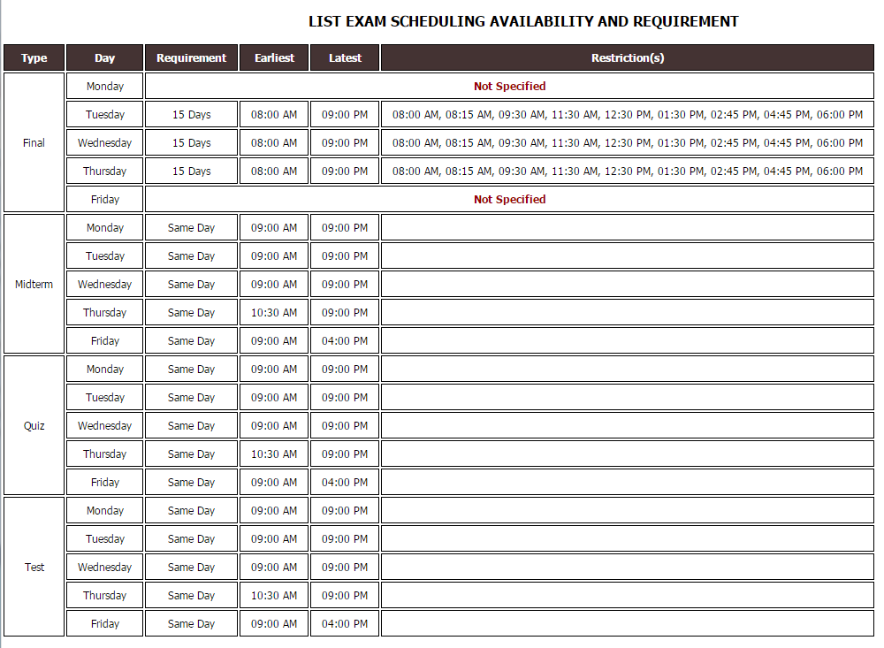
Exam Schedule Availability Table
The table is made up of six columns: Type, Day, Requirement, Earliest, Latest, and Restriction(s).
- Type: The types of exams you are allowed to request are listed in this first column, and may include Finals, Midterms, Quizzes, and Tests.
- Day: The second column lists the days of the week on which you are able to schedule each type of exam.
- Requirement: The requirement column lists how far in advance you need to schedule that type of exam. Please note that while you can schedule most exams on the same day, we prefer that you try to schedule at least 48 hours in advance whenever possible. Finals need to be scheduled at least 15 days in advance.
- Earliest: This column lists the earliest time that you may begin an exam with the DRC.
- Latest: This column lists the time by which your exam with the DRC must be completed.
- Restrictions: Currently, the information in the restrictions column applies only to Finals. The times you enter on your exam requests for finals must match one of the times listed in the requirements column. For example, if you try to schedule a test for 9AM it will be rejected.
After reviewing the information in the Exam Schedule Availability table, you can return to the Exam Request form. You may find it helpful to leave the table open in your browser to review as needed while filling out the rest of the form.

Class Schedule(s) and Location(s)
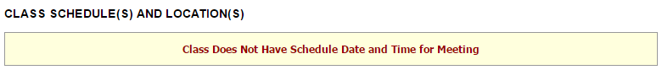
The next portion of the Exam Request form will list the days and times class meets each week, for the class that you are requesting an exam.
The example in the image above shows what this section will look like for online classes or classes without specified dates, times, and locations listed in the MyDRC system.
If you are scheduling an exam for a class that meets on campus, be sure to look at this section, since your exam appointment should generally overlap with the class period.

Upcoming Exam Request(s)
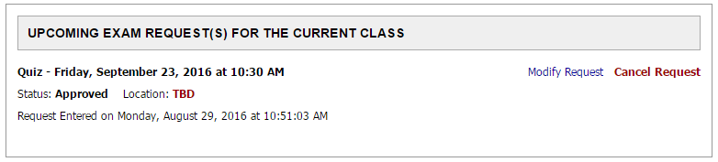
The next section of the form lists any exams that you have already requested for the class.
It will show the Type of exam and the date and time it is scheduled for. This section will also show the status of the exam request (whether or not it has been approved), where you will be taking the exam, and when the request was submitted.
On the right side of the box there are also links to modify the Exam Request or cancel it altogether. Further information about modifying exam requests will be presented in a different tutorial in the MyDRC User Guide.
NOTE: If you choose to cancel your Exam Request, you will no longer be able to request an exam for that same class on that same day.

Exam Detail
The Exam Detail box is the final section of the form and it’s where you enter all of the request information.
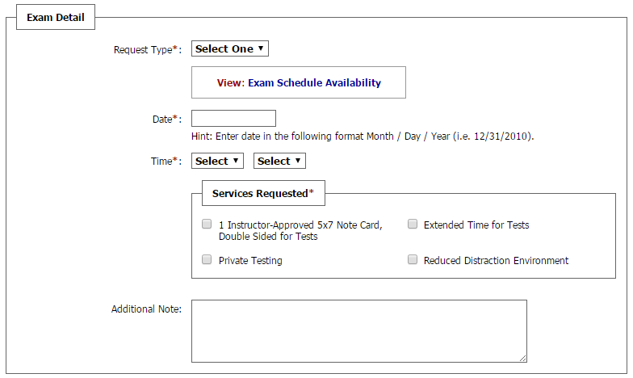
When filling out this section of the form, please note that any part marked with an asterisk (*) is required information and must be included in order for the form to be accepted.
- Request Type*: Select the type of exam from the drop-down menu. If you aren’t sure what kind of exam it is, just select the “Test” option.
  - A link to the Exam Schedule Availability Table is included again here. Again, it will open in a separate tab in case you need to refer to it.
- Date*: Enter the date you want to take the test. Be sure to follow the formatting guidelines provided on the form.
- Time*: Enter the time you want to start taking your exam. Be sure to double check the Exam Schedule Availability table for any time restrictions. Note that generally exams are started on the hour or half-hour.
- Services Requested*: This box only lists your approved testing accommodations. Please select all of the accommodations you want to use for this test. NOTE: Only the selected accommodations will appear on the Exam Request sent to both your instructor and the DRC. If you select an accommodation it will be assumed that you will use it, if you do not select one it will be assumed that you do not wish to use it.
- Additional Note: This note goes to the DRC, so if you have any questions for us about testing procedures or if there are other services or supplies you need that you don’t see listed in your accommodations (e.g. a computer, a calculator) then you can enter that here. You can also list other approved accommodations you may need for testing (e.g. adaptive furniture) that aren’t specifically testing related and thus not listed.

Submit the Exam Request Form
Take a moment to look over the information you have entered to verify that it is complete and accurate.
To submit your Exam Request, click on the button labeled “Add Exam Request” near the bottom of the page.
NOTE: Be sure to click on the “Add Exam Request” button on the left (circled in red in the above image). If you click the “Back to Testing Requests Overview” button, you will be returned to the Overview page and your Exam Request will NOT be submitted.

Finishing Up
  - What happens after I submit the Exam Request form?
Once you click on the “Add Exam Request” button, the browser will reload the Exam Request page and a box stating “System Update is Successful” will appear near the top of the page.
Additionally, your Exam Request will now appear in the box for “Upcoming Exam Request(s) for the Current Class,” and its status will be listed as “Processing” or “Approved” depending on a few factors.
This confirms that your Exam Request has been sent to the DRC, where it will be either approved or denied. If your Request is approved, the DRC will send a confirmation e-mail to both you and your instructor. If your Request is denied, the DRC will e-mail you an explanation of why it was denied, and instructions to either reschedule, submit a new request, or to modify the original.
For instructions on “How to Modify an Exam Request” or “How to Reschedule an Exam,” please see the tutorials with those titles located in the MyDRC User Guide.

