Uploading Exams to MyDRC and/or Adding Instructions
  - A Tutorial for Bellevue College Faculty from the Disability Resource Center

Introduction
  - Where do I upload an exam or add testing instructions online?
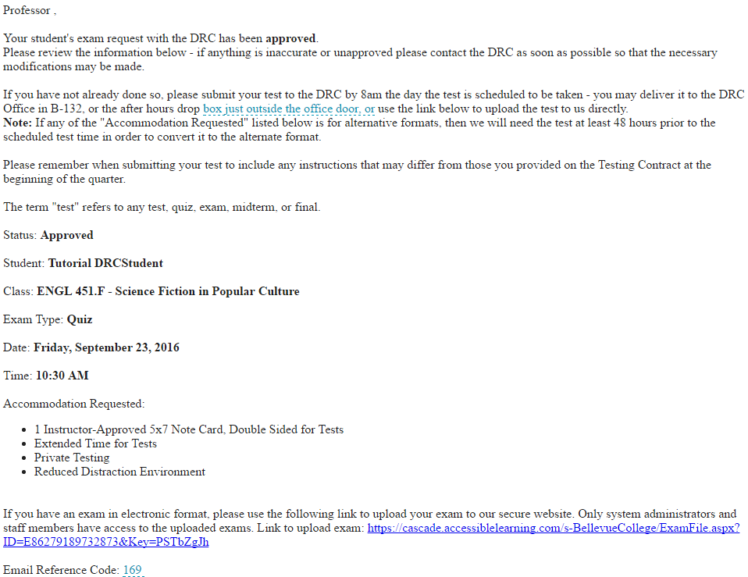
If one of your students has submitted an Exam Request that has been approved by the DRC, you will receive an e-mail similar to the following:
The e-mail will contain the status of the test (Pending or Approved), the name of the student who has requested the test, the class the test is for, the type of test, the date and time the test is scheduled to be taken with the DRC, and a list of the testing accommodations requested by the student.
If you have an electronic format of the exam that has been requested by the student and you would like to upload it directly to MyDRC, this e-mail will contain a link that will allow you to do so. This same link will also take you to a page where you can add supplemental or alternative instructions for this one test. Though you can do both items from the same page, it is not necessary to do both – MyDRC will let you do either of these options successfully!
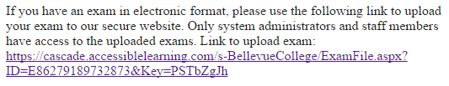
The upload link can be found near the bottom of the e-mail:

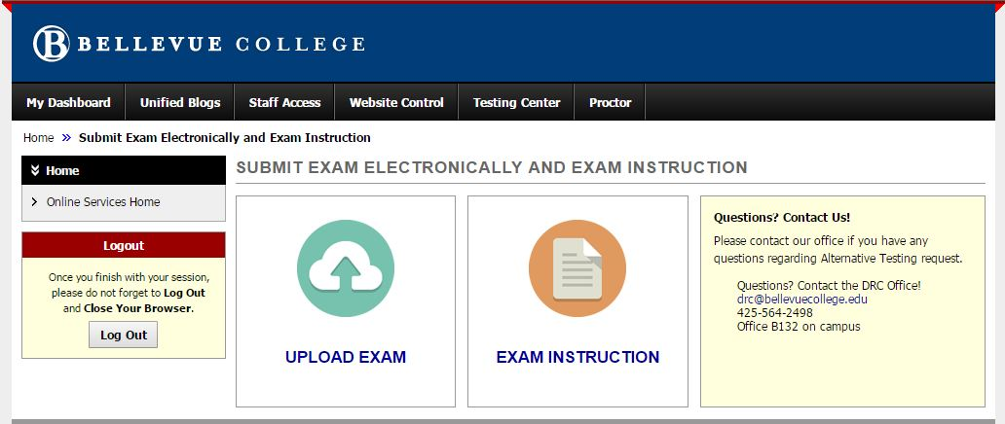
Submit Exam Electronically and Exam Instruction
Once you’ve clicked on the link in the email you should be taken to a webpage that looks similar to the one above. You may also reach the generic Bellevue College Single Sign-On page with a picture of the Bellevue College fountain on 2/3 of the screen that asks for your BC Email and Password on the right-side. If you reach any other webpage, especially one that looks similar to the page above but asks for you to log-in, try closing all browser tabs and selecting the link again. If issues persist contact the DRC for troubleshooting assistance.
Once you’ve reached this page you’ll be able to upload an exam, add instructions to an existing MyDRC Test Proctoring Form (either as additional or alternate instructions), or both!
- If you want instructions on how to upload an exam continue on with the next step.
- If you want instructions on how to add exam instructions, skip ahead to…..
- If you would like both you can start at either place! Completing one will automatically bring you back to this screen!

Submit Exam Electronically
  - How do I upload the exam file?
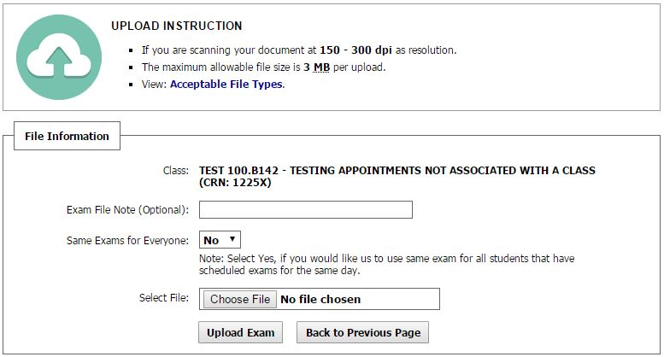
Clicking on the “Upload Exam” box pictured above will take you to the following page in the MyDRC system, where you will be able to upload the exam file.

Upload Instructions and File Information
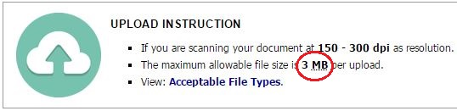
Before you begin uploading your exam file, be sure to review the Upload Instructions provided at the top of the page. This list will provide you with guidelines on the correct file sizes and formats to use. Please take note of the maximum allowable file size – it has been increased to 3 MB but that is still a fairly small file size, especially for some files. The DRC recommends converting some files (such as PPT into PDF) in order to conserve size if they are going to be uploaded.

Clicking on the link in the third bullet point will open a new tab in your browser that displays the following list of acceptable file types.
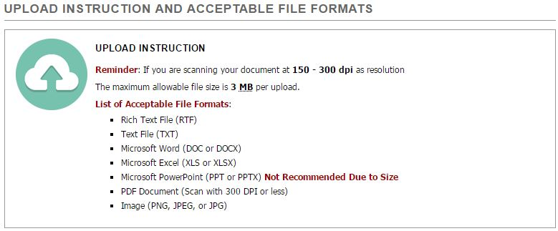
Acceptable file formats for exams are: Rich Text File (RTF), Text File (TXT), Microsoft Word (DOC or DOCX), Microsoft Excel (XLS or XLSX), Microsoft PowerPoint (PPT or PPTX), PDF Document (scan with 300 DPI or less), or Image (PNG, JPEG, JPG).
NOTE: The DRC does not recommend attempting to upload PowerPoint files due to their size.
Once you have reviewed these instructions and the list of acceptable file formats, you may close the tab and return to the upload page.

File Information
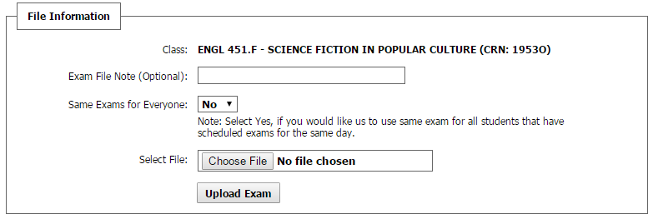
The next section of the file upload page is the File Information box.
Class: The class the exam is for will be listed at the top of the File Information box.
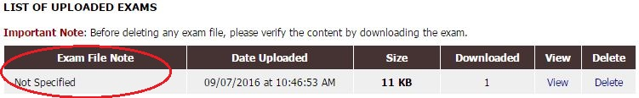
Exam File Note (Optional): Please use this box to give the file a descriptive name. This is what will appear when the DRC accesses the “List of Uploaded Exams” and so an accurate name will be helpful when the DRC needs to locate exams. Below is an example of an uploaded exam with the “Exam File Note” box left blank:
Same Exams for Everyone: If multiple students from this class will be taking the test at the DRC and you would like to use the same exam file for all of them, select “Yes” from the drop-down menu. This will automatically “upload” duplicate copies of the exam to their appointments as well meaning that you only need to do one upload for multiple students! NOTE: This only applies for the same section of a course (e.g. NUTR 100.A) so multiple sections will require multiple uploads OR a note to the DRC to use the same exam.
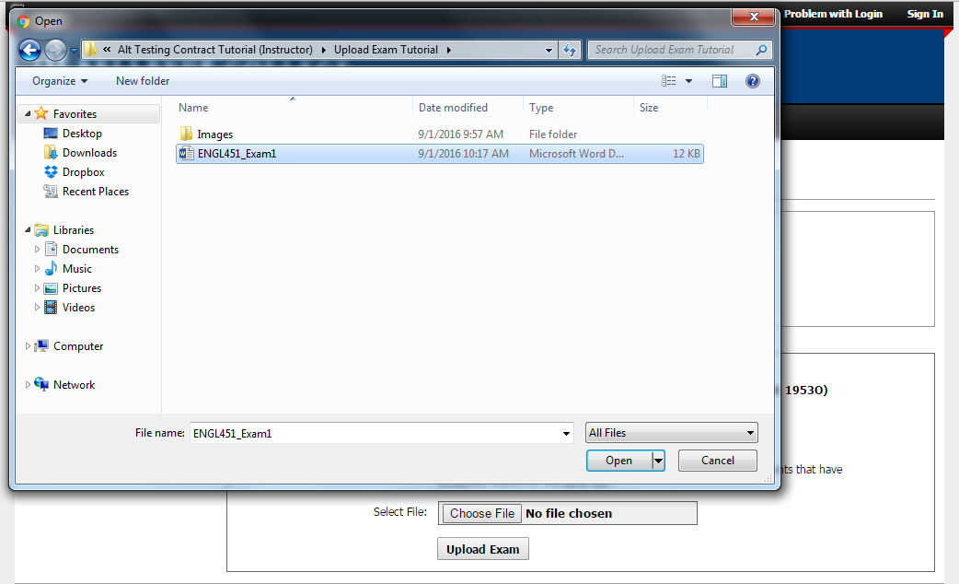
Select File: Click on the “Choose File” button to open the file explorer and browse through your files.
Once you have selected the correct exam file, press the Enter/Return key on your keyboard or click on the “Open” button in the file explorer, and the file will be uploaded to the page. The name of the file will now be listed in the text box next to “Select File.”

Finishing Up
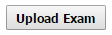
Take a moment to look over the page and verify that you have selected the correct exam file, and that all the information you have entered is accurate. Then, click on the button labeled “Upload Exam” located at the bottom of the File Information box to submit it to the DRC.
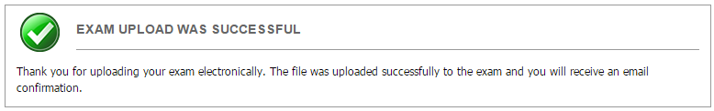
Once you click the button, your browser will reload the page. A message confirming that your file was successfully uploaded will display in a box near the top of the page.
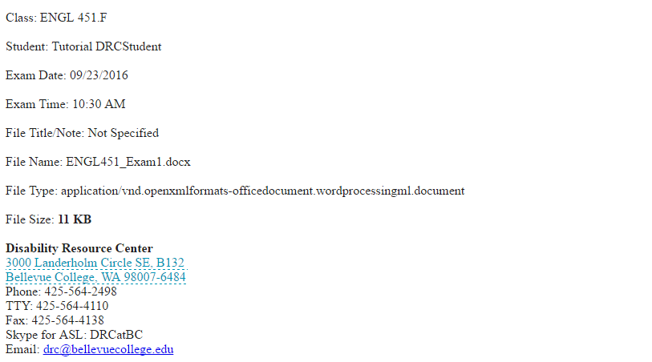
You will also receive an e-mail from the DRC confirming that your exam has been received. That e-mail will look similar to the following:
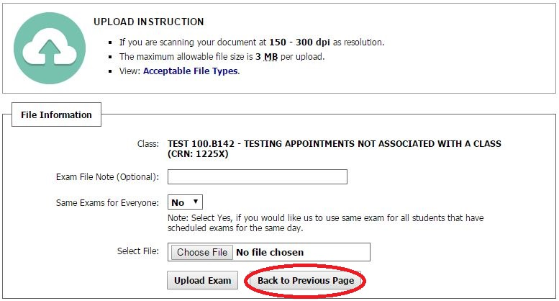
If you need to upload more files please repeat the upload process for each of those files. You can upload five (5) files per upload link, one at a time. Once you have completed uploading files, if you have no testing instructions to add click “Sign Out” in the upper right hand corner. Otherwise click the “Back to Previous Page” button:
to be returned to the “Submit Exam Electronically and Exam Instruction Screen” and then click on the “Exam Instruction” Box (see above).

Exam Instruction
Below is an image of the exam instruction page. If you reach a page that looks significantly different than this hit the back button and try clicking the “Exam Instruction” box again. If issues persist, contact the DRC for assistance.
If you reach a similar but not identical page, it’s possible we’ve updated the database but not the tutorial.
The introduction box at the top reads:
Instructor,
Please answer the few questions below to verify there are no additional instructions for this test. When complete, please upload your test.
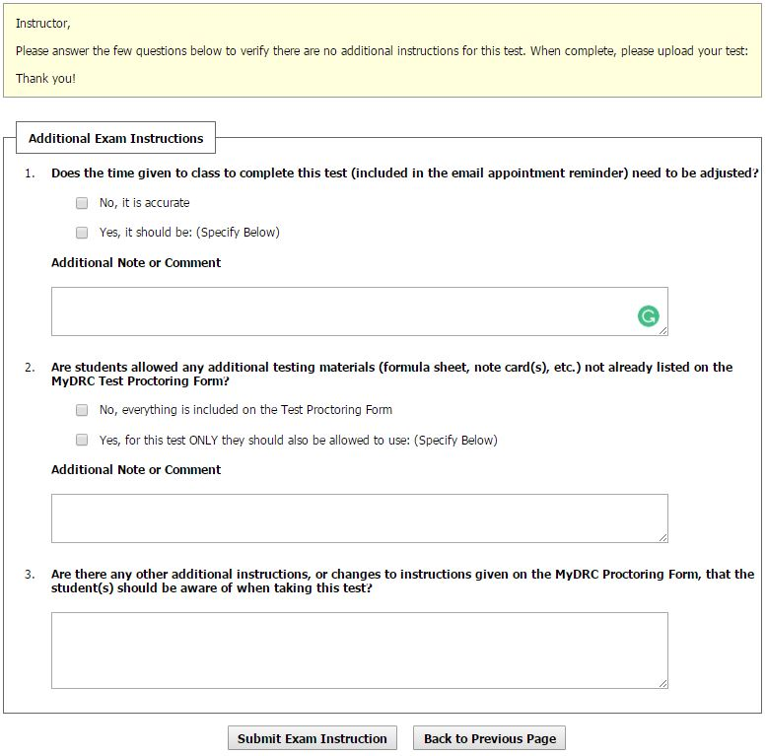
Thank You!

Additional Exam Instructions
Currently there are three additional exam instruction questions; please complete all three even if only one or two apply.
- Does the time given to class to complete this test (included in the email appointment reminder) need to be adjusted?
If the test time in either the Testing Appointment Approval email or the Appointment Reminder email is accurate, then click the box next to “No, it is accurate” and move on to question #2.
If you would like to adjust the time, click the box next to “Yes, it should be: (Specify Below)” and specify the amount of time the CLASS will receive in the text box.
If you select “Yes”, you must enter something into the text box in order for the form to be accepted.
- Are students allowed any additional testing materials (formula sheet, note card(s), etc.) not already listed on the MyDRC Test Proctoring Form?
If no changes to allowed materials is to be made, select “No, everything is included on the Test Proctoring Form”
If you would like to allow them to use something for this test and only this one test, then select “Yes, for this test ONLY they should also be allowed to use: (Specify Below)”
If you select “Yes”, you must enter something into the text box in order for the form to be accepted.
NOTE: If you would like to PERMANENTLY change the allowed testing materials on the MyDRC Test Proctoring Form, please contact the DRC.
NOTE 2: This can also be used to DISALLOW additional testing materials (e.g. NO calculators for this test)
- Are there any other additional instructions, or changes to instructions given on the MyDRC Test Proctoring Form, that the student(s) should be aware of when taking this test?
Please include any additional or changes to instructions or clarifications in this space.
You must enter something into the text box in order for the form to be accepted.
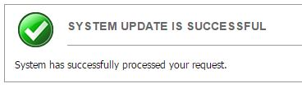
Once you have completed filling out the Addition Exam Instructions Form, click the “Submit Exam Instruction” button to add these instructions to the student’s testing appointment and return to the previous screen. This time you should see the green “Success” banner at the top:
Please Note: Make sure that your instructions are accurate before hitting the submit button – this can only be performed once per link (so once per student test). Once you hit submit changes cannot be undone; returning to the Exam Instruction screen only allows you to view changes made, not change them again.
Also Note: Unlike the Exam Upload which can be applied to all students, these instructions will be applied ONLY to the one student whose appointment notification or reminder link you used to access the exam upload/instruction page.

Replacement Exam
  - What if I need replace an exam I have already uploaded with a different one?
If you have already uploaded an exam to the system, but need to replace it with a different one, please follow the previous steps for uploading an exam. Then contact the DRC directly to let us know which copy of the exam to use and which to ignore.
You can also leave comments, when uploading an exam, in the “Exam File Note” text box that make it clear which test we are to use and which we are to ignore.

Testing Request Reminder E-mail
  - What should I do if I receive a Testing Request Reminder?
The DRC may send out an email reminding you to deliver a test before the student is scheduled to complete the exam. This email may will probably be sent out with the best of intentions, but may end up being sent out erroneously. If you receive a reminder to deliver a test to the DRC that you have already delivered, you may want to check in with us just to make sure that we have received it – usually it just hasn’t made it to our proctor yet.
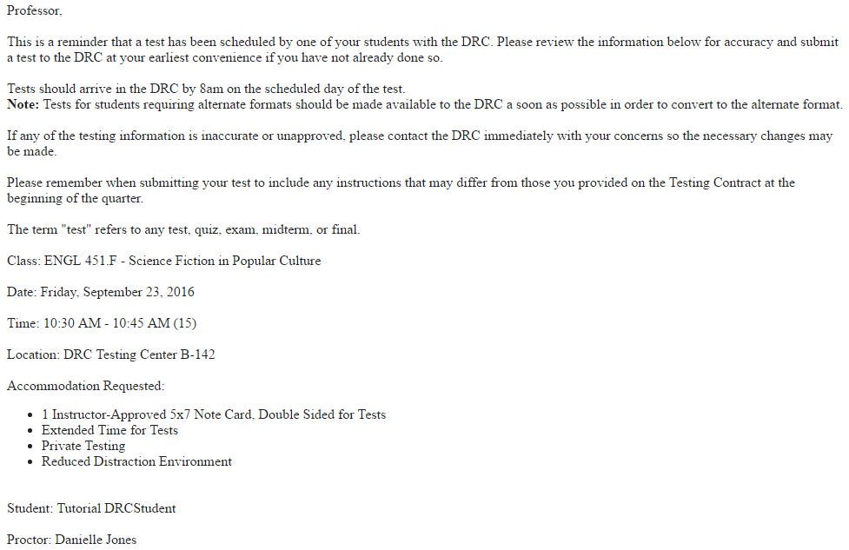
However, a reminder email can be very helpful to some instructors. Especially when testing appointments may be made several weeks in advance. That reminder email will look similar to the following:
The first part of the e-mail will remind the instructor of which exam the DRC is requesting, when and where the student is scheduled to take it, and what testing accommodations the student has. If any of this information appears to be wrong, please contact the DRC so that we can get on the same page.
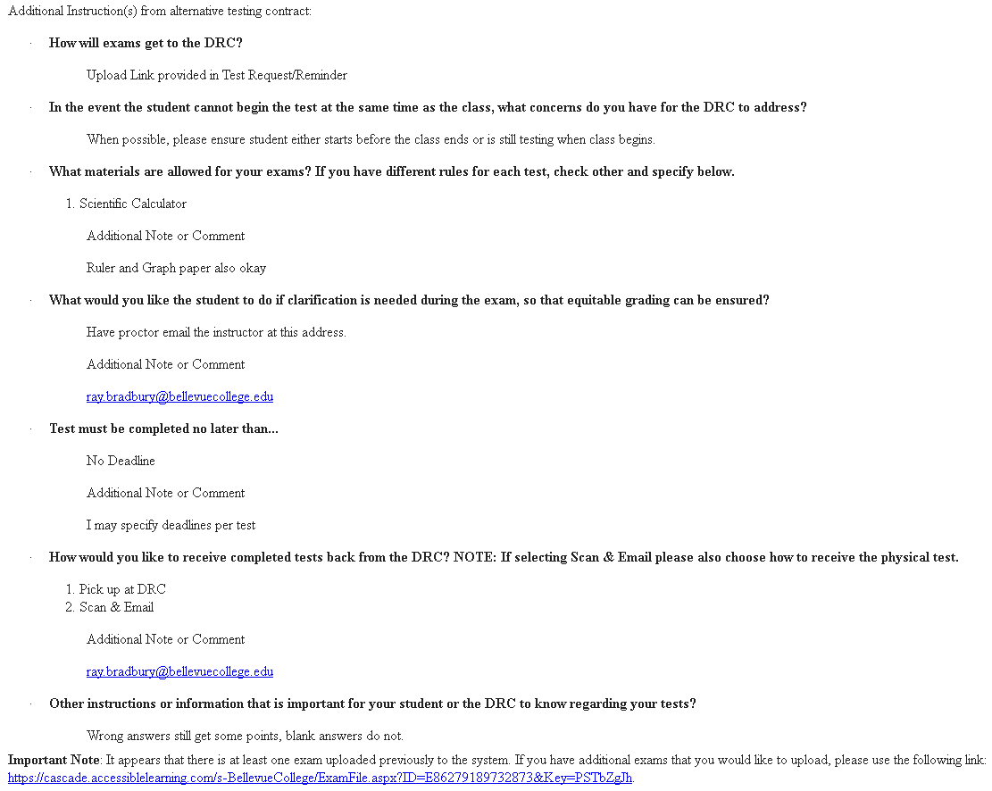
The reminder email will also include a copy of the MyDRC Test Proctoring Form along with the answers that you provided:
(For more information on the Proctoring Form, please see the tutorial titled “How to Fill Out the MyDRC Test Proctoring Form” available in the MyDRC User Guide.)

Previously Uploaded Exams
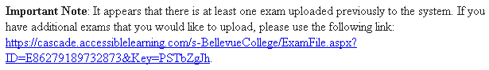
If you have previously uploaded any exams to MyDRC for this specific exam, this will be noted near the bottom of the reminder e-mail:
This note will also include an additional link to upload exams to MyDRC.
If you need to double-check which exams you have already uploaded, please review any exam upload confirmation e-mails you have received from the DRC, or contact the DRC directly and we can look up a list of files you have already uploaded for you.

Exceptions or Alterations to the MyDRC Test Proctoring Form

Exceptions
If you provide the DRC with a test that has parameters that differ from the MyDRC Test Proctoring Form you completed at the beginning of the quarter, the DRC advises:
- Complete the “Exam Instruction” segment of the Exam Upload as outlined above; or
- Include a supplemental instruction sheet in your test as part of the Exam upload; or
- Contact the DRC directly to inform us how the test instructions differ from those on file

Alterations
If, at any time during the quarter, adjustments need to be made to your MyDRC Test Proctoring Form, please contact the DRC and inform us of the changes. We will be able to update your instructions – for all students using that proctor form – in just a couple of minutes.
If you would like to fill out a new proctoring form, again contact us so that we can delete the existing one and send you a new link! We can be reached in the following ways:
Disability Resource Center
3000 Landerholm Circle SE, B132
Bellevue College, WA 98007-6484
Phone: 425-564-2498
TTY: 425-564-4110
Fax: 425-564-4138
Skype for ASL: DRCatBC
Email: drc@bellevuecollege.edu

