Confirming a Notetaking Services Request
  - A INTRODUCTORY GUIDE TO THE MYDRC NOTETAKING SERVICES MODULE

Overview of Notetaking Services
Welcome to the Notetaking Services module of MyDRC! In this first tutorial for students we will explore why it is necessary to confirm a notetaker request for a class and how to do so. But first, a bit about the notetaking module itself! By utilizing the MyDRC Notetaker Services Module, you will:
- Choose which classes you receive notes from:
  - When requesting accommodations at the beginning of the quarter, students should be mindful to only select accommodations they will use for a given class. That being said, it is better to select an accommodation when it doubt and not use it than not select it and need to use it. However, there are some other reasons that once the class starts a student may choose not to make use of their notetaking accommodation, which we will discuss in more detail shortly.
- Be notified when a notetaker has been assigned to your class
  - Once a notetaker has been assigned to a course a student has CONFIRMED they would like to receive notes for MyDRC will send out an automated email to notify them of the notetaker assignment. This email is purely to inform the student that a notetaker has been assigned and provides only what class has been covered.
- Be alerted via text message when notes have been uploaded to MyDRC (if enrolled in the SMS feature[L])
  - When a notetaker has uploaded notes to MyDRC students in the class will receive an automated email from MyDRC to inform them that notes are ready. Any students who have opted in to the MyDRC SMS feature [L] will also receive a text message alert to inform them notes are ready to be viewed, downloaded, and/or printed.
- Be able to print notes uploaded to MyDRC from any computer
  - Any student who has had a notetaker accommodation previously knows how busy the DRC office can be, which is why this particular feature is so exciting – one feature of the notetaking services module is that students will be able to view, download, and/or print uploaded notes on any computer on campus, at home, or virtually anywhere else with internet access. DRC staff will also be able to monitor how often notetakers are uploading notes and how often students are accessing them.
- Rate the quality of the notes provided by your notetaker at the end of each quarter
  - Leading up to finals a feature in the Notetaking Services module will be turned on that will allow students to rate and provide feedback for the quality of the notes provided to them during the quarter for each of their classes. Guidelines and feedback suggestions will also be made available for students so that the DRC will have a set of standard criteria by which to judge the notetakers and the comments on their work during the quarter.
As you can see, the Notetaker Services module will streamline a lot of the notetaker processes in the DRC office and should make it much simpler and quicker for students with notetaking accommodations to receive their notes. It will also make it simpler for notetakers to deliver notes to students, and it will consolidate the processes of the DRC staff in recruiting and placing notetakers in classes. Like anything new, however, it’s going to take some time using it for everyone to get used to it and for all of the idiosyncrasies of the system to be smoothed out before it’s up and running at maximum efficiency.
So, that having been said let’s go ahead and start getting familiar with Notetaking Services!

Why Confirm Your Notetaking Services Request
At the beginning of each quarter in which notetaking accommodations have been requested, students will be required to confirm Notetaking Services for each of the courses requested. There are a few different reasons for this:
- Classes That Aren’t Classes
MyDRC syncs it’s class list with Bellevue College’s system every night in order to maintain up-to-date records for our students. Unfortunately, Bellevue College’s system uses some creative methods to track students who are enrolled in payment plans, veteran deferred tuition, or have to pay other fees such as English Assessment by enrolling them in “classes” that the student doesn’t actually attend or aren’t actually classes. Ideally, when requesting accommodations students should not be selecting accommodations for these “classes” but since it does happen here’s a second chance to let the DRC know that a notetaker will not be needed for some of them.
- Classes That are Non-Lecture Classes
Most (but not all) Non-Lecture Classes (PE, Art, Music, etc) will not require notetakers as the classes are usually performance/participation based and not as much based on tests, quizzes, and reports – the sorts of things that are traditionally regarded as good measurements of the student’s understanding of lectures (where notes come from).
- Instructor Provided Notes are Sufficient
If a student either has an accommodation for Instructor Provided Notes/Copies of Lecture Materials or if an instructor provides these materials on their own AND these materials are sufficient enough that the student does not also require an in-class notetaker, then the student can decline the Notetaking Services Request. NOTE: Just because an instructor provides notes to a student does not invalidate the student’s need for an in-class notetaker – this is up to the sole discretion of the student.
- No Longer Enrolled in Class
Unfortunately, it happens that plans change and with that comes schedule changes and the need drop classes. In such circumstances Notetaking Services would obviously not be necessary and the request could be declined.

How to Confirm a Notetaking Services Request
Now that we have seen why it is necessary for students to confirm their Notetaking Services requests, we will explore how to do that. There are two possible ways in which a student can provide confirmation:
- Logging in to MyDRC and selecting the “Confirm Now” next to classes in the Notetaking Services section of the student dashboard
- Responding to the confirmation reminder emails
  - The confirmation reminder emails also allow students to cancel a Notetaking Services request – something that is not available in MyDRC
Both of these options essentially work the same, but logging in to MyDRC will generally be available to students first. This is because the confirmation reminder emails are delayed until a couple of days into the quarter so that students can judge whether or not they actually need a notetaker before confirming their decision.
If you are unsure whether or not you will need a notetaker, it is would be best to wait until you receive the confirmation email to decide. If you’re still undecided at that point it is suggested to confirm the need for a notetaker as it is better to have access to notes and not use them or end up canceling them later than not have access to notes and need them.

Confirming via MyDRC
Just prior to the beginning of each quarter DRC staff will activate a feature that allows students to confirm the need for a notetaker for their classes. This can be done proactively by logging-in to MyDRC and visiting the Notetaker Services section of the student dashboard. The biggest advantage of this option is not having to wait until MyDRC sends out reminder emails to be able to confirm your notetaker need – the biggest drawback is that you may end up confirming a notetaker for a class which you later discover you may not need (for one reason or another). Also, there’s currently no simple way to cancel a Notetaking Services request via MyDRC.

Login to MyDRC
The first step will be to login to your MyDRC student dashboard, so in a web browser (Google Chrome is preferred) navigate to: https://cascade.accessiblelearning.com/bellevuecollege or use the link on the DRC website in the left sidebar menu labeled “MyDRC” in order to locate MyDRC. For detailed instructions on how to login, please see our tutorial on How to Login to MyDRC.
To protect data stored within the database, MyDRC will timeout after a period of inactivity of about 15-30 minutes. It’s best not to leave it open in a background tab or window as this will likely lead to needing to login in again and losing any work/progress. Instead, prepare everything you will need before logging in to MyDRC so it will be possible to work nearly continuously and remained logged-in until the task(s) is completed.

Overview and To Do List
Once logged in to MyDRC the student dashboard should be loaded and a page titled “Overview” should be loaded. If the page looks drastically different than the on below, try clicking the “My Dashboard” tab in the upper left corner if there are multiple tabs. The exception to this is if the student followed a link included in an email in which case they can skip ahead to the next step: Notetaking Services.
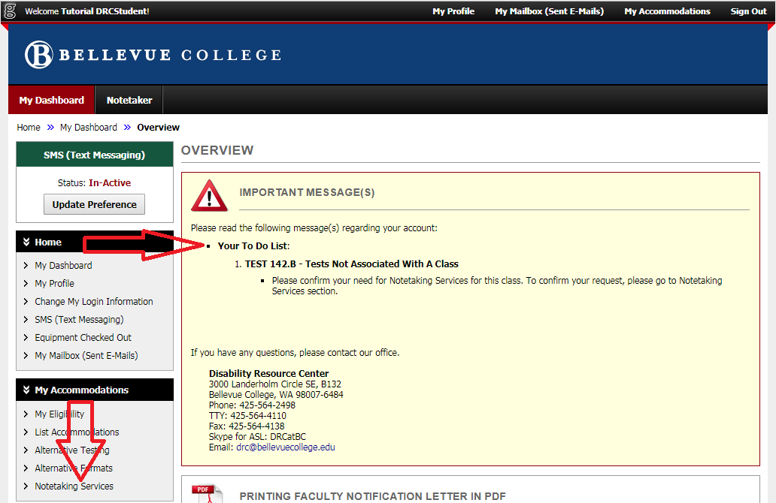
The student dashboard for most DRC students should look very similar to the following:
When logging in to MyDRC the student dashboard will always lead off with box entitled “Important Messages” which may include a “To Do List” depending on your accommodations and when during the quarter you login. Here we can see that the first large red arrow drawing our attention to the “To Do List” and it’s solitary item:
- TEST 142.B – Tests Not Associated With A Class
  - Please confirm your need for Notetaking Services for this class. To confirm your request, please go to Notetaking Services section.
Any additional classes also awaiting confirmation would be listed in the To Do List as well, but our Tutorial Student only has this one class.
The second large red arrow on the left side of the screen is point to the link for the Notetaking Services section – if it is not appearing in this area on your dashboard you may need to click the “My Accommodations” submenu heading to expand the list and make it available. Before continuing on to Notetaking Services, make sure all of the classes you want to use your notetaker accommodation for are listed in the To Do List. If not, select “List Accommodations” instead to view and modify your accommodation requests.

Notetaking Services
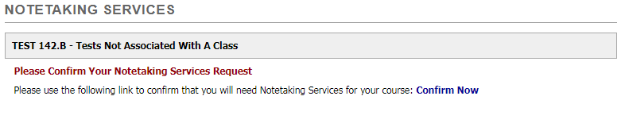
Clicking on the Notetaking Services link in the menu will take you to the section’s main page which looks different based on what stage of the process you’re in. When confirming a notetaking request, you’re just beginning the quarterly notetaking process and so the only option you’ll see on the page is a link to “Confirm Now” for each course that you have requested notetaking accommodations for:
If you have requested Notetaking Services for multiple classes you will see a list of classes instead of a single entry, but the process will be the same only repeated for each class. Clicking “Confirm Now” will take the student the next step in the process – if nothing happens when clicking the “Confirm Now” link then DRC staff has turned off the option that allows students to confirm their notetaker request. If this is DURING the quarter, this is probably a mistake and should be reported to the DRC. If it is prior to the start of the quarter then the DRC staff probably has not finished other necessary preparation before they are ready to for student confirmation.
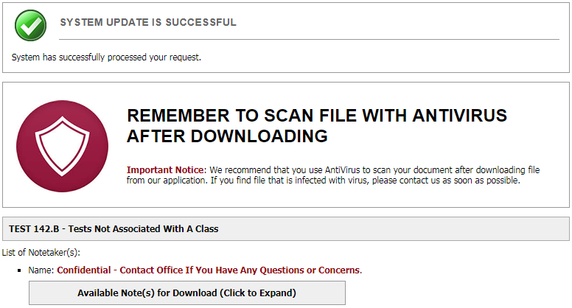
Ideally, when you click “Confirm Now” the page will reload and other than the static menus and header should look something like this:
The green circle around a white checkmark is MyDRC’s universal symbol of successful submission and that applies to Notetaking Services as well. Additionally, a warning about using antivirus software to scan downloads now appears. Below the name of the class it lists the name of the notetaker(s) – in this instance they’re confidential – and since notes have already been uploaded a button has appeared to allow them to be downloaded by the student.
Each of the classes will have a section that looks similar to this and other than the “System Update is Successful” message at the top this is how the Notetaking Services main page will look for the remainder of the quarter unless classes are added or dropped or Notetaking is suspended for one or more courses.

A Brief Note About Canceling Notetaking via MyDRC
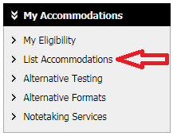
Though there is no direct link to do so, students can also cancel Notetaking Services for a class via MyDRC. The easiest way to do this would be to modify their accommodations request. To do this:
- Click “List Accommodations” from the My Accommodations submenu
- Scroll down to the class heading you want to cancel Notetaking from
- Click “Modify Request”
- Find “Notetaking Services” in the list of accommodations and uncheck the box
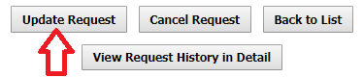
- Click the “Update Request” button at the bottom of the page
It may be necessary to logout of MyDRC and login again for changes to take effect, but this process will remove the Notetaking Services request from the selected class and the need to confirm or deny said request.

Confirming or Denying Notetaking via MyDRC Reminder Emails
Once the quarter has started, a series of confirmation reminder emails will be sent out to each student who has requested Notetaking Services. Each student will receive up to two (2) reminder emails per request (if a response is received from the first email, the second will not be sent), before MyDRC automatically cancels Notetaking Services and sends out cancelation emails. IMPORTANT: In order to receive Notetaking Services, a confirmation response MUST be received.
As an example: if a student were taking three (3) classes and requested notetaking for all of them they will receive a confirmation reminder email for each class. The first email to confirm their request will be sent either around the second day of the quarter or about two days after they request accommodations – whichever is later. Each email will contain links that will allow the student to respond to confirm Notetaking Services or choose a reason for declining the request.
IF the student doesn’t respond, a second confirmation reminder email will be sent out a couple of days later – again with links so the student can confirm or decline the request. If the student still hasn’t responded after the second email, a cancelation email will be sent out notifying the student that their Notetaking Services Request has been canceled due to non-response. This is NOT permanent. If a student does need a notetaker, services can be reactivated by contacting the DRC.

The Confirmation Reminder Email
All email correspondence from the Disability Resource Center and the MyDRC system must be directed to students’ official Bellevue College email address. If you do not regularly check your BC email or you do not forward your BC email to an email account that you do check often, DRC staff highly recommend that you set up your BC email to forward all emails to a preferred email account by following these directions on Bellevue College’s ITS website!
The confirmation reminder email should arrive to you from “drc@bellevuecollege.edu” or in some cases “Accessible Information Management” (the company that designs and manages the MyDRC database for us) with the subject:
- [DRC] Notetaking Confirmation Needed – First Notice
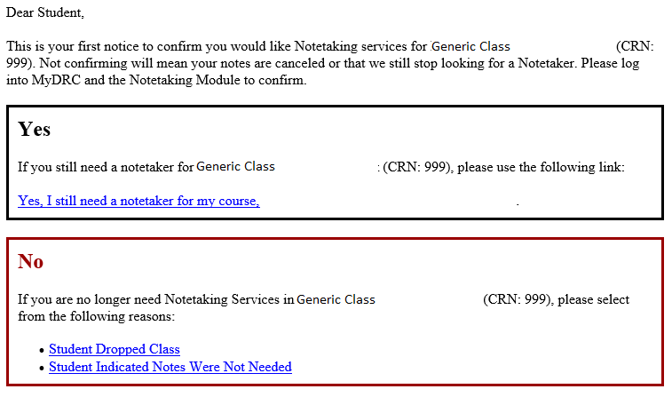
Though changes may occur in the exact content of the email, it should look similar to the following:
The email is pretty simplistic and straight forward, telling students what class it’s for, what will happen if they fail to confirm their request, and how to confirm their request.
First is the “Yes” box – click on the link “Yes, I still need a notetaker for my course…” in order to confirm Notetaking Services. Below that is a “No” box – click on one of the links provided in that box “If you are no longer need Notetaking Services” in order to cancel your notetaking request. Currently there are only two denial reasons – choose whichever you feel is most appropriate.
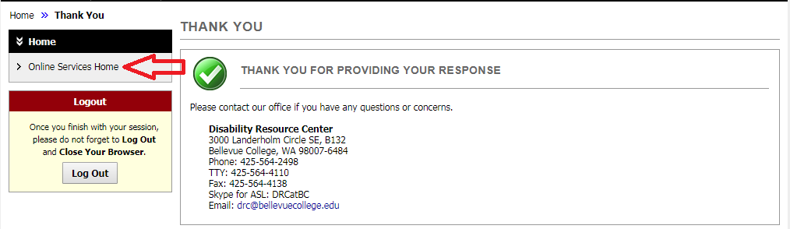
No matter which of the three links you end up clicking on, they will all take you to Bellevue College’s single sign-on page and after entering your username and password you’ll be granted access to MyDRC and be met with a Thank You for responding notice:
This is verification that your response was received and MyDRC has been updated with your selection.
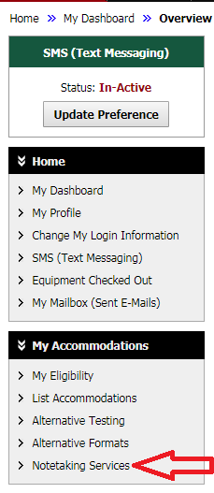
If you wish to verify your selection click on “Online Services Home” in the left sidebar menu (indicated with the red arrow) to take you back to the student dashboard. Once on the student dashboard click on “Notetaking Services” in the left sidebar menu (again indicated with the red arrow) in order to access the homepage for notetaking. On this page any notetaking requests that have been confirmed or are still pending will be displayed; notetaking requests that have been denied or canceled will not show up so if you do not see a class that you have requested and would like to receive Notetaking Services for please contact the DRC.

Conclusion
One of the two processes described above needs to be performed for each Notetaking Services request every quarter in order to receive notes for classes in which you are enrolled. Some classes may be simple to know in advance whether or not a notetaker will be needed and so you can confirm via MyDRC as soon as DRC staff make that option available whereas in other classes it may take some time to see how the material is handled, what resources the instructor provides, what the class structure is, and more before it can be determined whether or not a notetaker would be useful.
Remember also that none of these choices are permanent! Whether you confirm or refuse a notetaker – if you find yourself partway into the quarter and feel you have made the wrong choice and would like to change your mind just stop by the DRC office and our staff will be happy to see what we can arrange with you.
The next tutorial will talk about notifications you will receive from the Notetaking Services module of MyDRC as well as how to access notes that have been uploaded into MyDRC. The final tutorial for students on notetaking will cover rating your notetakers and the quality of the notes you were provided during the quarter.
If you have any questions or concerns about anything covered in this tutorial, Notetaking Services, MyDRC, or the DRC in general, please feel free to contact us. Thank you!

Disability Resource Center
3000 Landerholm Circle SE, B-132
Bellevue College, WA 98007-6484
Phone: 425-564-2498
TTY: 425-564-4110
Fax: 425-564-4138
Skype for ASL: DRCatBC
Email: drc@bellevuecollege.edu
https://www.bellevuecollege.edu/drc

