How to Download Notes from MyDRC
  - A TUTORIAL FOR DRC STUDENTS WITH NOTETAKING SERVICES ACCOMMODATIONS

Introduction
We’re down to it – the last and perhaps simplest part of the Notetaking Services module before students can assimilate the notes into useful information to help them be successful in achieving their higher education goals. Notes uploaded by notetakers will be kept in MyDRC for the entire quarter and may be downloaded as often as a student needs at any time during the quarter. This may become particularly useful if notes are misplaced or in order to keep study materials organized as Finals approach at the end of the quarter. Sometime after Finals have been completed DRC staff will erase all notes from the database – a couple of weeks prior to this an email will be sent out notifying students that they should download and save anything that they want to hold onto permanently as they will no longer have access to do so once it has been deleted from the database.

Downloading Notes from MyDRC
When a notetaker uploads notes to MyDRC an email will be sent to all students in the class who have confirmed their notetaking services request, to inform them that notes are available for download. Additionally, students who have opted to the SMS (Text Messaging) feature and selected Notetaking Services will also receive text notifications whenever notes for their classes are uploaded to the system. If you have not yet signed up for the SMS (Text Messaging) feature or you would like to change your preferences, please see the MyDRC Tutorial on the DRC website about the SMS feature for more instructions.

Notetaking Services
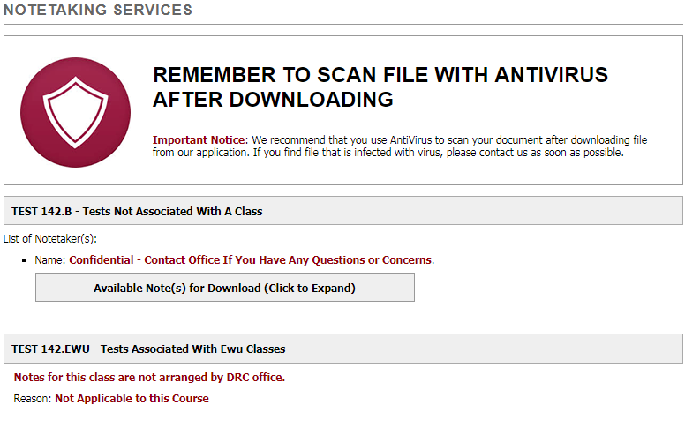
As with everything in this module before it, in order to get started students will want to login to MyDRC and then navigate to the Notetaking Services section by clicking on the link in the “My Accommodations” submenu on the left-side of the screen. This screen should look similar to the following:
The first box below the page title reminds students to scan files with an antivirus after downloading them; additionally the important notice message beneath that asks students to contact the DRC as soon as possible if they find any file they have downloaded is infected with a virus. Doing so will help the office contact other students who may be planning on downloading the notes as well as the notetaker in order to limit the spread of the virus.
Below this info box will be a list of classes that a student has requested notetaking services for. NOTE: Not all classes will be listed here – if a student has either not requested notetaking services for a class or if notetaking services have been cancelled because a student didn’t respond to the confirmation requests (see below), it will not be listed.
Each class will get its own section and the header for each section will be the course subject, number, and name.
- In the examples shown the first fake course listed is: TEST 142.B – Tests Not Associated With A Class
Below the class header it will list the Notetaker’s name and email address (all of them, if there are multiple notetakers for the class which may happen on occasion). This is so the student can contact the notetaker if there is any issue with the notes. NOTE: The notetakers do NOT have any information on the student(s) they are taking notes for and will not unless contacted by the student and informed directly.
- In the examples above a notetaker is assigned for only the first class and it is listed as confidential with the following message: Confidential – Contact Office If You Have Any Questions or Concerns.
  - In very rare circumstances the notetaker may be confidential, in which case all communication would need to go through the DRC.

Downloading Notes
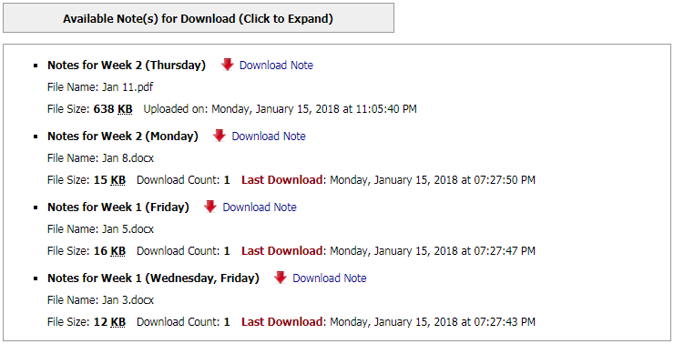
After the notetakers’ name and email(s) is a button that says “Available Note(s) for Download (Click to Expand)” – this button will only appear once notes have been uploaded by the notetaker to a student’s course. Clicking on the button will open a box listing all of the notes available for download for that course:
Notes that have been uploaded are listed in reverse chronological order with the most recently uploaded at the top of the page and the notes that were first uploaded at the bottom of the page. Each new upload is marked with a bullet point () and is broken down into three lines of information. Each informs the student:
- What week of the course and what day(s) (in parentheses) of the week the notes are from
  - Immediately after this is a red down arrow and a “Download Note” link
- Of the file name and type of file the notes are uploaded as
- Of the file size and when they were uploaded OR how many times they have been downloaded and when they were downloaded last
To save notes, either:
- Click on the “Download Note” link – the download will either automatically begin or open a window to choose a location and enter a filename for the downloaded file to be saved
–OR-
- Right-click on the “Download Note” link and select “Save As” in order to open a dialog window to choose the location and enter a filename for the downloaded file to be saved
Notes that have been uploaded to MyDRC will be available for download for the duration of the quarter, though they can be restricted from students with unexplained absences if deemed appropriate by faculty and DRC staff. Likewise, there is no limit to the number of times a specific file may be downloaded. NOTICE: All files will be purged from MyDRC after Finals have been completed, including any notes that have been uploaded. An email about this purge will be sent out to all students with Notetaking Services Accommodations a couple of weeks prior to finals to give them a chance to download any notes that a student may need to retain permanently.

Confirmation Required
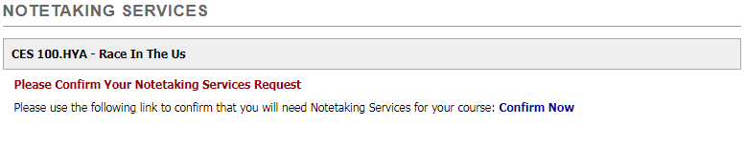
If, when logging in and navigating to notetaking services the screen looks different:
…this is because Notetaking Services has not been confirmed for the course yet. Students WILL still receive email (and SMS if activated) notifications of notes being uploaded while the system waits for the request to be confirmed, but a student will not be able to access the notes until confirmation has been completed. If a student has reached this stage, all that is needed to confirm the request is to click the blue Confirm Now link – this will need to be done for each course that needs notetaking services confirmed.
Once confirmed, the Notetaking Services page should look more similar to first one above, especially if there have already been notes uploaded for the course. Any notes already uploaded will be immediately available for download upon confirmation.

Missing Course
If a class isn’t listed on the Notetaking Services homepage, it is most likely for one of two reasons:
- Notetaking Services Accommodations were never requested for the course
–OR-
- Student didn’t respond to email requests from MyDRC to confirm Notetaking Services and didn’t login to MyDRC to confirm Notetaking Services
  - ALL Notetaking Services requests must be confirmed by a student before they can receive notes
  - Students will receive at least two email notifications before services are canceled
    - All communications go through BC email ONLY – to forward email automatically to another email address follow instructions here: https://www.bellevuecollege.edu/drc/bc-email-policy/

Conclusion
By providing notes electronically to students, the DRC is allowing students to have unprecedented access to notes for their courses. They can now download and view them as often as they need to without having to worry about what happens if they lose a copy or saving a copy to the right computer or having a portable drive on them at all times. And since notes will be available for the entire length of the quarter it will make review for midterms and finals that much easier – everything will be in one place.
If you have any questions about anything in this tutorial, MyDRC, or anything Disability related, feel free to connect with us:
Campus Office B-132
DRC Testing B-142
Phone: 425-564-2498
Fax: 425-564-4138 TTY: 425-564-4110
Skype for ASL: DRCatBC
Email: drc@bellevuecollege.edu
https://www.bellevuecollege.edu/drc

