MyDRC Initial Access Form Tutorial
If you are a new student to the Disability Resource Center, then this is the form for you! Be sure to review the New Students page of the DRC website for more information on getting started with the DRC and the initial access process. Please note: As explained on our website, this process will require a Bellevue College email address, a password to that email account, and a student ID number (SID). If you do not have these, please click the link above and follow the steps to acquire them or contact us!

Where to find the Initial Access Form
There are several ways to locate the Initial Access Form for the DRC. A link to the form can be found in the following locations:
- The DRC’s homepage under the “MyDRC and Other Forms” heading as “MyDRC Initial Access Form”
- The DRC’s New Students page; Step 1: Submit MyDRC Initial Access Form
- The DRC’s Forms page – underneath the Initial Access Form heading

Introduction
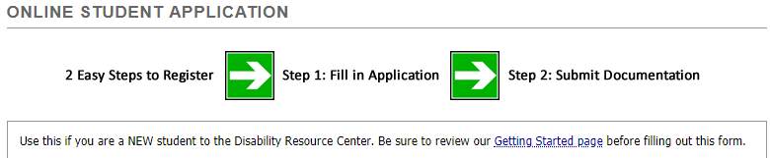
Once you’ve located and clicked on a link for the form you’ll be taken to the generic Bellevue College “Single Sign-On” Page where you will enter your BC username and password. For assistance logging in, please see our How to Login tutorial. Once logged in to MyDRC you’ll be taken directly to the initial access form which should be titled “Online Student Application.” The heading for the page should look like this:
The heading also contains the following two explanatory notices:
“The application asks some questions about affiliations and how you identify (e.g. race/ethnicity, sexual orientation, etc.). Affiliations are asked for so we know what resources you are already using and what we may be able to refer you to additionally.
Identity-based questions are asked because we believe that students with disabilities are an integral part of diversity. Unfortunately, this population is often not included in diversity research and reports on student success, and we want to do our part to change that. The information you provide will help us better understand our students and improve both DRC and other BC student services. We understand some of this information is asked on the BC application; that information is not shared with us and that’s why we ask some repeat information. This information is confidential and will only be used in anonymous data analysis. If you have any concerns or questions about this, ask us!”
All in all, this is a fairly standard application form, but there are a number of questions to get through. This tutorial will break the form down into several sections and explain how to fill out each one.
Please note that an asterisk (*) marks a required field in the form.

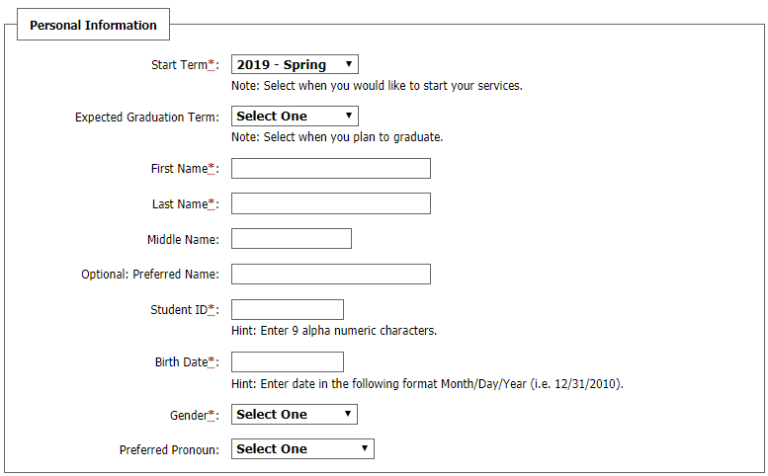
Personal Information
Start Term*: Use the drop-down menu to select the quarter you would like to start receiving services from the DRC. This is likely either the current or the next upcoming quarter. Please note this is not necessarily the same quarter you started (or will start) attending Bellevue College.
Expected Graduation Term: Use the drop-down menu to select the quarter you plan on graduating from Bellevue College. If you don’t yet know, you can enter your best estimate or leave this field blank.
First Name*: Enter your legal first name.
Last Name*: Enter your legal last name.
Middle Name: This information is optional, but you may enter it if you want.
Optional: Preferred Name: If you would prefer to be addressed by a name that is different from your legal first name, please enter that here.
Student ID*: This is a nine-digit ID number that was assigned to you when you were accepted to Bellevue College. An SID is required to create a profile and register with the DRC. If you believe you are entitled to an exception, please contact the DRC.
Birth Date*: Enter your birthday in a MM/DD/YYYY format.
Gender*: Select one of the options from the drop-down menu. While this is technically a required field, you can select “Not Specified” if you prefer not to answer.
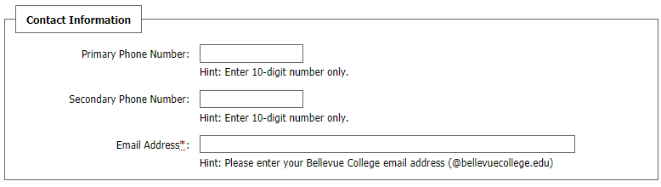
Preferred Pronoun: While not required, this option helps us address people according to their preference without resorting to assumption or bias.

Contact Information
Primary Phone Number: Enter a phone number where you are most likely to be reached in this space; enter only numbers, no spaces or punctuation. If you do not have a phone number or do not wish to be contacted by phone you can leave both phone spaces blank.
Secondary Phone Number: If you have a second number you would like to us to try and contact you at if we fail to reach you at the primary number, please enter it here; again, numbers only please.
Email Address*: Enter your Bellevue College email address into this field. NOTE: school policy requires all official email be sent specifically to a BC email address. Only email addresses ending in “@bellevuecollege.edu” will be accepted in this field.

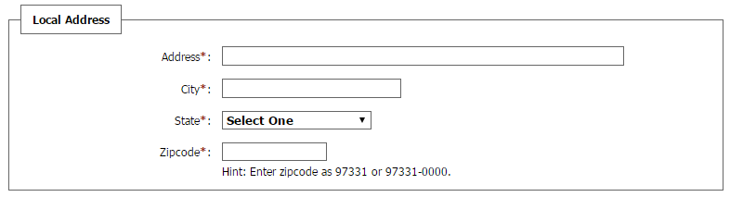
Local Address
Address, City, State, Zip Code*: Enter the street address, city, state, and zip code for where you are currently living. State can be selected from the drop-down menu. These are all required fields.

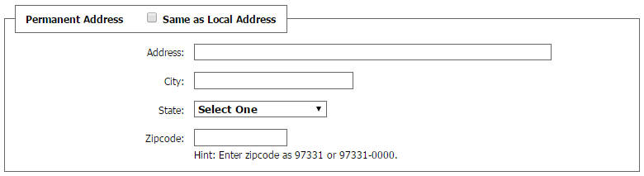
Permanent Address
Same as Local Address: If your permanent address is the same as your local address, please select the checkbox provided to copy the local address from above.
Address, City, State, Zip Code: If your permanent address is different from your local address, please enter that information as well.
NOTE: If you have an international address, “International” can be selected from the bottom of the drop-down menu for “State”.

Additional Information
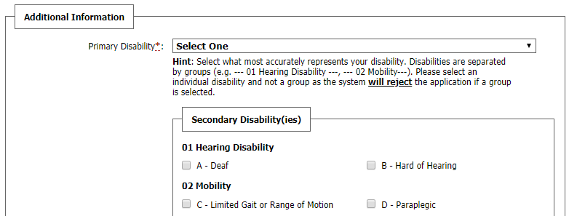
This is a fairly large section of the form, so this tutorial will cover it in smaller parts.

Disability Information
Primary Disability*: Select one of the listed disabilities from the drop-down menu. Note that while the section headings (preceded by a number) are selectable, this will cause an error in the coding and lead to your application being rejected. Please select one of the individual disabilities (preceded by a letter).
Secondary Disabilities: Select the check box next to any of your secondary disabilities.
Note: For both primary and secondary disabilities, the numbers and letters listed next to each option are there for DRC coding purposes only.
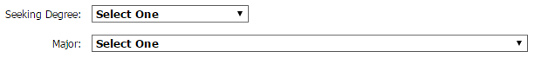
Other Disability or Note: If you have a disability that is not listed above, or you are unsure what category your disability falls into, please make note of it in the space provided here. This space can also be used to provide additional or more specific information about any of the disabilities you’ve selected above. However, it should be noted that the text box does have a 99 character limit.

Degree and Major Information
Seeking Degree: If you know the type of degree you will be pursuing at Bellevue College, please select it from the drop-down menu.
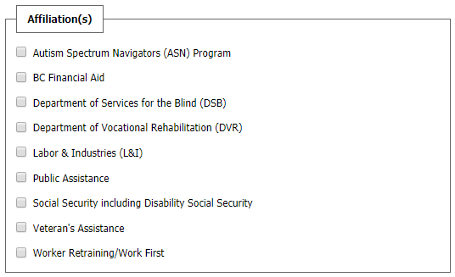
Major: If you know the name of your major or program, please select it from the drop-down menu.

Other Information
Affiliation: If you receive services or funding from any of the programs listed in this section, please select the checkbox next to them.
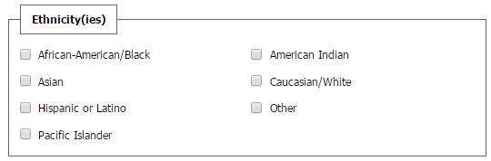
Ethnicity: If you wish to provide this optional demographic information, please select the checkbox next to any ethnicities that you identify with.
Below the box for Ethnicity is a text-entry box labeled “Additional Note”. This is an optional space to enter any additional information you feel might be relevant to your initial access form.

Questions
The questions in this section will prompt you for additional information that the DRC would like to have included in your file. Questions 1 through 9 are required and your Initial Access Form will not be accepted by MyDRC if they are left blank. Questions 10 through 16 are completely optional, but some of them may help us reach more students on campus or find ways to collaborate with other programs.
Most questions in this section include an additional field where you can include any notes or explanations needed for your answer.
- Emergency Contact Name and Relationship to Student*
Please enter the first and last name of a person who can be contacted on your behalf in case of emergency and explain how they are related to you. (For example: parent, friend, partner, relative, etc.)

- Emergency Contact Phone Number*
Please enter a phone number where that person can be reached.

- Describe how your disability affects you in an academic setting, including what barriers and difficulties you experience?*
Discuss how your disability (or disabilities) has impacted your academic pursuits and what barriers you may have encountered in the past. This helps tailor accommodations specifically to you and your individual academic needs. If you had an IEP or 504 Plan at any point during grades K-12, this is the place to mention it.

- What is the highest level of education you have completed?*
Select one of the options or choose other and provide an explanation.

- What is the first quarter you were, or will be enrolled at Bellevue College?*
Enter the quarter into the text box provided. Note that this is not necessarily the same as the quarter you want to start DRC services.

- Have you applied for admission to Bellevue College?*
Select yes or no. Add additional explanation in the provided text box if needed.

- Have you taken the Bellevue College Accuplacer English Assessment?*
Select yes or no. Add additional explanation in the provided text box if needed.

- Have you taken the Bellevue College ALEKS Math Assessment?*
Select yes or no. Add additional explanation in the provided text box if needed.

- Is English your primary language?*
Select yes or no. If no, please enter your primary language into the text box provided.

- How did you hear about the DRC? Please select all that apply.
Please provide us with information about how you first (or most recently) heard about the Disability Resource Center and services we provide by selecting as many of the options as are applicable and/or selecting other and providing an explanation in your own words.

- Do you want to learn more about any of the following?
Select the check box next to any topics, services, or programs you would like to receive more information about. If there is any information you’d like that you don’t see listed, feel free to enter it in the text box.

- Sexual Orientation
If you would like to provide this information, select the check box next to your identified orientation. If you don’t see it listed, click the box next to “Other,” and provide a response.

- Military service during…
If you have served in the military and would like to provide this information, select the check box next to any of the decades listed during which you served.

- Religion/Spirituality?
If you would like to provide this information, select the check box next to any options that apply.

- My annual income is…
If you would like to provide this information, select the checkbox next to your income bracket.

- Is there anything you want the DRC to know that you were not able to include elsewhere on this form?
If there is anything you feel is important for us to know in order to better support you in achieving your academic goals, this is the place to let us know!

Submitting the Form
Once you’ve completed the final question, take a moment to review the initial access form to ensure that you’ve completed the entire form and have everything entered correctly. When you’re done, simply click on the button labeled “Submit Application” at the bottom of the page.
Your initial access form will then be submitted to the DRC system to be processed. Be sure to check your BC email for confirmation and further instructions!

Summation and Questions
So in this tutorial we covered how to complete the Initial Access Form in MyDRC, which begins the process of receiving accommodations through the Disability Resource Center. The next step in the process will be to submit documentation which can be done in person in our office, via email, or through a link that will included in the verification email you receive after completing this Initial Access Form. Also, a member of the DRC should be contacting you soon about scheduling an appointment for your Initial Access meeting with one of our Access Specialists – this is the meeting where you get to discuss your disability and how it affects your ability to succeed in academics and how we can help support you and remove barriers.
Remember, all communication will go to your Bellevue College email so make sure that you check it regularly for notifications and updates.
If you have any questions about anything in this tutorial, MyDRC, or anything Disability related, feel free to connect with us:
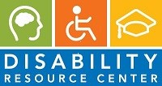
Campus Office B-132
DRC Testing B-142
Phone: 425-564-2498
Fax: 425-564-4138
TTY: 425-564-4110
Skype for ASL: DRCatBC
Email: drc@bellevuecollege.edu
https://www.bellevuecollege.edu/drc

