Requesting a Notetaking Assignment
  - A GUIDE FOR REGISTERING TO BE AN IN-CLASS NOTETAKER WITH THE DRC

PART II of Completing the MyDRC Notetaker Application

Overview
This tutorial is intended for Notetakers, either recently hired or established, who have fully completed the hiring process to be either employees or volunteers at Bellevue College DRC. This specific process is only for students seeking to take notes for the classes in which they are enrolled. In order to complete this part of the MyDRC Notetaker Application you will need your Bellevue College email address and password for logging in to your BC email as well as a list of your CRNs for the courses in which you are enrolled and would like to take notes for.
If you are a new notetaker and have NOT completed PART I: Creating a MyDRC User Profile, please follow these instructions to complete that before continuing with this tutorial. If you do not have a valid MyDRC User profile you will not be able to continue any further with this tutorial.
Likewise, if you are a student who is registered with the DRC to receive accommodations and would like to register to be a notetaker as well you need to visit the DRC Office to have a staff member update your MyDRC profile to include an employee profile! Only after doing this, will you be able to continue with Step 1: Requesting a Notetaking Assignment.
PLEASE NOTE: If you are not currently enrolled in classes OR you are interested in taking notes for classes other than ones you are enrolled in, please visit the DRC Office to be assigned to a class(es) based on prioritized needs. THIS process is only for students seeking to take notes for the classes in which they are enrolled.

Step 1: Requesting a Notetaking Assignment
Requesting a notetaking assignment is the first step in the notetaking process each quarter and can be completed as soon as registration begins. Once enrolled in classes, CRNs can be entered in MyDRC which then matches notetakers and students with notetaking accommodations in the same classes and alerts DRC staff to verify the matches. Classes that do not have generate any matches with notetakers requesting assignments will be added to a prioritized list managed by DRC staff, who will assign them to available notetakers seeking assignments in the DRC Office.
Some classes may not be available for assignment through MyDRC and will only be assigned through the DRC Office each quarter to established notetakers.

Login to MyDRC
To begin the request process, in a web browser (Google Chrome is preferred) navigate to the MyDRC homepage in order to sign-in. There is also a link on the DRC website in the left sidebar menu labeled “MyDRC” that will take you to the same sign-in page. For detailed instructions on how to login, please see our tutorial on How to Login to MyDRC.
To protect data stored within the database, MyDRC will timeout after a period of inactivity of about 15-30 minutes. It’s best not to leave it open in a background tab or window as this will likely lead to needing to login in again and losing any work/progress. Instead, prepare everything you will need before logging in to MyDRC so it will be possible to work nearly continuously and remained logged-in until the task(s) are completed.

Notetaker Home
Once logged in MyDRC should open to the Notetaker Home page. If it has not, click the “Notetaker” tab at the top of the page, just below the Bellevue College header, to pull up the Notetaker Home page. This page is not just the starting page for Requesting a Notetaking Assignment, but will be the homepage for all of the notetaker activities that take places in MyDRC during the quarter(s).
On the left hand side of the screen is a Tools sidebar menu as well as a logout button. This tutorial will only concern itself with the first option – “Request and View Assignments” – and the other options will be covered in future tutorials. Clicking on the “Request and View Assignments” option in the Tools sidebar menu will load the Notetaker Home should you navigate away from it or need to return to request another assignment, change an assignment, or view the status of assignments already requested. To begin with, the Notetaker Home page should look something like the image below:
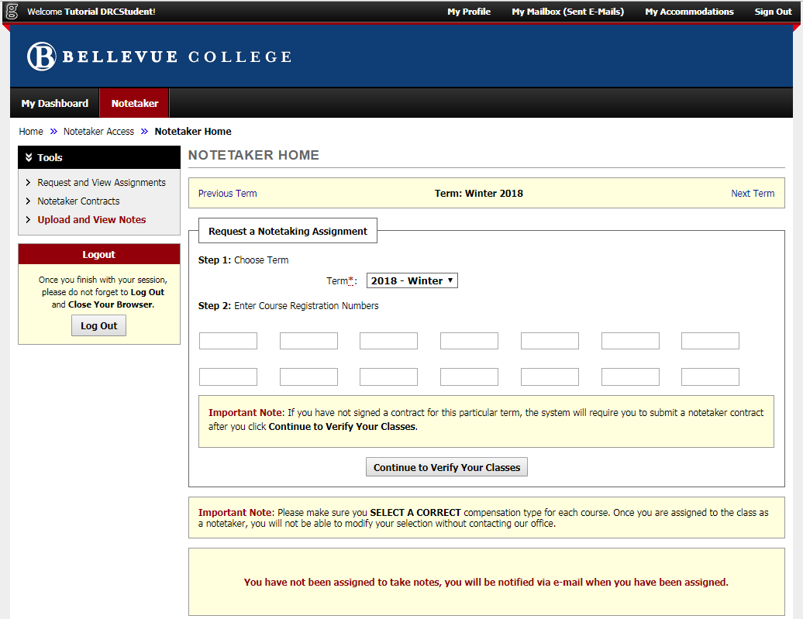
The first yellow-ish box at the top allows you to select the term. This is mostly used when viewing assignments from previous or upcoming terms.
The second box down, labeled “Request a Notetaking Assignment” is where CRNs will be entered in an attempt to match up with students who have notetaking accommodations. First, make sure that the drop-down menu next to “Term” has the current term selected, then enter the CRN for each of the classes that you would be willing to take notes for that term. Enter each CRN in a separate box – up to 14 CRNs can be entered at one time, so there’s plenty of space. If you have checked with the DRC Office and received a CRN from them for a priority need class, this is also where you would enter that.
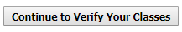
Once you have entered and double-checked the accuracy of all the CRNs for courses you want to take notes in, click the “Continue to Verify Your Classes” button in order to move on to the next step in the process.

Step 2: Submit a Notetaker Contract
Each quarter a DRC Notetaker Agreement must be submitted before a notetaker can accept any notetaking assignments. The DRC Notetaker Agreement consists of a list of responsibilities both new and established notetakers will be held accountable to during the course of the quarter. DRC students depend heavily on quality production from their notetakers in order to receive equal access in their courses, so failing to meet the responsibilities laid out in the Notetaking Agreement could have very adverse effects for the student. As a result, failure to meet these responsibilities could result in corrective action including dismissal from an assignment or dismissal from the notetaking position altogether.
If you have already submitted a DRC Notetaker Agreement for the current quarter, this step will be skipped and you will go straight to verifying your classes. Example: If you requested notetaker assignments at or before the beginning of the quarter and submitted a DRC Notetaker Agreement and then later added an additional assignment – since you already have the notetaker contract for the current quarter “on file” in MyDRC it will skip this step and go straight to Step 3: Verifying Your Classes.

DRC Notetaker Agreement
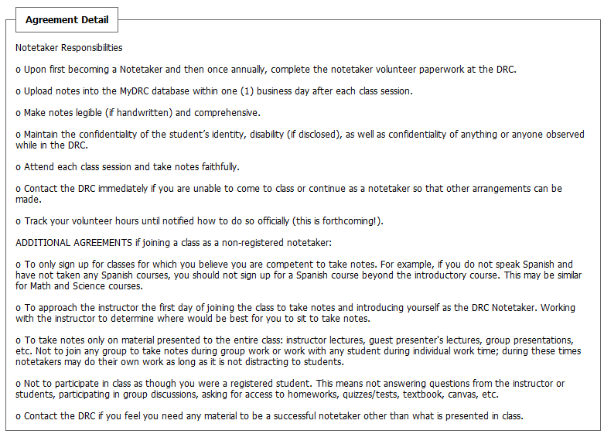
The DRC Notetaker Agreement should look the same or similar to the one below:
Though the Agreement may change and evolve over the course of quarters, here’s how the current agreement reads (Spring Quarter 2019):
- Notetaker Responsibilities
  - Upon first becoming a Notetaker and then once annually, complete the notetaker volunteer paperwork at the DRC.
  - Provide notes within one (1) business day after each class session.
  - Make notes legible (if handwritten) and comprehensive.
  - Maintain the confidentiality of the student’s identity, disability (if disclosed), as well as confidentiality of anything or anyone observed while in the DRC.
  - Attend each class session and take notes faithfully.
  - Contact the DRC immediately if you are unable to come to class or continue as a notetaker so that other arrangements can be made.
  - Track your volunteer hours until notified how to do so officially (this is forthcoming!).
- ADDITIONAL AGREEMENTS if joining a class as a non-registered notetaker:
  - To only sign up for classes for which you believe you are competent to take notes. For example, if you do not speak Spanish and have not taken any Spanish courses, you should not sign up for a Spanish course beyond the introductory course. This may be similar for Math and Science courses.
  - To approach the instructor the first day of joining the class to take notes and introducing yourself as the DRC Notetaker. Working with the instructor to determine where would be best for you to sit to take notes.
  - To take notes only on material presented to the entire class: instructor lectures, guest presenter’s lectures, group presentations, etc. Not to join any group to take notes during group work or work with any student during individual work time; during these times notetakers may do their own work as long as it is not distracting to students.
  - Not to participate in class as though you were a registered student. This means not answering questions from the instructor or students, participating in group discussions, asking for access to homework, quizzes/tests, textbook, canvas, etc.
  - Contact the DRC if you feel you need any material to be a successful notetaker other than what is presented in class.

Required Step
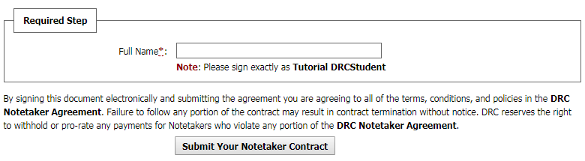
After the bulleted responsibilities of the DRC Notetaker Agreement is a box for an electronic signature. Please enter your full name exactly as it was entered in the very first step when creating a login. For reference, it’s provided underneath the text box: “Note: Please sign exactly as…”
Be sure to read the notice below the electronic signature box: “By signing this document electronically and submitting the agreement you are agreeing to all of the terms, conditions, and policies in the DRC Notetaker Agreement. Failure to follow any portion of the contract may result in contract termination without notice. DRC reserves the right to withhold or prorate any payments for Notetakers who violate any portion of the DRC Notetaker Agreement.”
After reading through the DRC Notetaker Agreement and providing an electronic signature, click the button labeled “Submit Your Notetaker Contract” in order to move on to the last step in the initial process.

Step 3: Verifying Your Classes
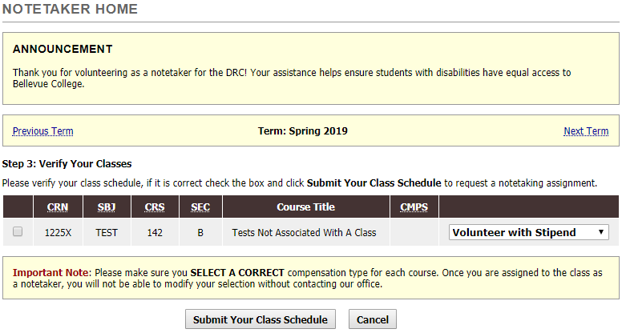
After clicking on the submit button a page will load that should display the current term and be titled “Step 3: Verify your Classes” – below which will be a list of classes populated based on the CRNs entered on a previous page. Though future updates may change the formatting somewhat, it should look similar to the following:
Notice the instructions for verifying: “Please verify your class schedule, if it is correct check the box and click Submit Your Class Schedule to request a notetaking assignment.” We want you to inspect each row and column to make sure the data is accurate so we can be assured you attend the class we need notes for, we do not have multiple notetakers for the same course (unless necessary), or you do not sign up for a class you are not enrolled in (students only).

Verifying
There are eight (8) data columns with information to either verify or input and we will be looking at them from left to right. Unfortunately, the left-most and the right-most are both currently unlabeled, but the other six are: CRN, SBJ, CRS, SEC, Course Title, and CMPS. Note: All of the ones that are abbreviated are underlined, and if the cursor is held over the abbreviations it will display the full title.

Columns
- First (left-most) unlabeled column – Verification Check box
  - Click the box after verifying all the other information is accurate to request an assignment for this class.
  - Leaving it unchecked will result in no assignment being requested.
- CRN – Course Registration Number: Verify this matches the course you are enrolled in or want to be assigned
- SBJ – Course Subject: Make sure this is the right subject (e.g. MATH)
- CRS – Course Number: Make sure this is the right number for the subject next to it (e.g. MATH 099)
- SEC – Course Section: Verify that the section is accurate, perhaps the most important!
  - Some courses have several sections taught at different times of day, requesting the right section is crucial for scheduling accuracy!
- Course Title – This is the most generic of identifiers as all courses with the same Subject and Course Number should also have the same title, but verify it’s accuracy just the same.
- CMPS – Campus: More than likely this is going to be empty or blank. If ever you see anything that indicates “North Campus” notify DRC Staff immediately.
- Last (right-most) unlabeled column – Compensation type drop-down menu
  - Currently (Spring 2019) the only option is Volunteer with Stipend
The notice at the bottom is largely unnecessary as there is only one pay option and is not possible to not select a pay option, but it is still included out of necessity: “Important Note: Please make sure you SELECT A CORRECT compensation type for each course. Once you are assigned to the class as a notetaker, you will not be able to modify your selection without contacting our office.”
Once the accuracy of the class list has been verified, the correct compensation types selected, and the check boxes marked, clicking on the “Submit Your Class Schedule” will officially complete your MyDRC Notetaker Application for the quarter and submit your classes to the DRC to assign you as a notetaker if needed.
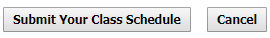
Clicking on the “Cancel” button will return you to Step 1 of this process where there is the option to select a term and enter CRNs to Request a Notetaking Assignment. It is suggested to only select cancel if you have made a mistake and entered the wrong CRN – or if the CRN you have entered is pulling up erroneous information or no information at all.

Success!
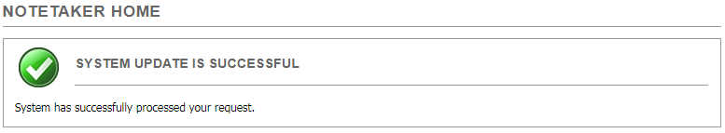
If everything has been done properly, the following success message should be displayed after clicking submit:
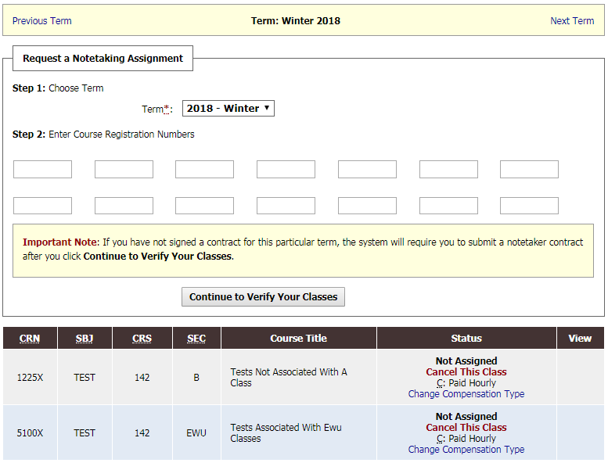
Additionally, below that the Notetaker Home page has been updated:
While the “Request a Notetaking Assignment” box is the same and still available should more classes need to be added, below that the classes that have just been added are now listed along with their status. Please take notice that there are four (4) lines in the status currently – this will change as the quarter progresses, but here are what each of those lines means as of now:
- Not Assigned – This class has just been requested for assignment and the DRC has not yet assigned it to you. DRC staff will go through assignments a determine how many (if any) notetakers are needed for each one and assign notetakers based on that need. The notetaker(s) will then verify that they accept the assignment and start delivering notes (this is covered in another tutorial).
- Cancel This Class – Click this link if you wish to cancel the Notetaking Assignment Request for the associated class. You will be taken to another page where that cancelation is verified before it is finalized.
- C: Paid Hourly – Hover the cursor over the C to see it stands for “Compensation Type”; this indicates the chosen compensation of hourly pay.
- Change Compensation Type – Click this link if you wish to change your Compensation Type. NOTE: This can only be done prior to the class being assigned. Once the class is assigned only DRC staff can edit compensation type.

Conclusion
Once Step 3: Verify Your Classes has been completed the classes will be matched with DRC students requesting notetaker accommodations and assigned by the DRC. You will not be asked to confirm an assignment once your class is matched with a DRC need – your request for a notetaking assignment is considered confirmation that you are willing and able to take notes in the listed courses for yourself as well as for the DRC. Once you have been assigned you will be notified via your BC email and should begin taking notes immediately (if you haven’t already done so). NOTE: All communications from MyDRC and the DRC Office will go to your BC email address – if that is not an email address that you regularly check, either begin to do so or follow these instructions to forward your BC email to another email address that you will check on a daily basis!
If you change your mind and decide that you do not wish to take notes for a particular class BEFORE you have been assigned, return to the Notetaker Home page and click the Cancel This Class link.
If you change your mind and wish to stop taking notes for a particular class AFTER you have been assigned, please stop by the DRC Office to let us know – we may ask that you continue to take notes while we find someone to take your place, depending on the situation.
We are pleased that you have requested notetaking assignments! Thank you for helping us provide equal access to students with disabilities!
If you run into any issues or have any concerns with this tutorial or when requesting a notetaking assignment, please feel free to contact the DRC Office.
Disability Resource Center
3000 Landerholm Circle SE, B-132
Bellevue College, WA 98007-6484
Phone: 425-564-2498
TTY: 425-564-4110
Fax: 425-564-4138
Skype for ASL: DRCatBC
Email: drc@bellevuecollege.edu
https://www.bellevuecollege.edu/drc

