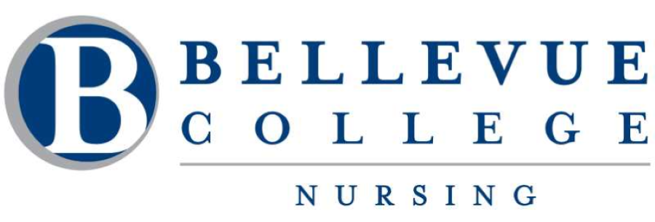

Faculty Cohort Advisors
Each nursing student cohort will be assigned a nursing faculty cohort advisor. The faculty cohort advisor will be able to provide direction regarding courses and college resources. Advisors are available to meet with students regarding personal and academic support by appointment.

- Winter 2024 Cohort – Muntaha Alibrahim Graduates 1225
- Spring 2024 Cohort – Shadi Kanan Graduates 0826
- Fall 2024 Cohort – Lisa Tedeschi Graduates 0626
- Winter 2025 Cohort – Marilu Bumgardner Graduates 1226
- Spring 2025 Cohort- Dianne Caraway Graduates 0827
- Fall 2025 Cohort – Teaessa Chism Graduates 0627
- Winter 2026 Cohort- Caroline Fitzpatrick Graduates 1227
- Spring 2026 Cohort- Dan Shade Graduates 0828
- Fall 2026 Cohort- Jennifer Celms Graduates Graduates 0628

