To receive information about courses you have or planning to take that may meet equivalency requirements for the Diagnostic Ultrasound Program PREREQUISITES, please submit the following form along with an unofficial copy of the college transcript. The courses thought to be equivalent should be highlighted to help in identification.
Name: | Date:
Email: | Phone:
Mailing Address:
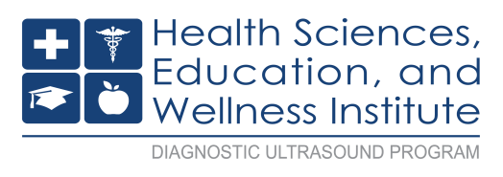
Send the completed form back to us via: FAX (425) 564-4193, Email: imaging@bellevuecollege.edu or Mail: Diagnostic Ultrasound Program – A242, Bellevue College, 3000 Landerholm Circle SE, Bellevue WA 98007-6484. Allow 7-10 working days to receive a reply from Program Advisor. If you don't receive a response within that time please follow up by emailing imaging@bellevuecollege.edu. This completed form should be included with your packet when you apply.
PREREQUISITE EQUIVALENCY WORKSHEET
BC Prerequisite Courses | Course Equivalency  Requested: Name of  College, Course Name/  Number/Title and # of Credits | Course Description from College Catalog | COMMENTS – BC Program Advisor
ENGL 201
The Research Paper
5 credits
OR
ENGL& 235
Technical Writing previously ENGL 270
5 credits
MATH 130
Introduction to Statistics
5 credits
(completed within the last 5 years)
BIOL& 241 - Human Anatomy &
Physiology I previously BIOL 260
6 Credits
(completed within the last 5 years)
BIOL& 242 - Human Anatomy &
Physiology II previously BIOL 261
6 Credits
(completed within the last 5 years)
PHYS& 100
Physics Basic Concepts previously PHYS 106 (completed within last 5 years)
CULTURAL DIVERSITY COURSE:
CMST& 230 OR
CMST 250 OR
CMST 280 OR
Any course from BC cultural diversity list (5 credits)
http://bellevuecollege.edu/programs/ degrees/culturaldiversity/
AHE 110
Medical Terminology previously HPRO 120
5 credits
Additional Comments:

For program information go to: http://bellevuecollege.edu/health/ultrasound/
Phone: (425) 564-2317
Email: imaging@bellevuecollege.edu

