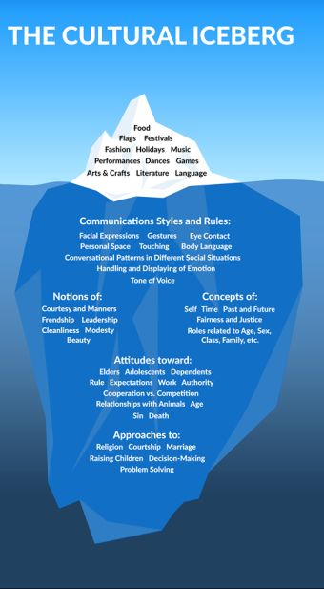
Cultural Iceberg
By Edward T. Hall

Surface Culture:

Food
Flags
Festivals
Fashion
Holidays
Music
Performances
Dances
Games
Arts & Crafts
Literature
Language

Deep Culture:

Communication Styles & Rules

Facial Expressions
Gestures
Eye Contact
Personal Space
Touching
Body Language
Conversational Patterns in Different Social Situations
Handling and Displaying of Emotion
Tone of Voice

Notions of:

Courtesy and Manners
Friendship
Leadership
Cleanliness
Modesty
Beauty

Concepts of:

Self
Time
Past and Future
Fairness and Justice
Roles Related to Age
Sex
Class
Family, etc.

Attitudes towards:

Elders
Adolescents
Dependents
Rules
Expectations
Work
Authority
Cooperation vs. Competition
Relationships with Animals
Age
Sin
Death

Approaches to:

Religion Raising Children
Courtship Decision-Making
Marriage Problem-Solving

