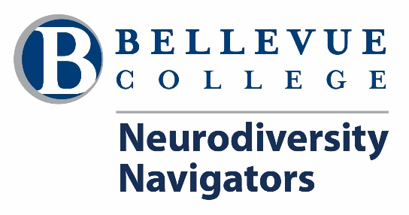

*Fall 2022 Program Enrollment Checklist

*Full details regarding these steps are available on the Future Students page!

☐ 1. Watch Videos & Attend Q&A Information Session
☐ 2. Apply to Bellevue College 6/10
☐ 3. Create Bellevue College NetID Account (Email) 6/20
☐ 4. Determine Your English Placement 6/20
☐ 5. Attend BC New Student Orientation 7/1
☐ 6. Meet w/Admissions Advisor 7/1
☐ 7. Request Appointment to Meet w/Us! 6/24
☐ 8. Register for Classes 7/1
☐ 9. Complete Availability Survey 7/1
☐ 10. Pay Tuition for Fall Quarter Classes !!!!
deadlines
☐ 11. Check Your Bellevue College Email daily
☐ 12. Send Any Class Schedule Updates 8/24

Please contact us if you run into any barriers, including missed deadlines.

Phone: (425) 564-2764 Text: (833) 227-4551 Email: asn@bellevuecollege.edu

Chat: Chat on Microsoft Teams

